Ages and Stages of Development
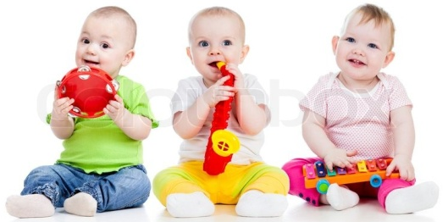
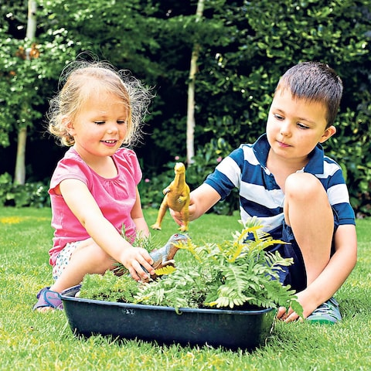
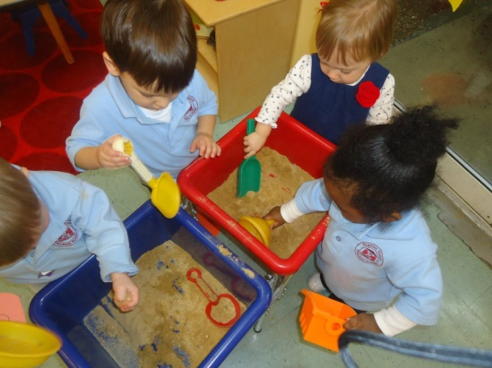
Name: Tracey Shackle Date: 24/4/2019
1.2 Give example of play activities which can help a child’s development
2.1 Give examples of at least two play activities for two different stages of child development
2.2 Identify the purpose of each activity

2 years – Children playing with the sand. As they play they use their imagination. They are also developing their hand and eye coordination and their fine motor skills along with their maths skills

9 months – Children playing with musical instruments to support their physical development and language skills.
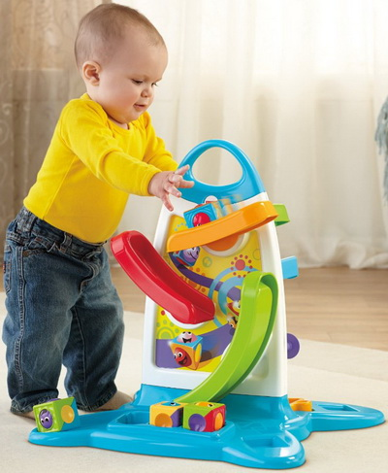
4 years – Children playing with dinosaurs and natural materials outside. To support their expressive arts and design and personal, social and emotional development as they play together

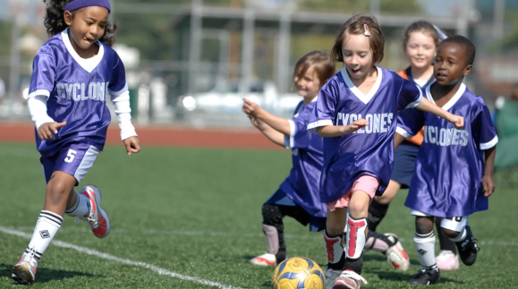
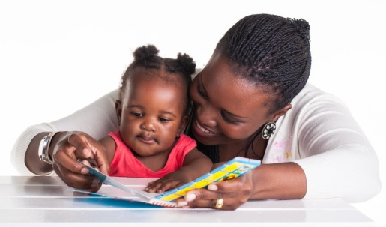
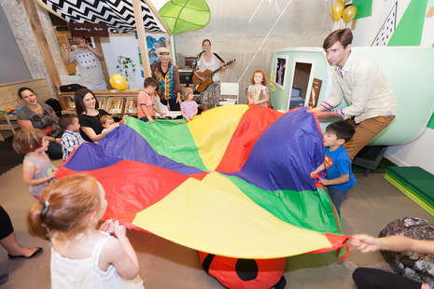
3 years – Children playing with the parachute, counting, singing and playing with each other. They are developing their maths, language and personal social and emotional skills.
5 years – Children playing football together developing their personal, social and emotional skills and physical development, kicking the ball to each other and running

18 months old- Sharing story time with mum developing, literacy skills communication and language skills

1-year-old exploring and investigating the activity centre. Developing fine motor skills, and maths skills.

