Personal Information Questions Name _______________ Date __________
- What’s your name? How do you spell it?
- Where do you live?
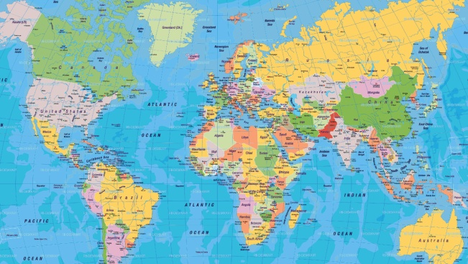
- Where are you from?
- What languages do you speak?
- What do you like doing in your free time?2
- What’s your favourite food?
- Why do you want to improve your English?
- What are your plans for the future?

Now fill in the table with information about you.

name | live | country | language(s) | free time | favourite food | reasons for learning English | future plans

