Sweet potatoes tortilla with black beans and avocado

Sweet potatoes tortilla
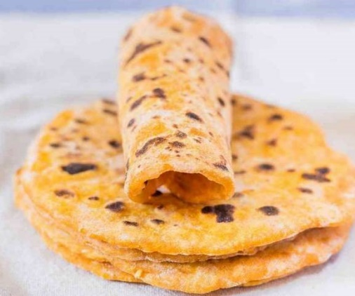
Ingredients:
1 medium sweet potatoes, boiled
200g plain flour

Method:
- To a mixing bowl, add the mashed sweet potato and the flour and stir until well-combined. Use your hands to form a dough ball. It should not be too sticky.
- Separate the dough ball into 5 equal parts. Dust your working surface with flour and roll out each tortilla with a rolling pin (they should be roughly 1/2 cm thick). Don't make them too thin, otherwise they won't be as soft and flexible.
- Place the tortillas in a hot pan over medium-high heat and cook for 1 minute on both sides. Stack the cooked tortillas on a plate covered with a clean kitchen towel while you cook the rest. This will allow them to stay very flexible.

Black beans and Avocado

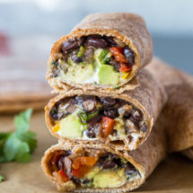
Black beans and Avocado salsa

Ingredients:
- 1 tablespoon oil
- 1/2 onion chopped
- 1 red pepper chopped
- 1 tablespoon tomato puree
- 1 clove garlic minced
- 1 can black beans drained
- 1/2 tsp cumin, 1/2 tsp paprika, 1/2 tsp chili powder
- Salt and pepper to taste
For the avocado salsa
- 1 avocado pitted and chopped
- 1 small tomato chopped
- 2 tablespoons fresh coriander
- Juice of 1 lime
- Few salad leaves

Method:
- Heat the oil in a large pan on a medium/low heat.
- Add the onion, pepper and garlic and cook for 2/3 minutes
- Add the beans and seasoning , and cook for another 2/3 minutes
- Remove from the heat and cool for few minutes before assembling
- In a medium bowl, combine the avocado, coriander, tomato and lime juice and mash with a fork

