Inserting elastic into a stitched band Unit 102 Task 1b

You will need: Fabric 30cmX30cm minimum Scissors
Elastic 1cm wide Pins
Hand sewing needle Safety pin
Sewing Machine

1. Cut a strip of fabric from your main piece.
2. Zigzag the sides of the main piece.
3a. Attach the strip about 10cms from the bottom using a 0.5cm seam allowance.
3b. Keep the ends of the strip folded to inside the seam allowance.
3c. Fold over and stitch very close to the edge.
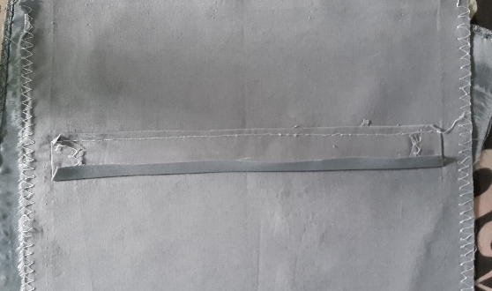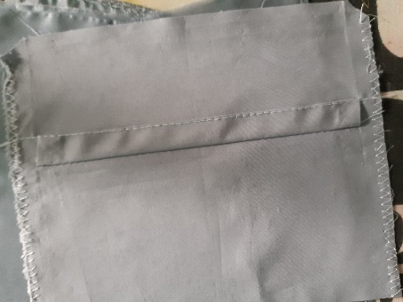
3a 3b 3c

4a. Stitch side seam turn right side out and attach safety pin to elastic and insert into stitched band. 4b. Stitch elastic ends together flat using zigzag.
4c. Wriggle elastic into position and hand stitch opening.

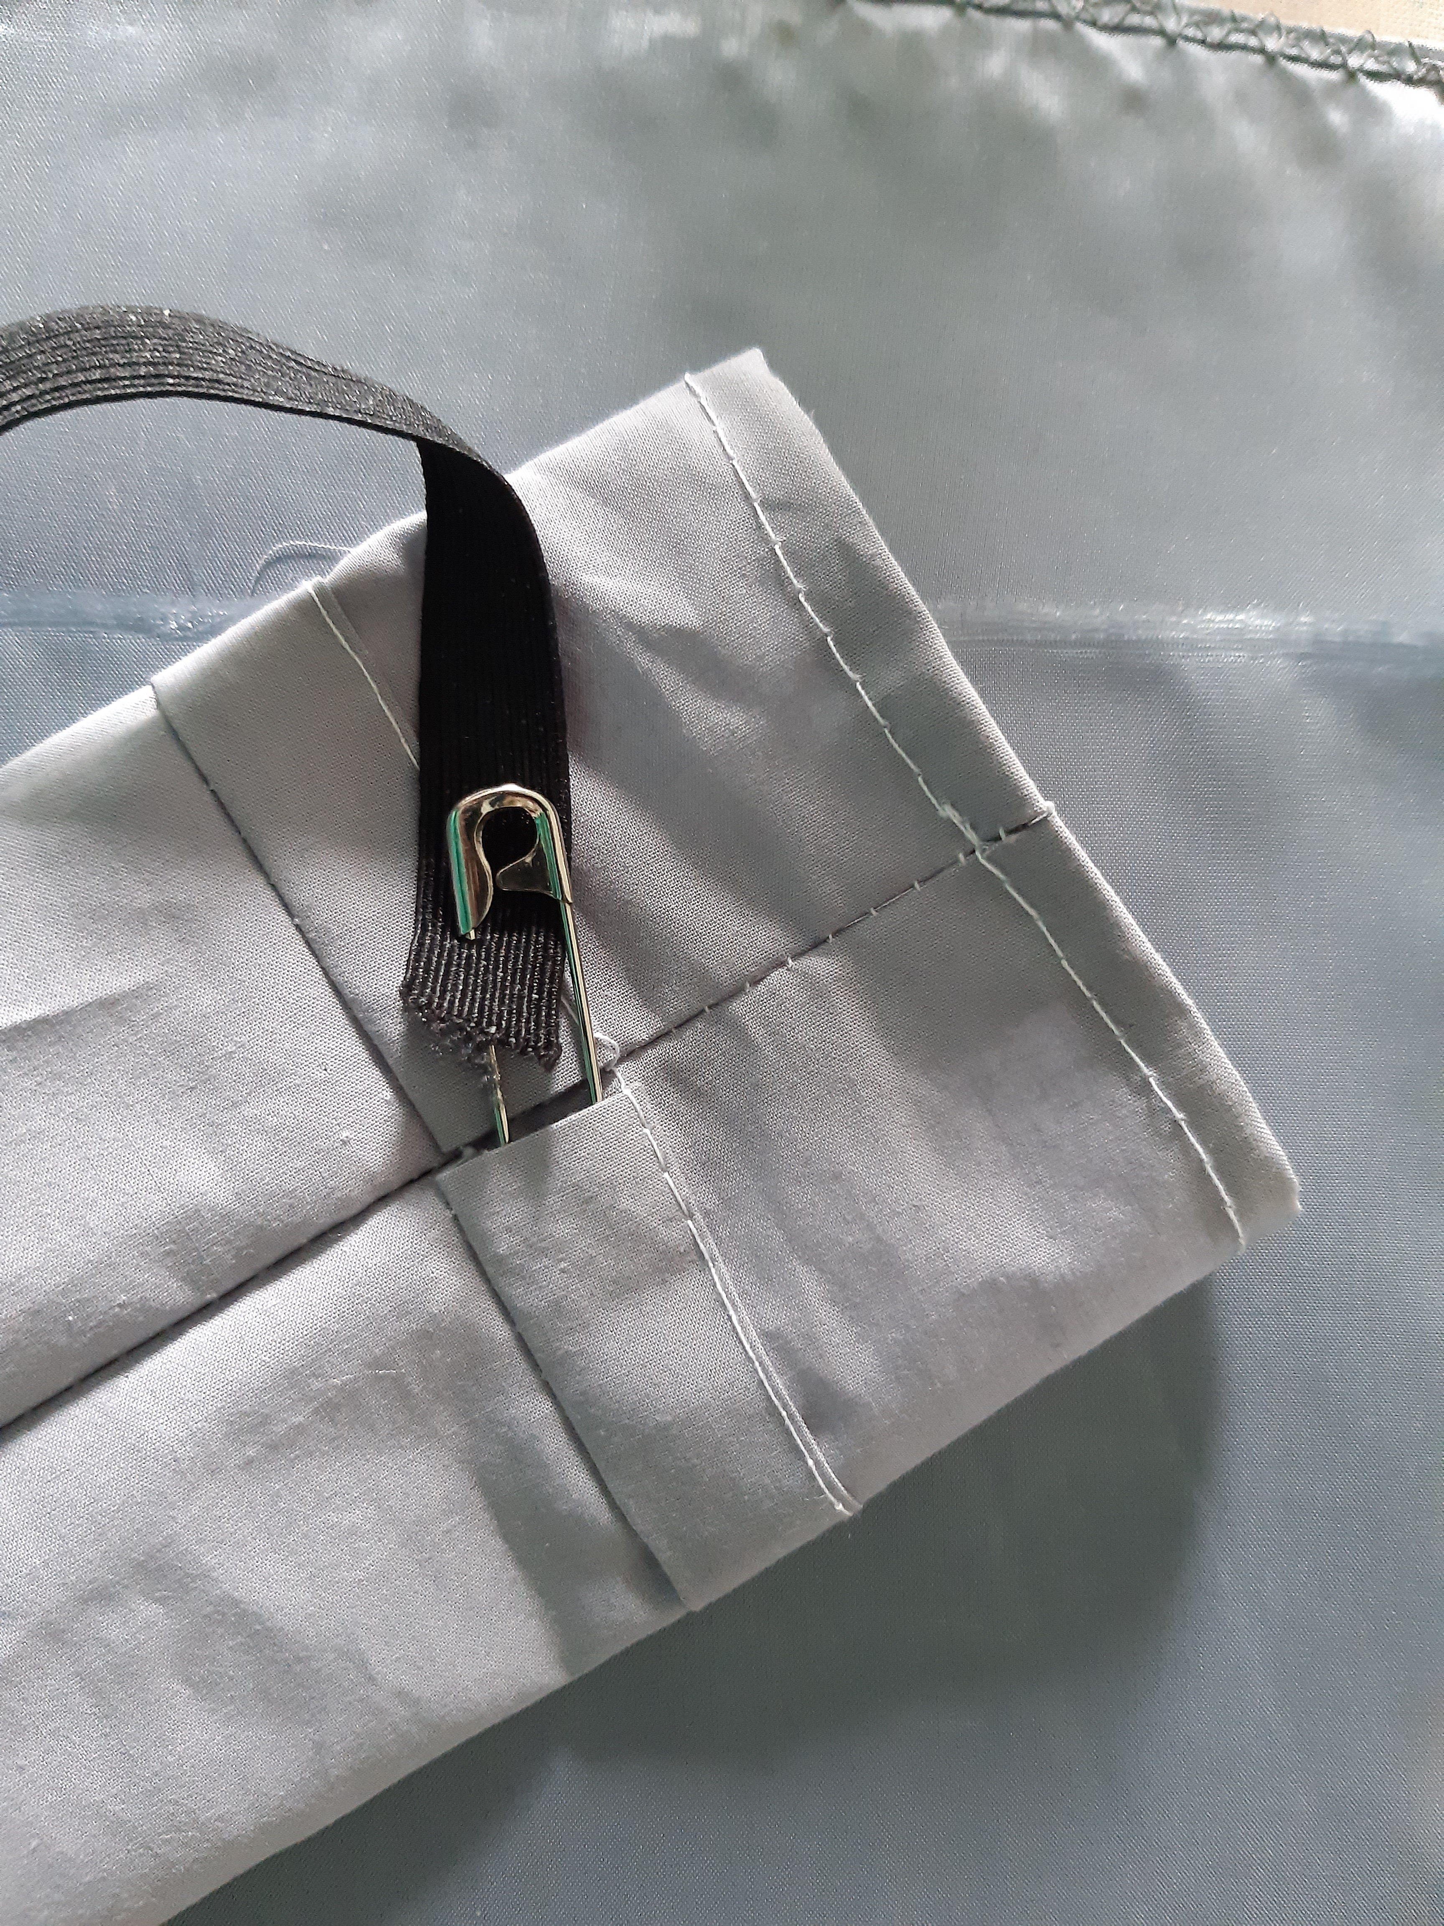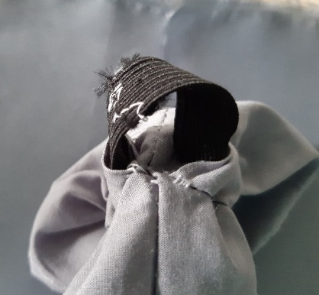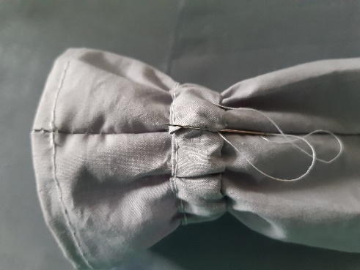
4a 4b 4c

