Faux coverstitch using a twin needle
Coverstitching is made on a coverstitch machine.
Faux (fake) coverstitch is possible using a twin needle on a domestic machine.
Great for hems on stretch fabrics and others.
Because there is only one bobbin the bobbin thread zigzags between the two needle threads creating a seam with give that can stretch with fabric.

- Finish raw edges and press hem under to wrong side of fabric.
- Insert a twin needle and thread.
- Thread the machine with two threads. If you don’t have two matching spools load an extra bobbin and use that as your second thread.
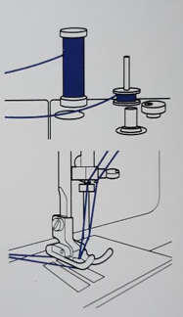

- Stitch on the right side of the fabric so the two needles cover the edge of the hem inside.
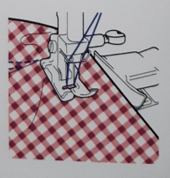

Good cutting and prep is essential and you can feel the surface of your fabric to make sure the edge of the hem is feeding correctly as you stitch.

