Fabric Grain and Nap

Cutting out
Accurate, straight cutting will set you up for easier sewing and great results.
Poor cutting sets you up for difficulties all the way.
Press creased fabric before cutting, check for flaws in the fabric or the design/pattern on it.
To avoid shrinkage wash it first.

Fabric grain
Pattern pieces must be cut on the correct grain this affects the way fabric hangs, how it stitches and the garment’s strength.
The grain is the direction the threads lie in. There are two:
- Warp threads run the length of the fabric parallel to the selvedge (the side edge of the fabric) and are the strongest threads (less likely to stretch) so should be used as the grain for trousers or skirts for example.
- Weft threads are not so strong so sometimes decisions have to be made regarding pattern and amount of fabric. You need to optimise the grain for the most important blocks.

- Knitted fabric also has grain, some stretch one way, some both. Use the grain with the most stretch unless the pattern says otherwise.
- Bias is at 45 degrees to the grain.
The pattern terminology handout will help you to check grain markings if you are not sure.

- The selvedge is the non-frayable edge.

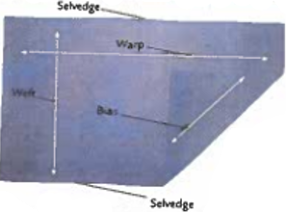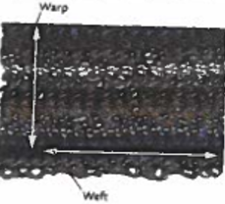

Nap

This is about fabrics that only work in one direction because of the pile or pattern.

- Corduroy, velvet and velour have a pile which shadows when it is smoothed in one direction. It’s not a good look to have one piece in the wrong direction and will be noticeable.
- Furnishing fabrics often have a one way design and it’s not unusual in dress fabrics.
- If you are working with a fabric with nap you need to allow extra material.

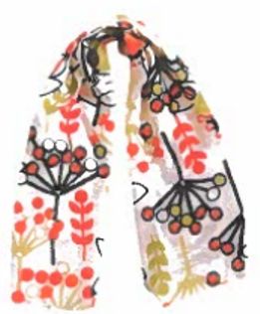The flowers are upside down on one side. Maybe this doesn’t matter in a scarf but in a garment it does, unless you balance it.

