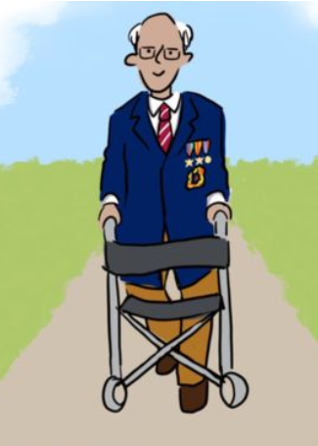
You are writing an article about Captain Tom Moore.
If you don’t know about Captain Tom, you will need to do some research first or watch the presentation.

General features of news articles
- title / headline
- by-line
- information (facts / quotes /statistics or percentages / personal views)
- formal writing style

In your article explain:
- how you first heard about Tom.
- who Tom is (give some details about his life).
- why he has been noticed by social media and given so much support.
- about three things he has achieved (use bullet points)
- why the week leading up to April 30th 2020 was a special week for Tom.
- what you would say to Tom if you met him.

You must:
- include some appropriate language features (for example: hyperbole, alliteration, rule of three, effective vocabulary).
- use a variety of sentence types
- write approximately 250 words
- organise your work into paragraphs
- check your SPaG (spelling, punctuation and grammar)

Name ________________ Date ___________

Title
By line
Paragraphs (minimum of 3)

