CAN WE AUTO-CORRECT HUMANITY? By Prince EA
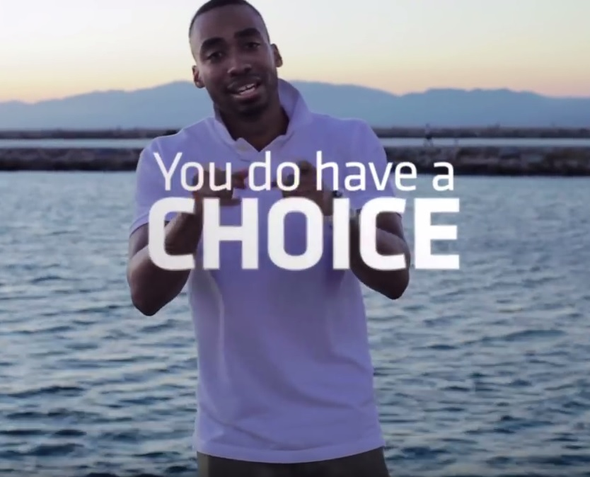
Did you know the average person spends four years of his life looking down at his cell phone? It is kind of ironic, isn’t it? How these touch-screens can make us lose touch. But it's no wonder in a world filled with iMac’s, iPads and iPhones. So many "i"’s, so many selfies, not enough "us"'s and "we"’s
See, technology has made us more selfish and separate than ever because while it claims to connect us, connection has gotten no better. Let me express first, Mr. Zuckerberg, not to be rude but you should re-classify Facebook to what it is: an anti-social network, because while we may have big friend lists, so many of us are friendless.
Friendships are more broken than the screens on our phones! We sit at home on our computers measuring self-worth by numbers of followers and likes. We ignore those who actually love us!
It seems we’d rather write an angry post, than talk to someone who might actually hug us or give us affection. Am I bugging? You tell me, I asked a friend the other day, "Let's meet up face to face." He said, "Alright. What time you wanna Skype?"
I responded with omg, srs, and then a bunch of smh's, and I realized: what about me? Do I not have the patience to have conversation without abbreviation? This is the generation of media over stimulation, chats have been reduced to snaps. The news is 140 characters; videos are 6 seconds at high speed; and you wonder why ADD is on the rise faster than 4G LTE.
But get a load of this: studies show the attention span of the average adult today is one second lower than that of a gold fish! So if you're one of the few people or aquatic animals that have yet to click off or close this screen, congratulations!
Let me finish by saying you do have a choice, yes? But this one my friends we cannot Auto-Correct - we must do it ourselves. Take control or be controlled; make a decision.
Me? No longer do I want to spoil a precious moment by recording it with a phone, I'm just going to live them. I don’t want to take a picture of all my meals anymore - I 'm just going to eat them.
I don't want the new app, the new software, or the new update. If I want to post an old photo, who says I have to wait until Thursday. I'm so tired of performing in the pageantry of vanity and conforming to this accepted form of digital insanity!
Call me crazy but, I imagine a world where we smile when we have low batteries because that will mean we'll be one bar closer - to humanity.

