Buttonhole stitch
Used to hand stitch buttonholes (still used in tailoring) and attach fastenings: snaps (press studs) and hooks and eyes, because these all undergo a lot of wear, tear and pulling and this is a quick, strong fix that will last and done well is very neat and tidy.
It’s very similar to blanket stitch except the needle is inserted from the top of the fabric and twists are incorporated into each stitch to create a knot.
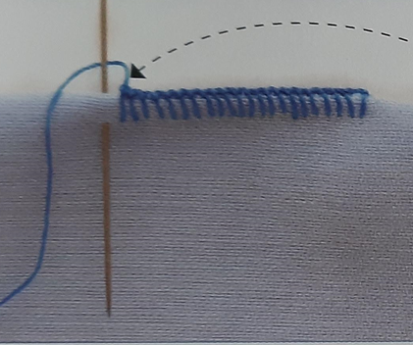 1. Insert the needle from the top and wrap the thread behind the needle as shown in this picture.
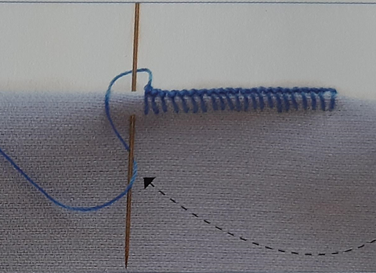 2. Then wrap the thread behind the needle where it comes out of the fabric shown here.
As you pull the needle through gently you will create a knot on the edge of the fabric shown by the previous stitches in the pictures. Use a finger nail or pin to reposition the knot if needed.
When using this for fastenings position the knots next to the fastening rather than the fabric, it will sit better.
If you have button thread stitch with a single thread if you don’t I recommend using a double thread but you will need to work slowly and make sure the threads pull through together evenly.

