Ruching or Shirring
An easy and effective way to gather cuffs, necks, waists and bodices that will stretch. Works best on lightweight and light to medium weight fabrics.
You can buy shirring elastic in a range of colours but black and white are easiest to get. Never use old elastic, it loses its stretch.
If you’re ruching near an edge that needs finishing do that first.

- This is the one time you need to load the bobbin by hand and make sure the elastic (bobbin thread) comes through correctly especially with top loading bobbins.

- Set the machine to its longest straight stitch and tension 9. You are working with a very high tension so slow is best to avoid breaking the threads and use a good quality top thread.
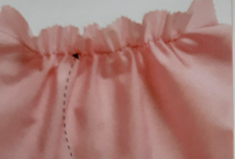 3. To start, do a couple of forward stitches and a couple back to secure the elastic. Then stitch slowly and straight across the area to be gathered.
4. If you are stitching panels before joining them, pivot on the needle and stitch 4 – 5 stitches downwards, just inside and parallel to the seam allowance. Pivot again and you are ready to stitch row two. If you are ruching a finished garment stitch down to the next row on the seam. This avoids lots of ends that will need tying off or backstitching.
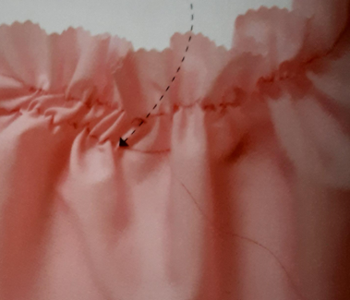 5. Stitch each row absolutely parallel to the last one and you must stretch out the fabric fully as you stitch or the ruching won’t work properly.
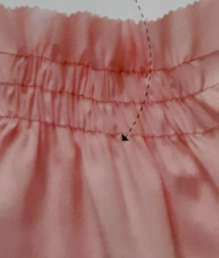 6. Stitch as many rows as you want and end by back then forward stitching.
7. For added security knot the threads and elastic together at the ends and if there are joins.
This example is very lightweight fabric so gathers well. Gathering will reduce with heavier fabrics. More rows and the closer they are will increase the gathering.

Waffle ruching
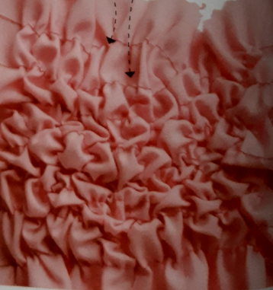 Vertical rows are stitched over the horizontal rows.

Static corded ruching
For heavier weight fabrics and upholstery. This does not stretch but is strong.
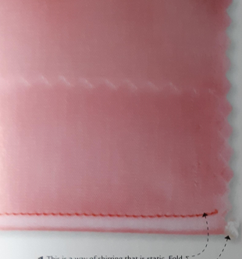 1. Fold the fabric and place piping cord in the fold. Using a zipper foot stitch close to the cord but do not catch it.
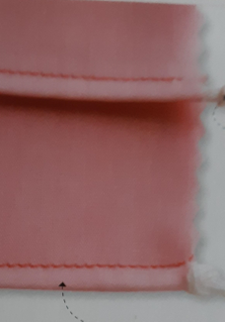 2. Make as many rows as required.
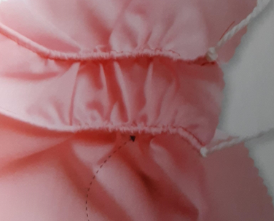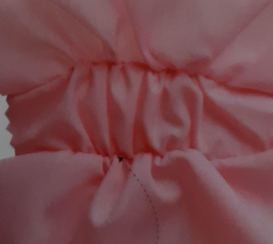
- Push the fabric along the cords to create gathers and knot piping cords so they are all the same length. Turnover and even out gathers.

As an alternative to folding you can use tape to secure the piping cord. With the widest zigzag stitch the cord and tape to the back of your fabric, without catching the cord. The zigzag stitches won’t show on the right side because they will be hidden in the gathers.

