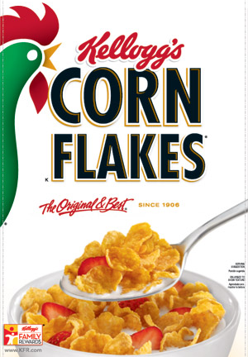
Table of nutritional information
 | Per 100g | Per 30g serving
Energy | 278 kcal | 113 kcal
Fat | 0.9g | 0.3g
of which saturates | 0.2g | 0.1g
Carbohydrates | 84g | 25g
of which sugars | 8g | 2.4g
Fibre | 3g | 0.9g
Protein | 7g | 2.1g
Salt | 1.13g | 0.34g

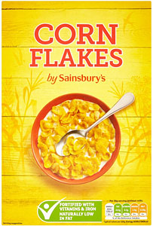
Table of nutritional information
 | Per 100g | Per 30g serving
Energy | 386 kcal | 116 kcal
Fat | 1.2g | 0.4g
of which saturates | 0.6g | 0.2g
Carbohydrates | 83.9g | 25.2g
of which sugars | 6.6g | 2.0g
Fibre | 3.4g | 1.0g
Protein | 8.1g | 2.4g
Salt | 0.95g | 0.29g

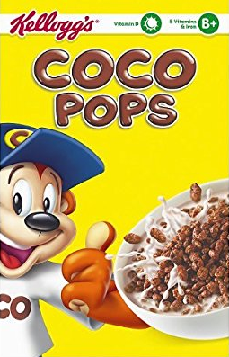
Table of nutritional information
 | Per 100g | Per 30g serving
Energy | 367 kcal | 116 kcal
Fat | 2.9g | 0.8g
of which saturates | 1g | 0.3g
Carbohydrates | 84g | 25g
of which sugars | 30g | 9.0g
Fibre | 3g | 0.9g
Protein | 5.5g | 1.7g
Salt | 0.75g | 0.22g

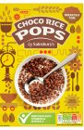
Table of nutritional information
 | Per 100g | Per 30g serving
Energy | 395 kcal | 118 kcal
Fat | 2.8g | 0.8g
of which saturates | 1.5g | 0.4g
Carbohydrates | 85.0g | 25.5g
of which sugars | 28.0g | 8.4g
Fibre | 2.7g | 0.8g
Protein | 6.0g | 1.8g
Salt | 0.66g | 0.20g

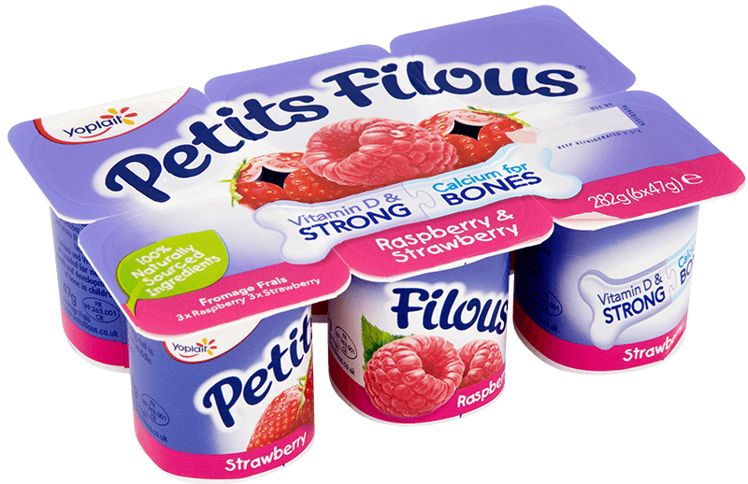
Table of nutritional information
 | Per 100g | 94g serving  (2 pots)
Energy | 86 kcal | 83 kcal
Fat | 2.4g | 0.3g
of which saturates | 1.6g | 1.5g
Carbohydrates | 10.4g | 9.8g
of which sugars | 9.9g | 9.3g
Fibre | <0.1g | <0.1g
Protein | 5.3g | 5.0g
Salt | 0.12g | 0.11g

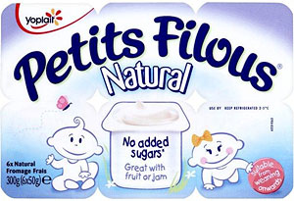
Table of nutritional information
 | Per 100g | Per 50g serving
Energy | 77 kcal | 39 kcal
Fat | 3.2g | 1.6g
of which saturates | 2.2g | 1.1g
Carbohydrates | 4.9g | 2.5g
of which sugars | 4.9g | 2.5g
Fibre | <0.1g | <0.1g
Protein | 6.9g | 3.5g
Salt | 0.15g | 0.8g

