FASTENINGS: Hooks and Eyes and Snaps/Press Studs Unit 105/6/7: 4.3
Task 2a Fastenings

You will need:
Hooks and Eyes Snaps
Fabric, folded and top stitched 5mm from folded edge Hand sewing needle
Pins Buttonhole thread (if available)
Scissors

- Use the video in Moodle Term 1 Week 7 or the guides below to help
- We use buttonhole thread and buttonhole stitch for this because they are strong
- Present samples on an A4 sheet with notes on haberdashery, tools and equipment used, stitches used and any H&S measures. Add the title (in bold above) and your name.
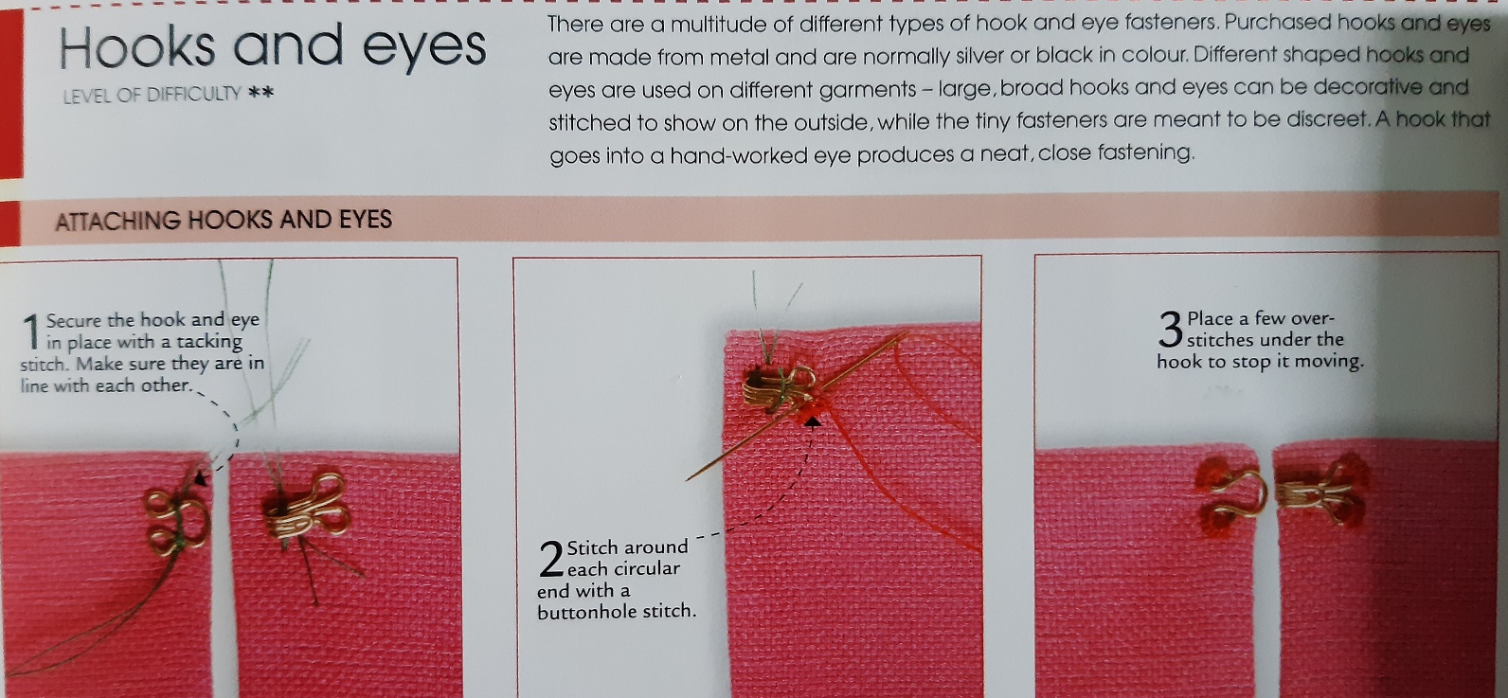
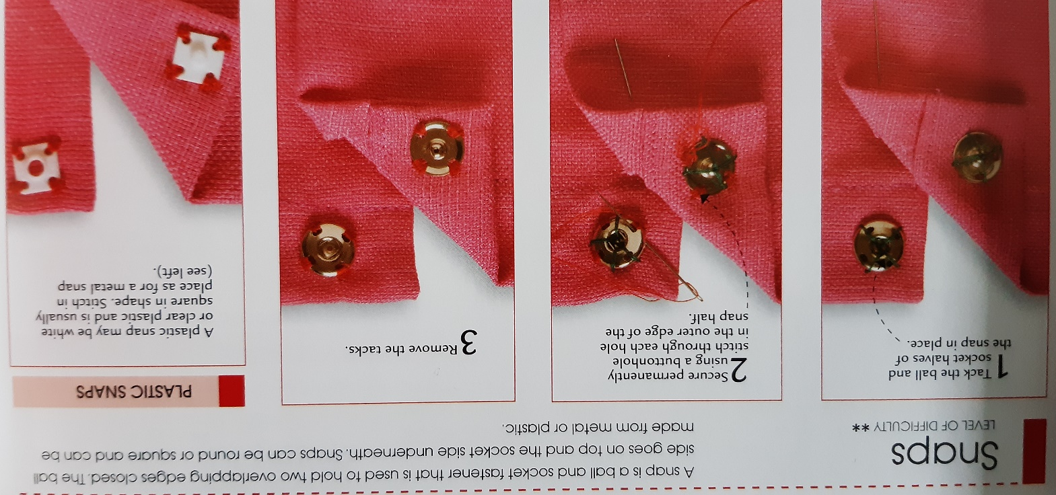
This is an alternative fastening we will do later
