Materials for assessing
adult literacy

Task 1
Delton Carnival Booklet
1
2
6
The following questions refer to the Delton Carnival booklet. You will need to read it in order to answer the questions.
Read text 1 and answer the questions.
Read these statements. Three are true and three are false.
Tick whether each statement is true or false.
True False
- The Mystic Samba Dancers will perform after the Children’s Fancy Dress Awards.
- The Mystic Samba Dancers will perform after MapleMime Troupe.
- Da Hai Kung Fu Club will perform after Maple Mime Troupe.
- Mala Bab Drummers will perform before the Da Hai Kung Fu Club Display.
Rt/L2.3 Rt/L2.7 | 1
- Intangible Linguists are on before Snow White and the Seven Dwarfs.
- There are two award ceremonies on the Bambaattaa stage.
Match the beginning of these statements with their correct endings by putting the number in the box.
The first one has been done for you.
- 63 floats can be seen after the Children’s Fancy Dress Awards
- The Samba dancers will perform by the Intangible Linguists
- The Maple Mime Troupe will by Delton Children’s Centre perform
- Poetry and stories will be on the Fresh FM Stage performed
- The Steel Drum Band at 2.00pm on Saturday
Championships take place 27th July
- ‘Snow White and the Seven on a 3 mile circuit
Dwarfs’ will be performed

Task 1
3The following questions relate to several or all of the texts.
6
TOTAL
In which of the texts do you find information about the following?
Write the number of the text in each box.
2 | Rt/L2.3 Rt/L2.7
The first one has been done for you.
- The number of people at the carnival this year
- The problem of pickpockets
- The number of sound systems
- The origins of the carnival tradition
- The damage caused to private property

Read text 2 and answer the questions.
What caused the fight? Tick one box.
Greg thought he was being over-charged.
Sean’s friend started an argument.
Greg’s arm was broken.
The police detained five people.
When was the fight which was believed to be drug related? Tick one box.
26th July
27th July
28th July
29th July
What happened to Sean Malcolm? Tick one box.
Rt/L2.1 Rt/L2.3 Rt/L2.8 | 3
He was taken to hospital.
1
2
3
4
He was released without charge.
He was sent to prison.
He was charged with drug offences.
Read text 3 and answer the questions.
The Delton Carnival started 35 years ago. Which of these statements was correct at the time? Mark each one true or false.
True False
- It was started by immigrants to Delton.
- It was a multicultural arts festival.
- It had nearly a million visitors.
- It was a parade with costumes and steel drums.
- It was held in Trinidad.
- It took place in the summer.
Why was the festival started? Tick one box.
to increase employment to encourage Caribbean culture to build a united community to increase tourism
Read text 5 and answer the questions.
What does William Drayton think about the carnival? Tick one box.
The carnival should be moved to another place.
There is too much violence at the carnival.
Too many people go to the carnival.
4 | Rt/L2.1 Rt/L2.3 Rt/L2.8
The carnival should continue as it is.
5
6
7
8
What is the main point of what William Drayton has written?
Tick one box.
About a million people go to the carnival.
People go to the carnival to have a great time.
Many people work hard to prepare for the carnival.
Small amounts of violence should not stop the carnival.
Read text 6 and answer the questions.
Who does Carlton Williams play with? Tick one box.
The Delton Steel Band
The Carnival Steel Band
The Blackstar Steel Band
The Trinidad Steel Band
How long has Carlton Williams’s Steel Band been going? Tick one box.
TOTAL
Rt/L2.1 Rt/L2.3 Rt/L2.8 | 5
at least 5 years more than 30 years only six days less than one year
9
10
What does Constable Richard Carmichael think is the most important part of his job at the carnival? Tick one box.
preventing fights patrolling the streets having a great time arresting people

Task 3
Read text 4 and answer the questions.
1
2
3
From what he writes in his letter, which of these statements would Karl
Rossman agree with?
Agree Disagree
- Ice cream is too expensive at the carnival.
- There should be more police at the carnival.
- All young people cause trouble at the carnival.
- Delton is not big enough for the carnival.
- There is more trouble at the carnival now than in the past.
6 | Rt/L2.4 Rt/L2.5
- The carnival brings the people of Delton together.
Which one of these points do Karl Rossman and the Residents’ Group both agree on? Tick one box.
The carnival is too big for its location.
Toilet facilities are a major problem.
The carnival goes on too late.
The carnival results in vandalism to private property.
Which one of these points do Karl Rossman and William Drayton disagree on? Tick one box.
Many people come to the carnival just to enjoy themselves.
The carnival fills Delton with excitement and music.
The Delton community suffers from a carnival in its streets.
Many cultures are represented at the carnival.
⁴Read these statements. Tick the correct box to show if each one is fact or opinion. The first one has been done for you. Fact Opinion

- Many people at the carnival take illegal drugs.
- The carnival has been taking place for the last 35 years.
- The carnival is intended for all ages and ethnic backgrounds.
- The streets of Delton are not suited to a carnival.
- The floats at the carnival are spectacular.
- The 45 sound systems are licensed.
- The carnival attracts tourists to Delton.
- Police presence at the carnival is probably inadequate.
Rt/L2.4 Rt/L2.5 | 7
- There will always be violence in a very large crowd.
TOTAL
8 | Ww/L2.1
TOTAL
1
2
3
4
5
6
7
8
9
10
11
12
13
14
15
Your tutor will read you some words.
Write
one
word on each line.
Try to spell the words correctly.

Choose the correct word or words for each space.
The train was late. When
finally stopped at the
platform, Sara
to the first carriages.
she
they
it
he
will run
is running
ran
have run
A
B
A
B
might have being able
Tick one box.
Example
Ws/L2.2 | 9
Velma and Bob to go to the cinema. wants has wanted want ✔ is wanting
1
2
3
4
The report about property values by the agents.
should have been amended has amended were being amended should have amended
The men who on the new tube line had a meeting at nine o’clock. would be working has worked have be working are being working
If I had worked harder, I to pass the exam.
have been able
might have been able had been able

Task 5
‘You give me your address,’ he said, ‘but you forgot.’
TOTAL
10 | Ws/L2.2
are going to would have were going to will go to
5
6
The weather better, but it’s cold today.
were gettingwill have been getting has been gettingwould have been getting

Task 6
Read each set of four lines.
In each set, there is one line which is not correct. It may not be a complete sentence, or it may use a comma instead of a full stop.

Tick the box in each set where there is a mistake.
Example
Pushing his way into the queue, the man explained that he was in a hurry.
The man was in a hurry, he pushed his way into the queue.
As he was hurrying to work, the man pushed into the queue.
Ws/L2.1 | 11
The man pushed his way into the queue because he was in a hurry.
1
2
3
When the flowers were in bloom, they were blown down by the wind.
The wind, blowing hard, pushed the flowers to the ground.
The flowers on the ground and the wind blowing them down.
The wind had blown down the flowers that were on the ground.
Quiet glens with ruined houses that are surrounded by unspoilt countryside.
Although the countryside is unspoilt, there are some ruined houses in the glens.
See the quiet glens surrounded by unspoilt countryside.
In the quiet glens, the unspoilt countryside is dotted with ruined houses.
The marble floors in the airport are glossy and reflect the light.
If floors reflect the light, they are often made of marble.
Because airports often have marble floors which reflect the light.
Marble reflects the light. It is often used for floors in airports.

Task 6
The magnificent Western Isles where whirlpools devour boats.
The Western Isles are magnificent, though whirlpools are dangerous to boats.
Boats are sometimes devoured by whirlpools in the Western Isles.
12 | Ws/L2.1
In the Western Isles there are whirlpools, which are dangerous to boats.
4
5
6
Imagine riding across the open plains surrounded by zebra and wildebeest.
TOTAL
Zebra and wildebeest abound in the open plains of the vast savannah.
You can trek across the open plain to see zebra and wildebeest.
The zebra and wildebeest that abound in the open plains of the savannah.
It is best to wear gloves when mixing up dry, plaster-based products.
If you are mixing up plaster-based products, you should wear gloves.
Products that are plaster-based need to be mixed up, you should wear gloves.
Wear gloves to protect your hands when you mix up plaster-based products.

Task 7
There is one punctuation mistake on each line below.
?
.
you’re
TOTAL
This may be a wrong punctuation mark or a missing punctuation mark. Underline the place where there is an error, and write the correction on the line. The first three have been done for you.
Are you having trouble making ends meet. Why not take
in a lodger? It could be the answer to your problems
If youre thinking of trying it, Harry Finn has some
Ws/L2.4 | 13
advice. Harry who lives in Leeds, lets out a room in his
1
flat. Now hes finding his weekly budget stretches much
further. First, however there were a few things he had to
do. Harrys landlord had to give permission. He had to
check his insurance buy new furniture and draw up a
written agreement, Harry has a lot of animals, including
several cats and dogs so he needed to find a lodger who
didn’t mind them?
“It was no problem really, Harry said. “It’s even made
my animals lives easier. The lodger feeds them for me.”
14 | Wt/L2.1-7 Ws/L2.1-4 Ww/L2.1-2
Lucky escape for driver as hit and run van speeds away
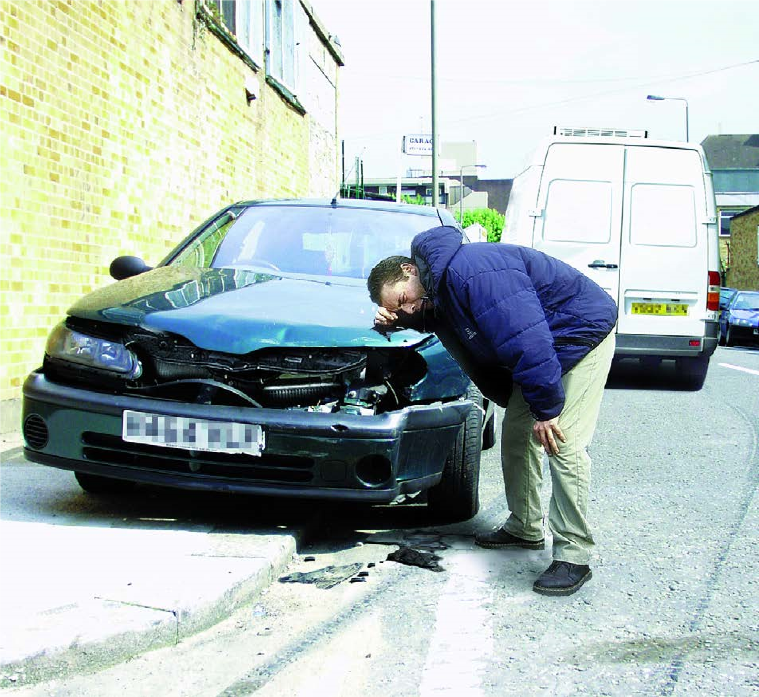
Wt/L2.1-7 Ws/L2.1-4 Ww/L2.1-2 | 15
Write a short report for the local newspaper about the driver’s lucky escape.

Lucky escape for driver as hit and run van speeds away

16 | Wt/L2.1-7 Ws/L2.1-4 Ww/L2.1-2

Wt/L2.1-7 Ws/L2.1-4 Ww/L2.1-2 | 17

