Tips for staying safe and secure online: 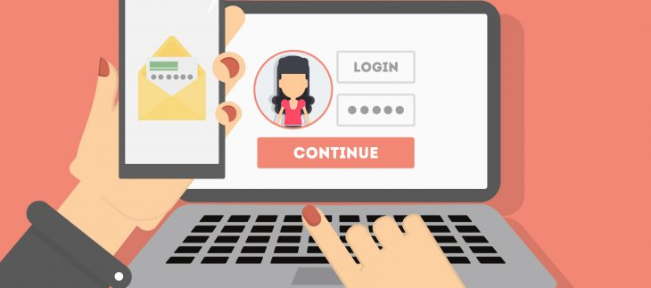

- Choose strong passwords and never tell anyone your passwords.
- Never open an email attachment from people you don’t know.
- Don’t give money or personal details to people you don’t know.
- Banks will never call, text or email you and ask for personal information, your pin number or password.
- Don’t send personal pictures to anyone.
- Don’t become online friends with people you don’t know.
- Don’t arrange to meet someone you don’t know personally.
- Don’t believe everything you read online.

