HEALTH AND SAFETY
Learner Information
Name:
Course Title: | Brush Up Your English ENGSSOL2039
Tutor: | Nilupa Rahim

Online classroom rules
- Try to be somewhere quiet.
- Even if you’re at home wear appropriate clothes.
- Be on time.
- Respect everyone and do as the teacher asks.
- Wait until you’re asked to speak.
- Turn your microphone off when others are talking.
- Be patient because sometimes the systems don’t work.
- Do your homework.
- Never record or screenshot any part of the lesson.
- Have fun and learn!

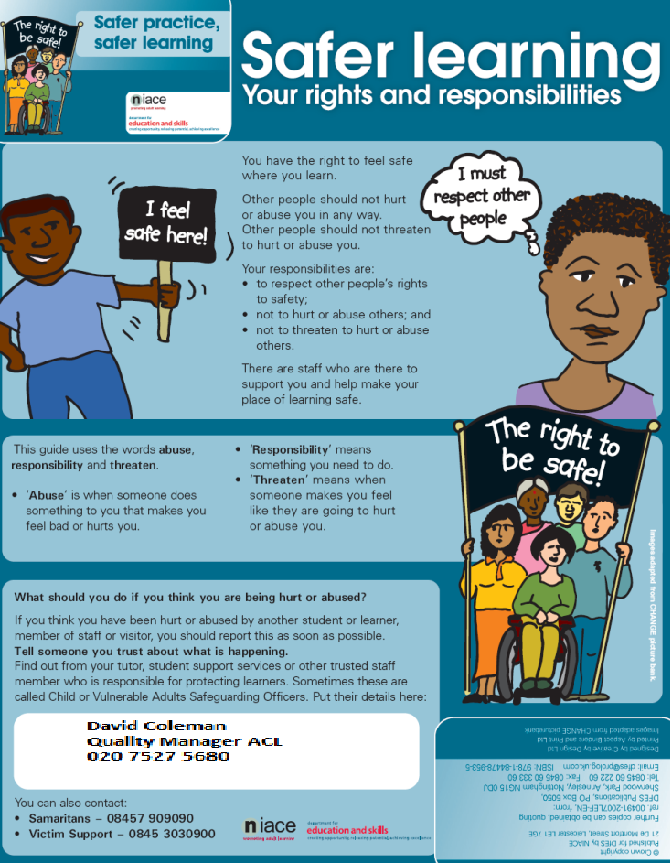

Please keep this information safe in your folder.

