Easing
Joining a curved edge or slightly longer edge to another, sleeves and collars for example. Unlike gathering there should be no pleats or tucks only the seam allowance gathers slightly and that can be clipped if needed. The seam matches smoothly.
You can use easestitching but pinning well is usually sufficient.

Easestitching
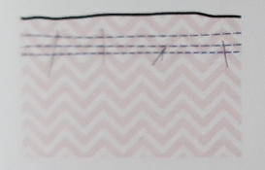 Using a long stitch, tension 0, no backstitch (reverse), stitch just inside the seam allowance and another just inside that for the area to ease, using pattern markings if you have them. Pin both pieces together spacing evenly then pull the bobbin threads till they are equal in length.
Stitch carefully avoiding creases and tucks.

Pressing is great for removing slight discrepancies.

