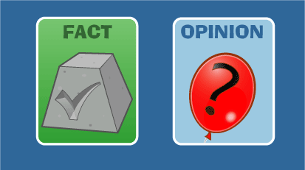
Fact and opinion

Fact: An actual thing that exists and is provable, observable and measurable. | Opinion: A personal belief or judgement that is not based on proof or certainty.
There are 26 letters in the alphabet. | Young people are in gangs because they want to belong somewhere.
There are 12 months in a year. | The best thing about summer is the long days.
London is the capital of England. | You shouldn’t get married before you’re 30.
My car is a Ford Fiesta. | I think ghosts are real.

Beware of “facts” used in advertising
8 out of 10 cats prefer Whiskas – have you ever asked a cat?
Guinness is good for you – says who?

How do you work out if something is fact or opinion?

Look for signal words
FACT OPINION
numbers think
statistics believe
verified good/bad
document should
eye witness best
prove most
record might
FACTS ARE CERTAINTIES OPINIONS ARE DISPUTABLE

