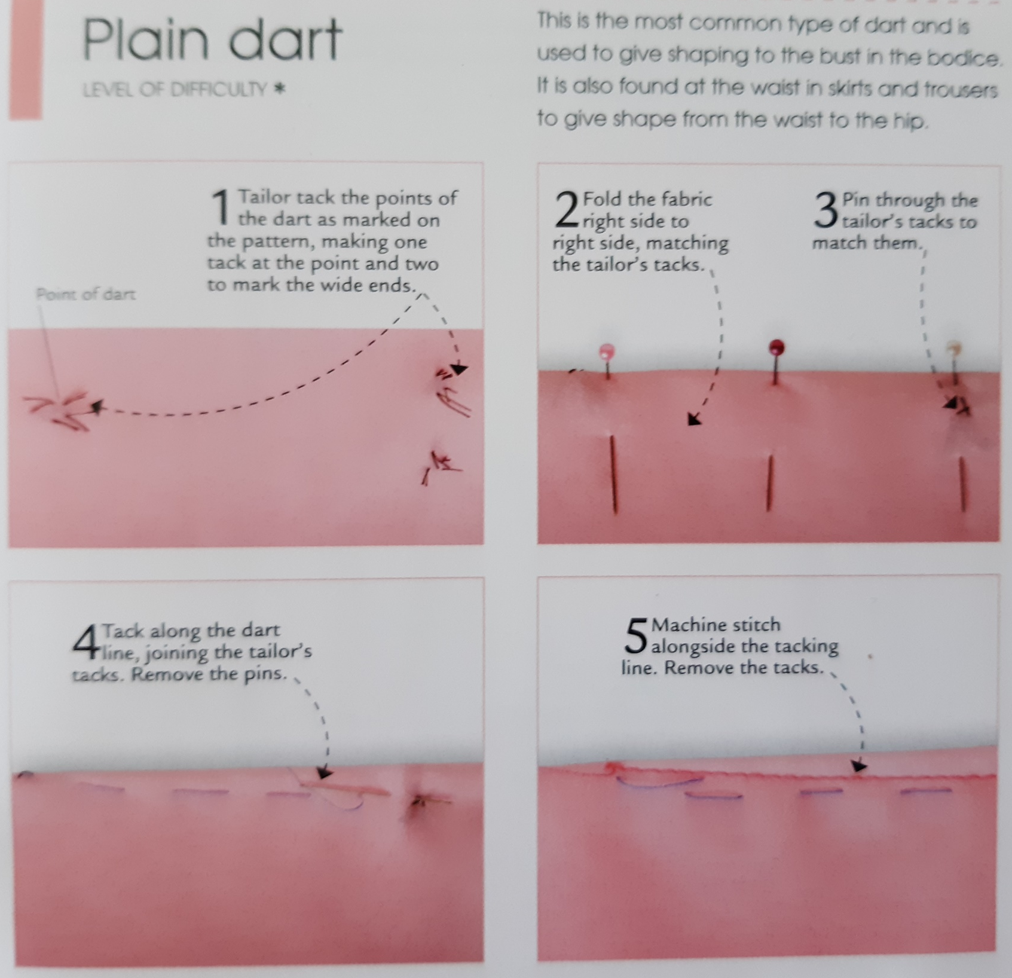
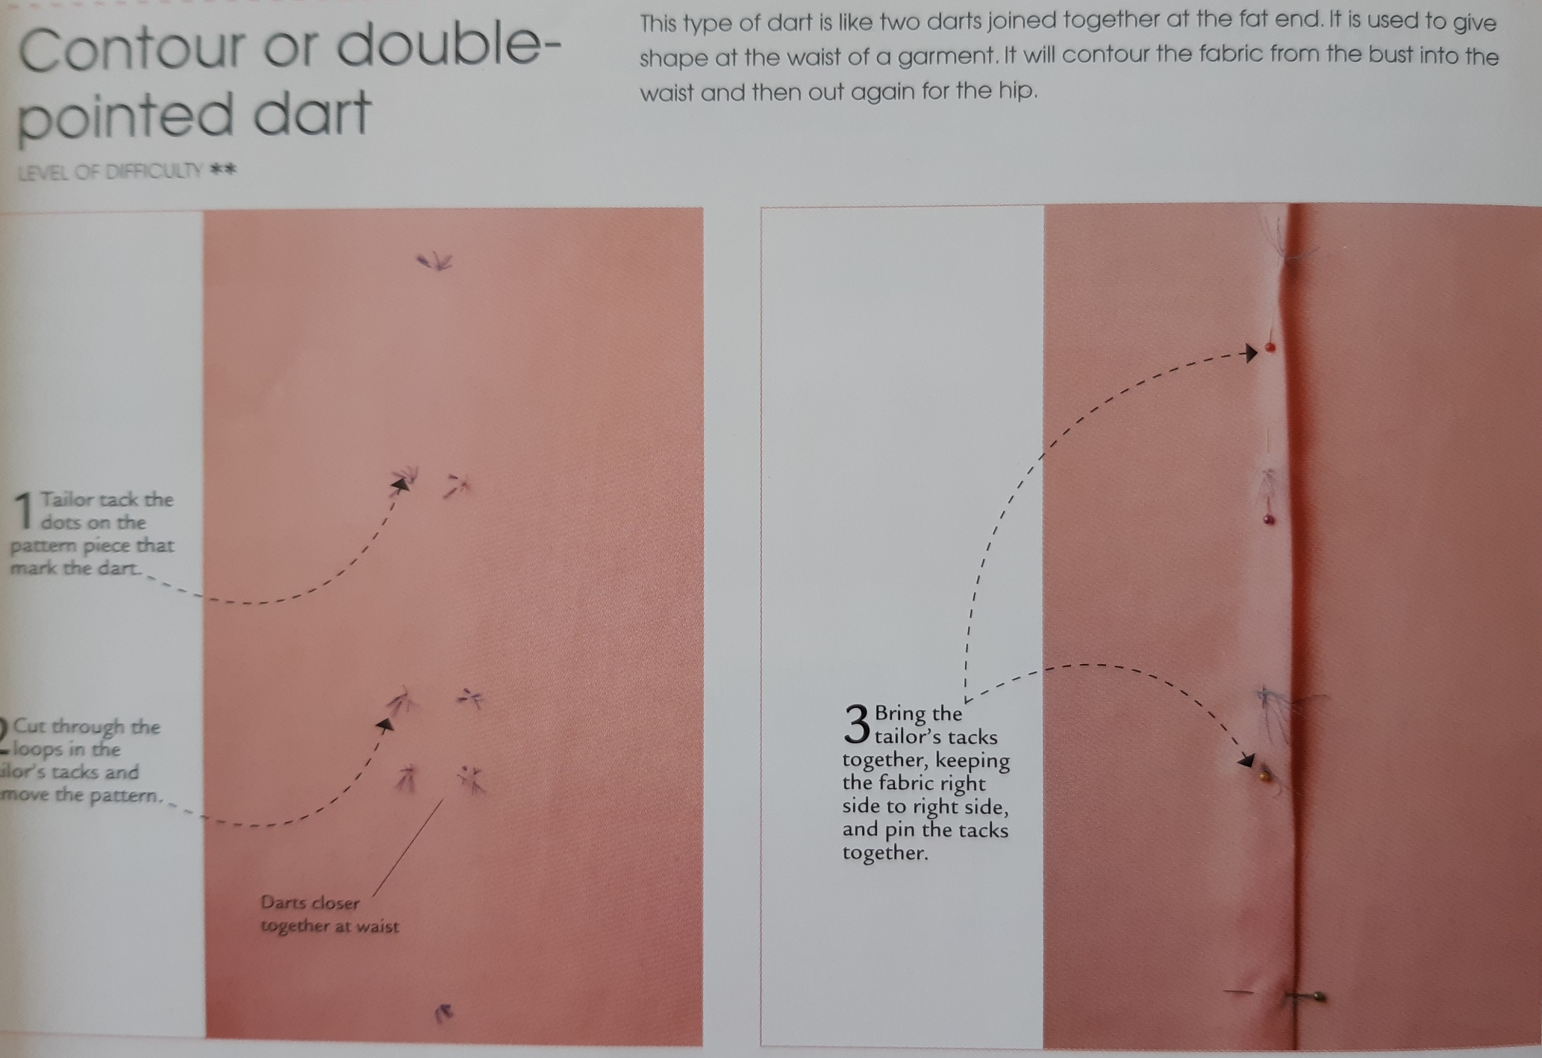
Key points for the best finish are:
- Start stitching the contour dart from the middle for both points using a couple of reverse stitches
- Finish stitching at the points with 3 stitches on the fold, avoid using reverse it can distort the fabric, instead hand sew the threads back into the last 3 stitches
- Then tie off the threads near the point of the dart
You only need to make samples for the plain and the double pointed darts, contour and convex are shown for info.

