ISLINGTON FAMILY KITCHEN – ‘No bake carrot and coconut balls’
https://youtu.be/zXhXtDM3zd8
Watch the video, answer the questions

- Family Kitchen recipes are …….
- healthy
- expensive
- difficult

- How many carrots do you need to make Carrot and Coconut balls?
- 6
- 2
- 3

- How much coconut do you need?
- 60g
- 70g plus more for rolling
- 70g

- Match the instruction verbs with the correct picture.

- grate
- chop

- peel
- mash

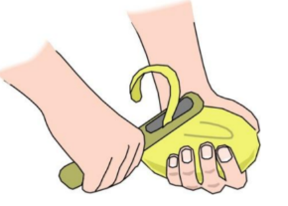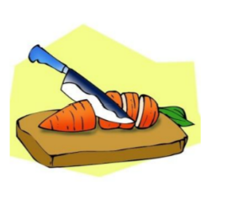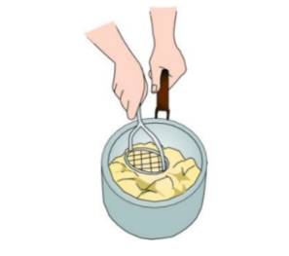

- Complete the sentences:

Instead of added ________ , this recipe uses naturally occurring sugars from the carrots, bananas, coconut and _______.
These also all count towards our _________and are packed with __________, minerals and fibre.

************************************************************************
Find more recipes on our website:
Summer Couscous Salad
https://youtu.be/hDyOZeAjTbs

Chocolate Courgette Brownie
https://youtu.be/xQrNfZGiMz0

https://www.islington.gov.uk/children-and-families/things-to-do/lunch-bunch/recipes

