Gathering
Attaching a much longer piece of fabric to a shorter one.

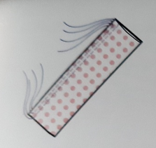 Using a long straight stitch, tension 0, no backstitch (reverse) stitch two rows, one just inside the seam allowance and another just inside that.
Pin to the shorter fabric, spacing evenly then pull the bobbin threads gently to gather fabric into position. You may need to add more pins.
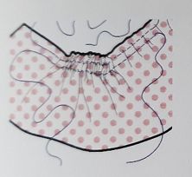
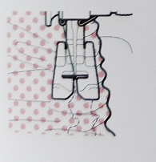 Reset tension and stitch slowly because of the pins, avoiding tucks by positioning needle into centre of gathers.

This technique is good for light and medium weight fabrics. For heavier fabrics and upholstery corded gathers or shirring are better.
A fine cord is stitched to the fabric using a wide zigzag and not stitching the cord.
The cord can then be pulled to the required gather and knotted off.

Gathering can be strengthened using cover tape, this also increases comfort when worn.

