Firm Futures | Workbook  Facilitator: Janice Beckles

Reflection Time

My top achievement?

My best customers?

I enjoyed – offering/delivering?

“If you want to reach a goal, you must “see the reaching” in your own mind before you actually arrive at your goal.” – Zig Ziglar

Goal: Break it down ____________________________________________________________________________________________________________________________

Steps to achieve
____________________________________________________________________________________________________________________________
Tips to make your goals stick
Schedule it and put it on the to-do list
Sometimes we forget the steps we need to take to achieve our new goals/actions. Schedule your new actions or make them part of your daily to-do list until they become something you do automatically.

Make it public and be accountable
Let family and friends know what new habits/goals you plan to work on. They will call you out if you don’t stick to your plan and get you back on track.
You may even go as far as sharing it publicly on Facebook or write a blog about your new journey. Knowing that others read it and know about it might be just enough to keep you going when you feel like throwing in the towel.
Or
Find an accountability partner and help each other along
Find someone with the same or similar goal. Keep tabs on each other and encourage each other to keep going. It’s much harder to slip if you know someone else is depending on you being there.

“The future belongs to those who believe in the beauty of their dreams.”—Eleanor Roosevelt.

Dream Client DNA
____________________________________________________________________________________________________________________________________________________________________
___________________________________________________________________________________________________________________________

Personal Development Plan
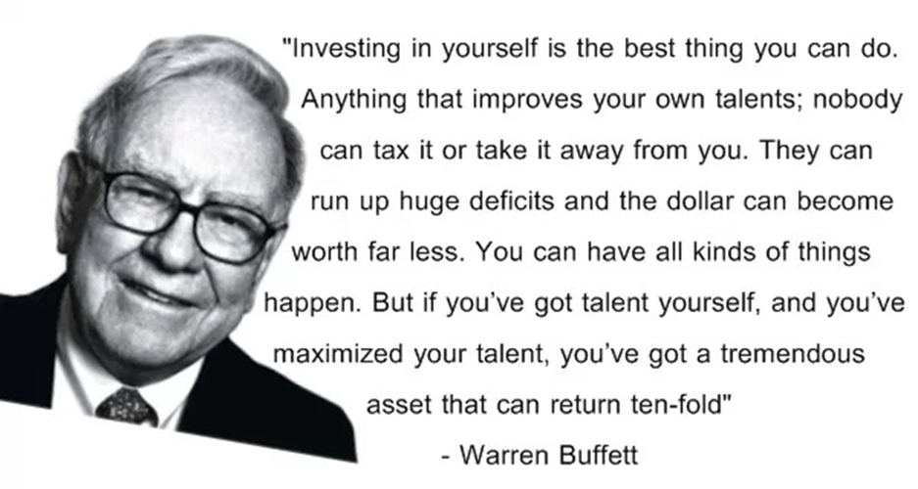

Actions:

- _______________________________________________

- _______________________________________________

- _______________________________________________

Action Plan
How will you use the things you have learned? Creating an action plan can help you stay on track and on target. When you take responsibility for yourself and your results, you get things done!
In this session, you will be asked questions to help you plan your short-term and long-term goals. This final exercise is a way for you to synthesise the learning that you have done and put it into practice.

I am already doing these things well:

I want to improve these areas:

What will I say yes to?

What will I say no to?

As a result of what I have learned on the course, I am going to… | My target date is… | I will know I have succeeded when… | I will follow up with myself on…

You don’t have to be great to start, but you have to start to be great.
~ Joe Sabah

Free and Low-Cost Marketing Tools

Video
- https://slide.ly/promo
- https://vimeo.com
- http://ripl.com/
Make, share, and watch videos

Graphics, Posters, Presentations, Infographics
- https://www.canva.com/
- https://piktochart.com/ - Infographics
- https://www.picmonkey.com/
- http://ripl.com/

Royalty Free Images
https://www.pexels.com/royalty-free-images/
https://pixabay.com/
https://unsplash.com
https://burst.shopify.com/
https://foodiesfeed.com/
https://www.gratisography.com/

Manage and schedule your Social Media
- https://meetedgar.com/
- https://hootsuite.com/dashboard
- https://buffer.com/

Customer Relationship Management and other cool tools
- https://www.hubspot.com/resources
Free CRM tool to grow and manage your business
Marketing & Social Media Planner
- https://coschedule.com
- https://www.hubspot.com/resources

Analyse headlines for blogs etc
- https://coschedule.com/headline-analyzer

Databases and emails
- https://mailchimp.com

Schedule meetings
- https://doodle.com

Sourcing Content and Influencers
www.rightrelevance.com
https://www.crowdfireapp.com/

Generate Free PR
https://www.helpareporter.com/
Sign up with Help A Reporter Out (HARO) and generate free PR. You can respond to any relevant media queries and get mentions in major publications.
#journorequest

Good training sites
Hubspot & Co Schedule

NOTES/LEARNINGS

