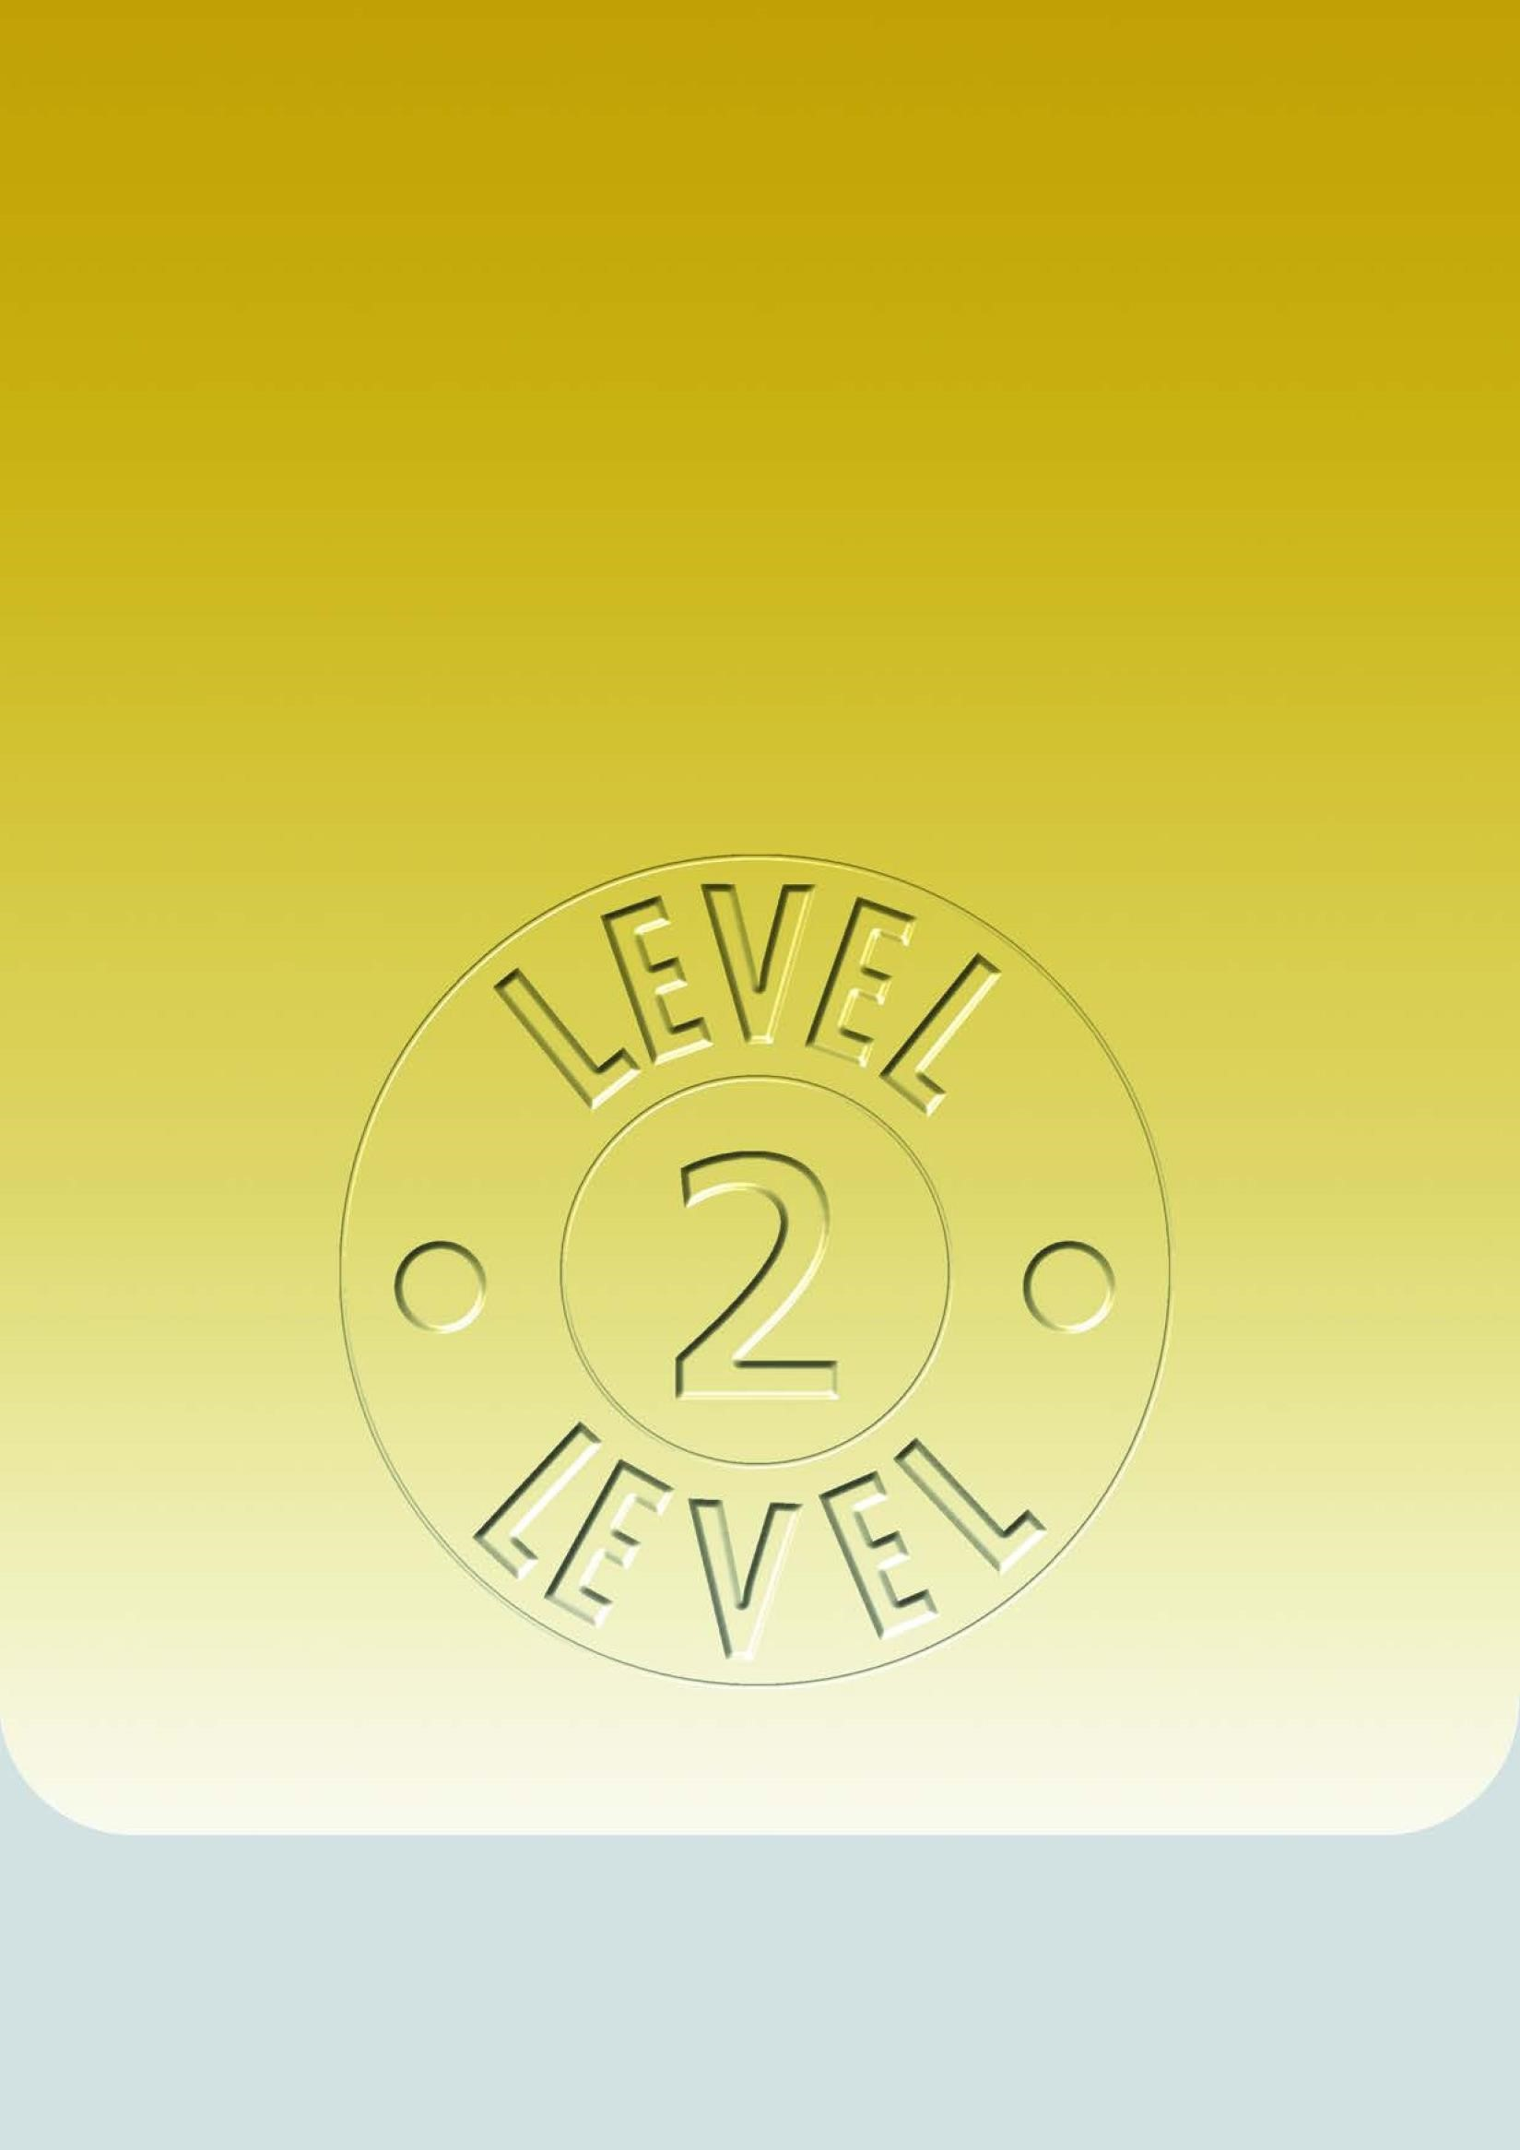

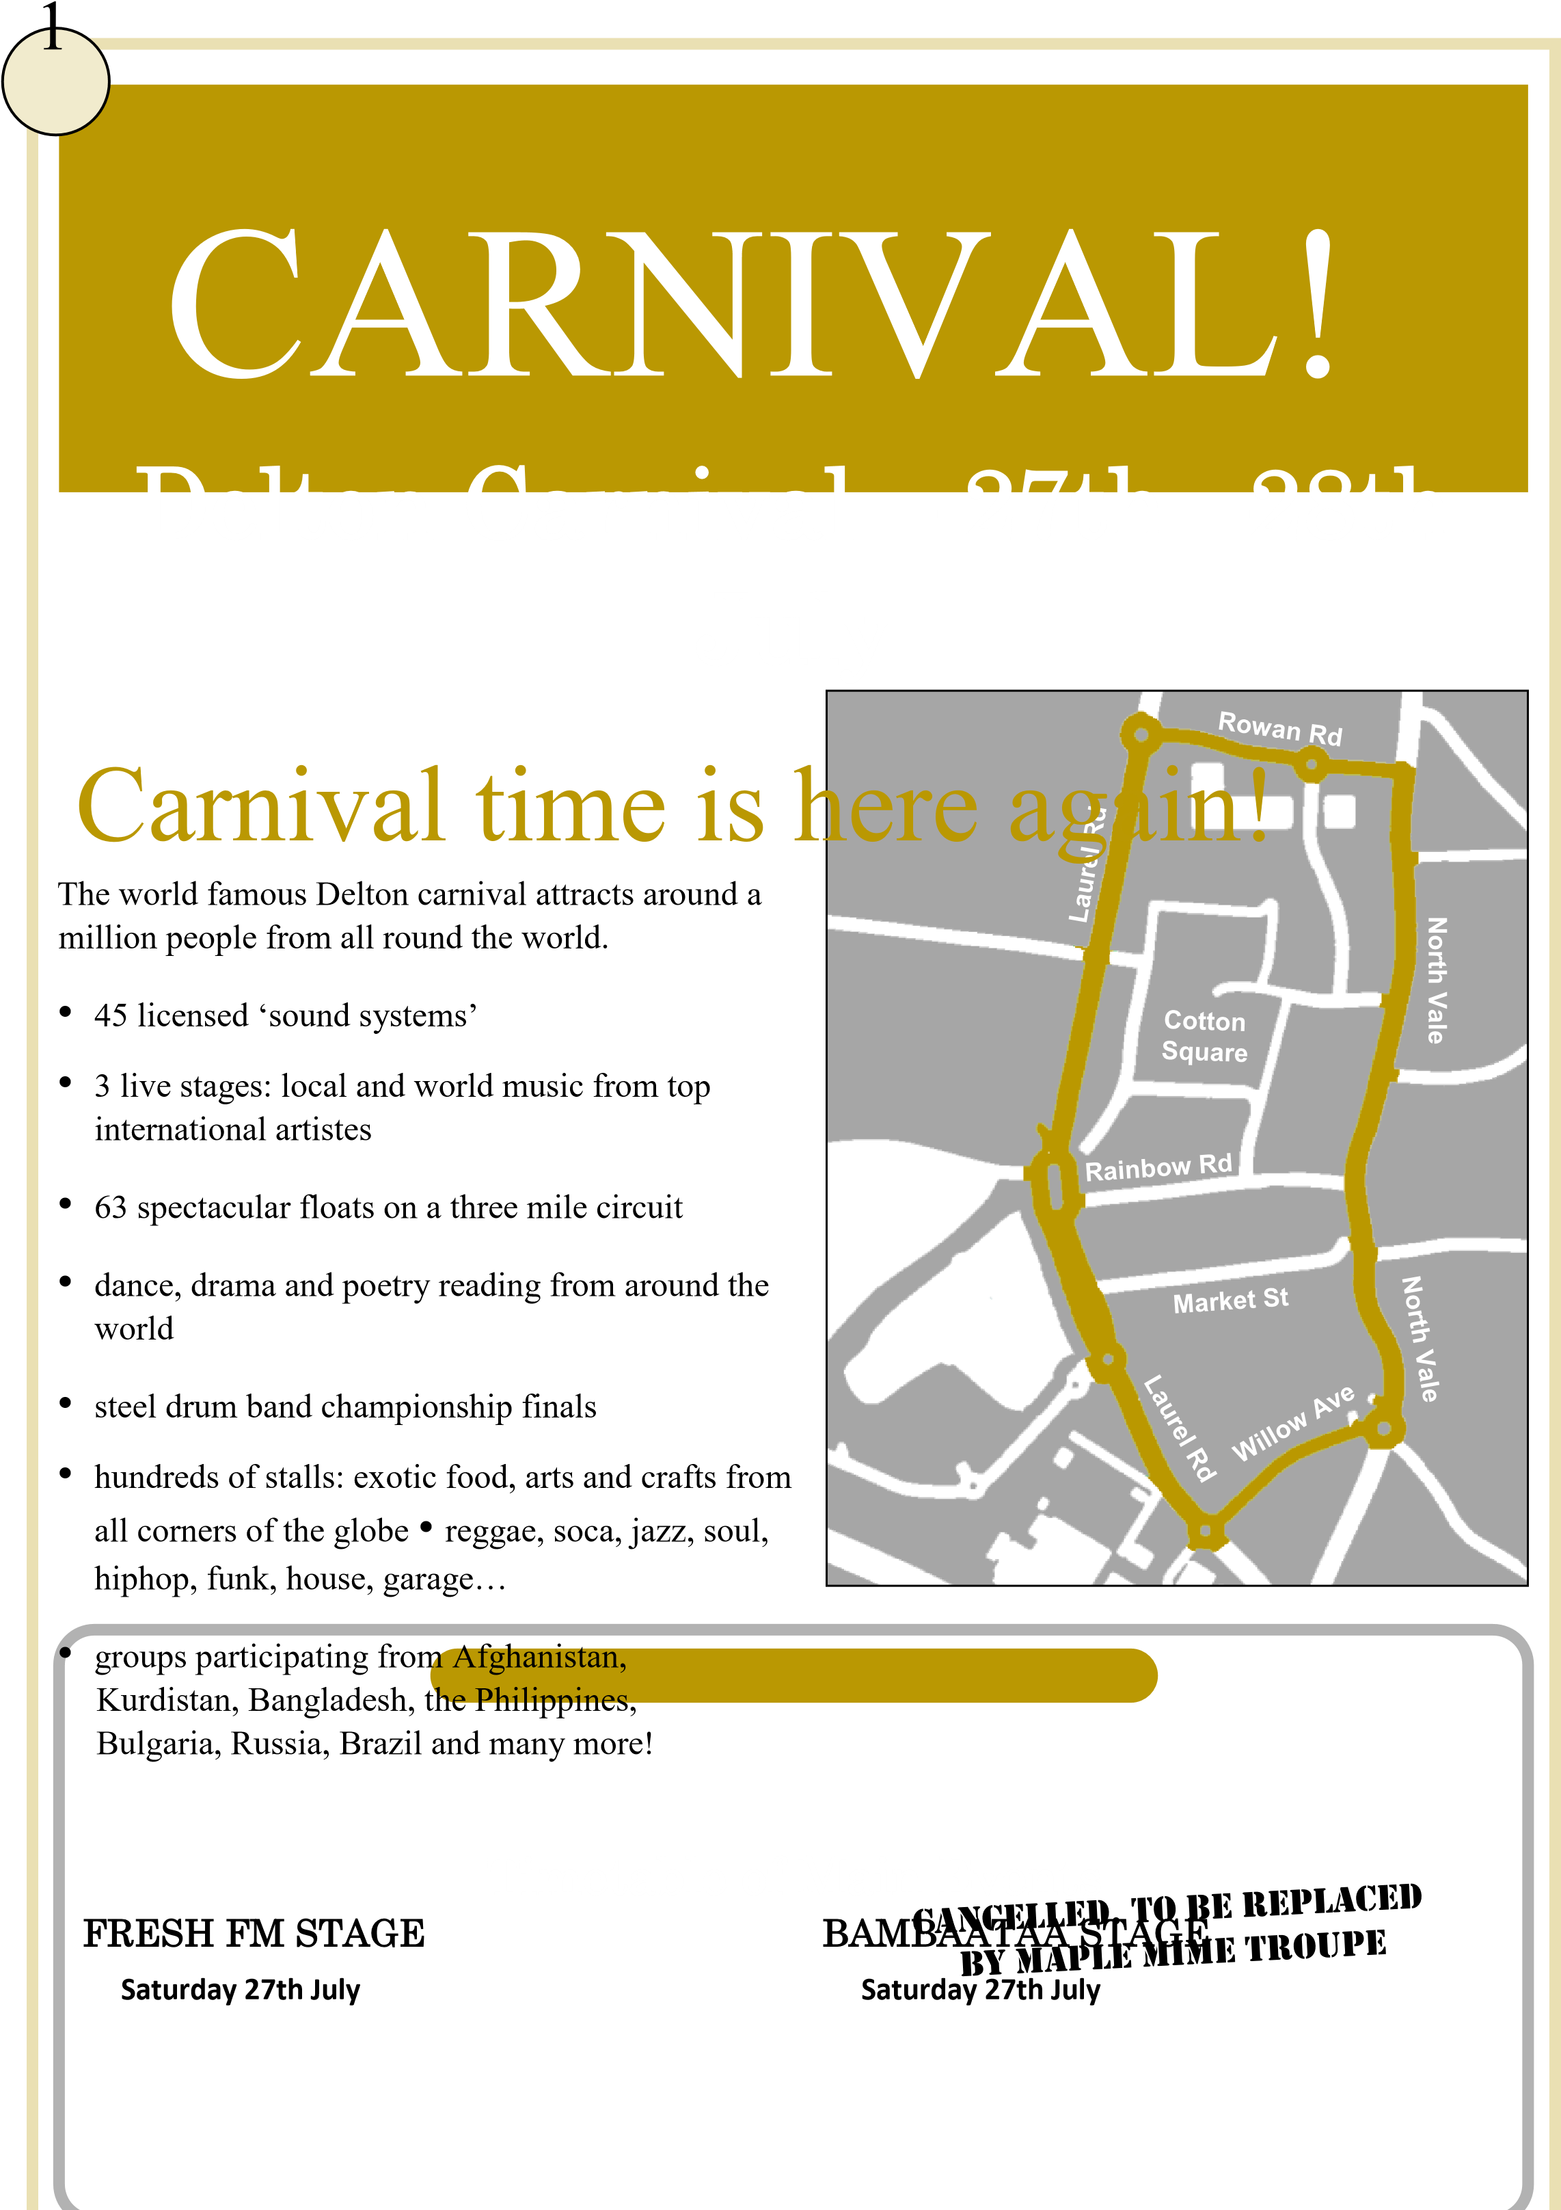

12:00 Intangible Linguists – Poetry and Stories 12:00 Da Hai Kung Fu Club Display
2:00 Delton Children’s Centre Present ‘Snow 2:00 Topo – Bulgarian Puppeteers White and the Seven Dwarfs’ White and the Seven Dwarfs
4:00 Mystic Samba Dancers 4:00 Children’s Fancy Dress Awards
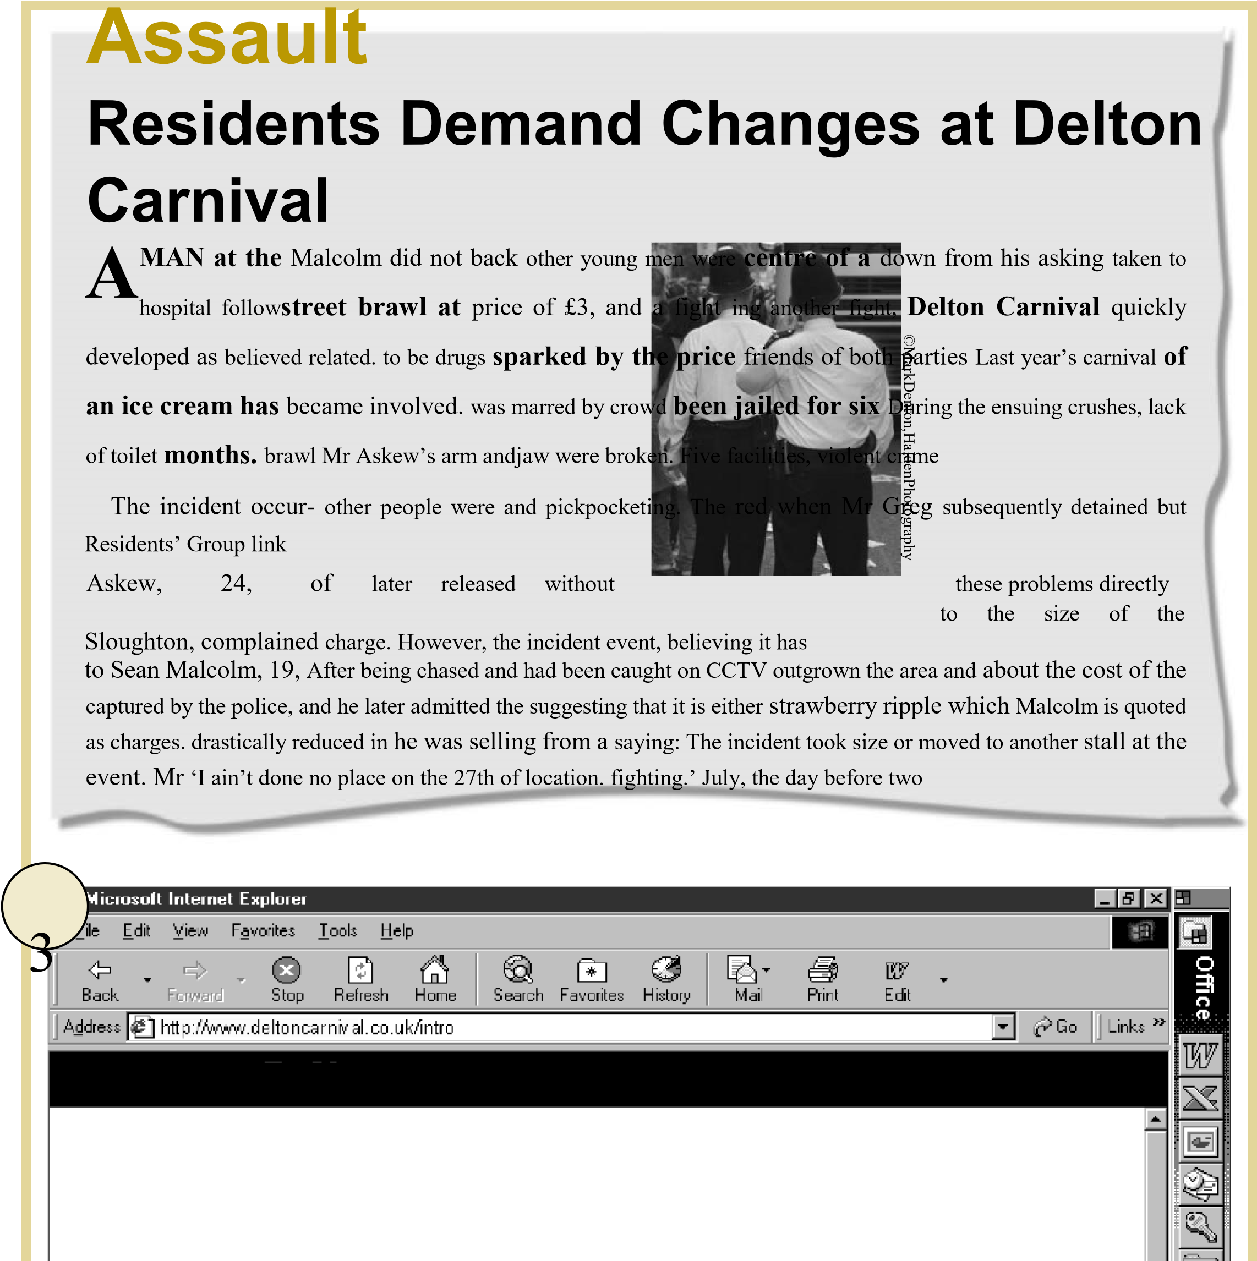
6:00 Mala Bab Drummers 6:00 Steel Drum Band Championship Awards
Live coverage by Fresh FM from the Fresh FM Stage and other events
Watch and listen online at www.getfresh.co.uk
2

Man Jailed for Ice Cream

Introduction
The Delton Carnival is one of Europe’s largest, with more than 1 million visitors attending. It is a festival of freedom and peace for everyone, embracing music, costumes and other art forms from the Caribbean and other parts of the world.
The Carnival has taken place in the streets of Delton at the end of July for the past thirty-five years. This great festival began initially from the energies of black immigrants from the Caribbean, particularly from Trinidad, where the Carnival tradition is very strong. People living locally dreamed of creating a festival to bring together the people of Delton, many of whom, as immigrants from many countries, were facing racism, lack of working opportunities and poor housing conditions, resulting in a general lack of selfesteem.
From a small procession through the streets with just a few people in costume and carrying steel drums in the 1960s, the carnival has evolved into a huge multicultural arts festival. It is a great tourist attraction that brings life to Delton at the height of summer.

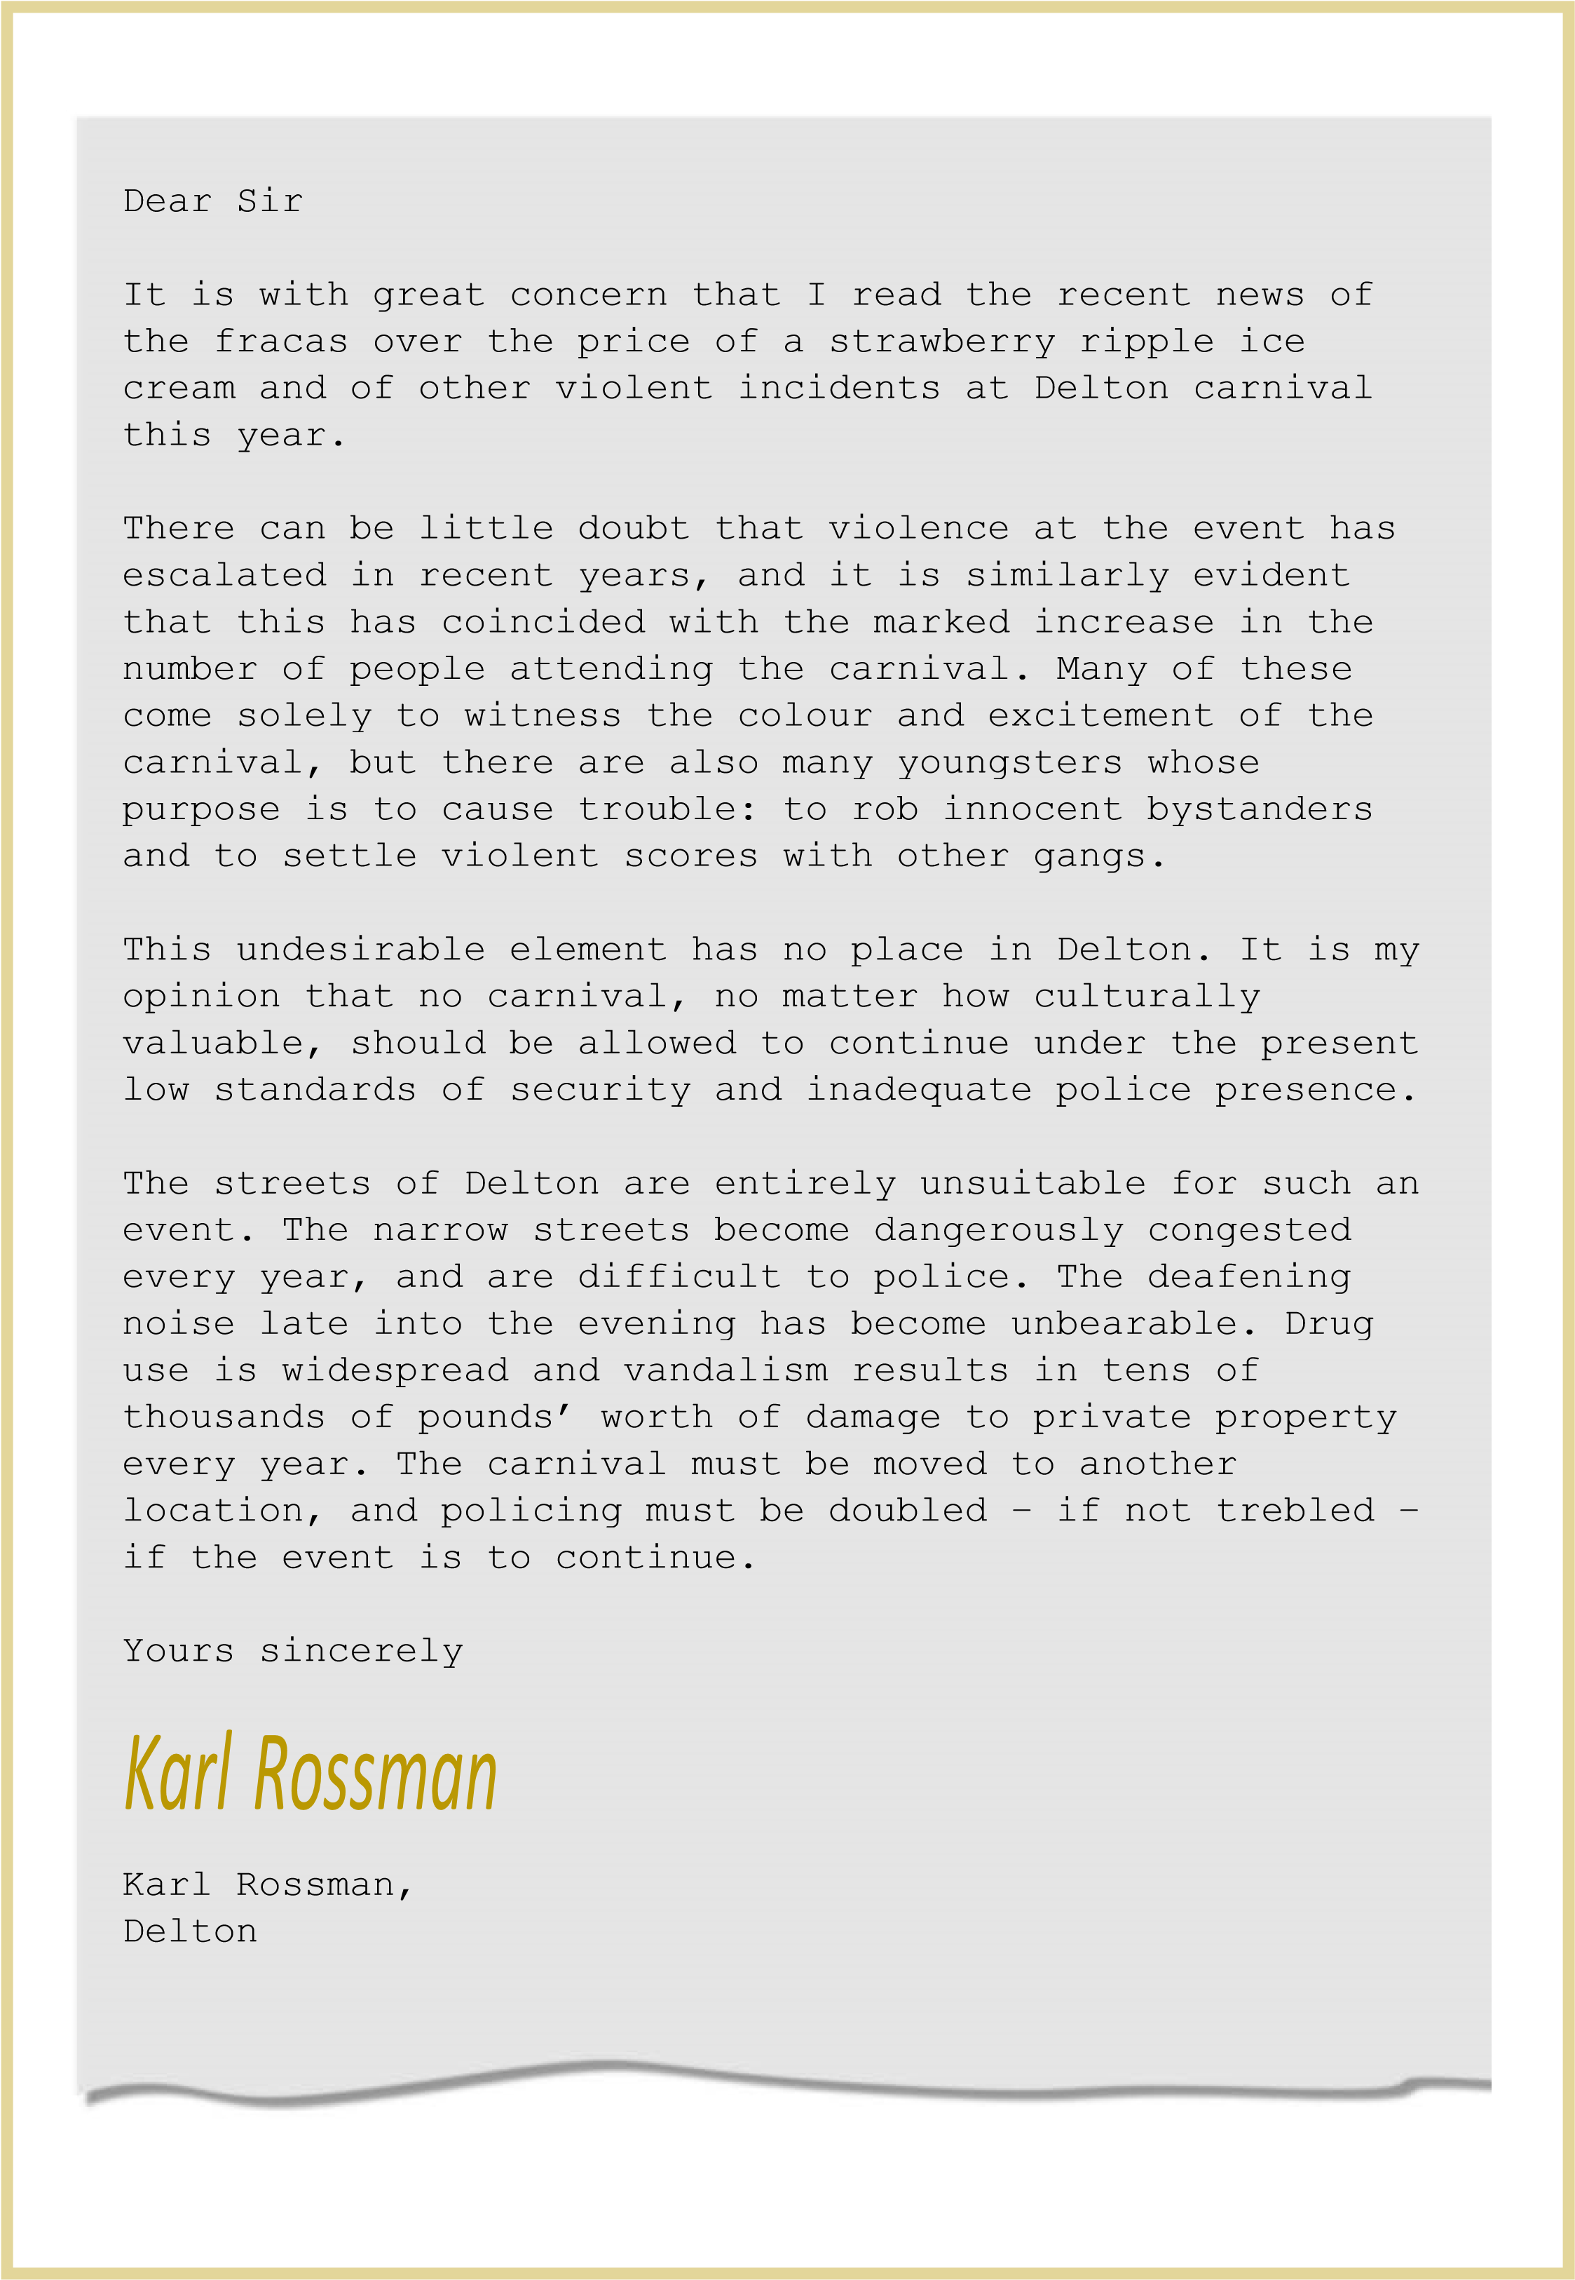
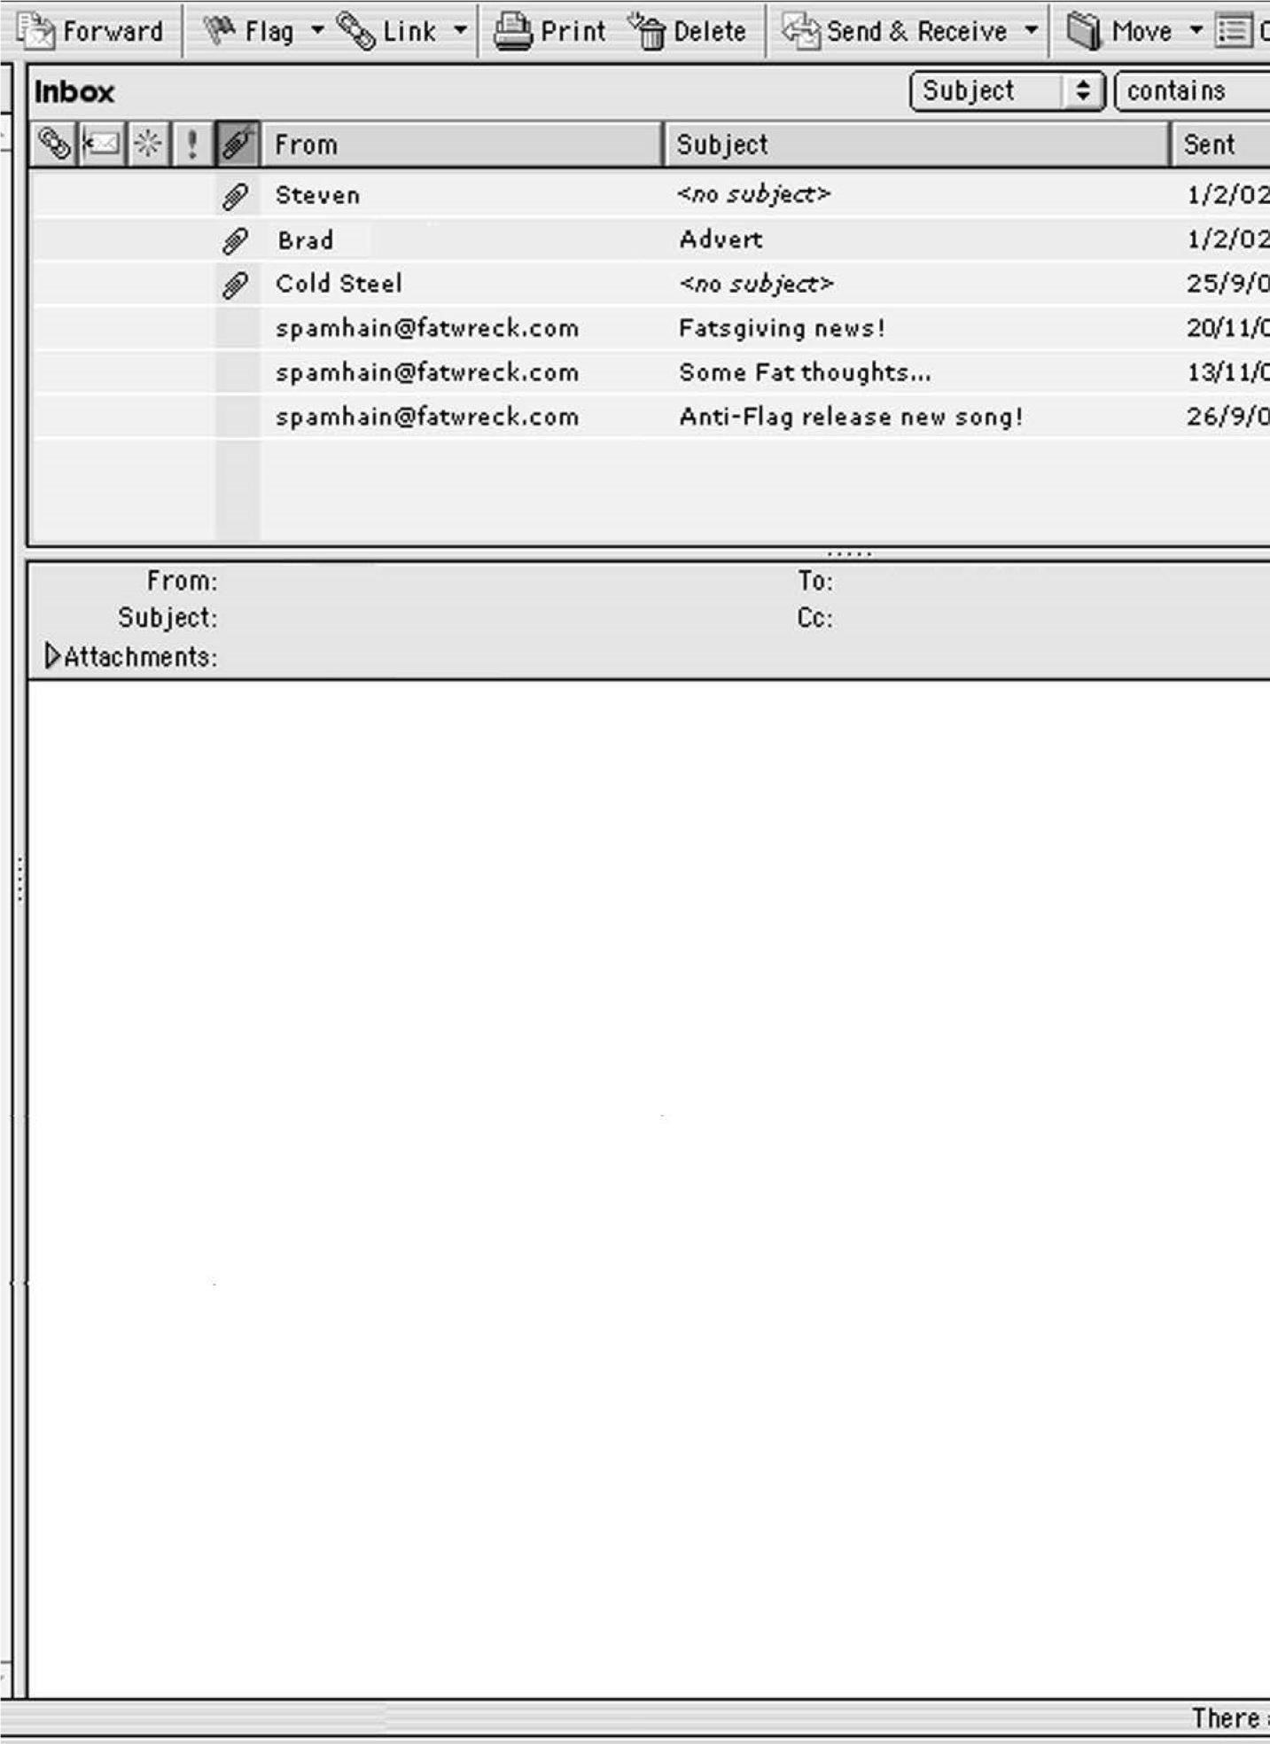
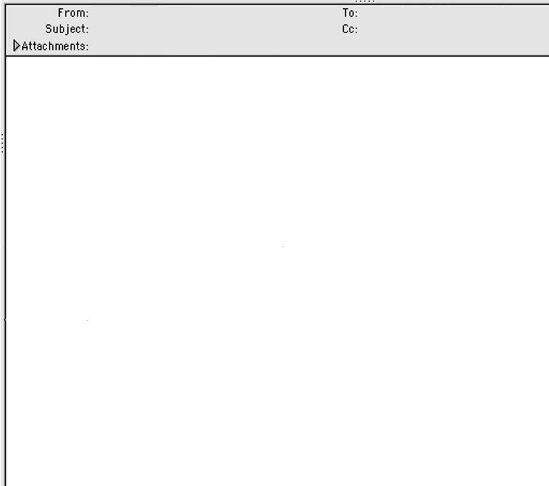

Karl Rossman in your paper has got things all wrong. Just because there is

violence and things at carnival doesn’t mean that we have to move it or stop

it. There are something like a million people that go to carnival. There are

always
going to be bad people out of a million.

But most people who go to carnival just go to dance and have a brilliant

time. The people who do the floats and things work so hard to get

everything ready. It’s not fair that just because of a few bad people
the

whole thing should stop.

I look forward to carnival all year and so do all my friends. We don’t cause

trouble, we just go to have a laugh. It’s not fair to stop carnival, and I don’t

think it should be allowed to be stopped now.

Respect carn
ival and all those that put in work to make Delton a place full of

colour and music.

Peace.

William Drayton

William Drayton

Editor, Delton News

Delton Carnival

