Pattern terminology
Pattern markings: the basics
Sewing patterns have a language of their own. This is a brief guide to the symbols and how to use them.
They help you know how to place your pattern pieces on fabric and where to mark for joining, shaping and fastenings. Using them ensures you match your fabric pieces correctly.
Always fold fabric on the grain unless the pattern says otherwise. The fold and grainline markings are important as this affects how fabric hangs and moves. The grain is the threads and the strongest is the warp grain parallel to the selvedge, running the length of your fabric.
Notches: for example on sleeves there are double notches on the back and single on the front. These correspond with double notches on the back of the body block and single on the front and make sure you position sleeves the right way round.
The dots ⃝ are where you should make tailor tacks, often for darts also centre top of sleeves to match with the shoulder seam.
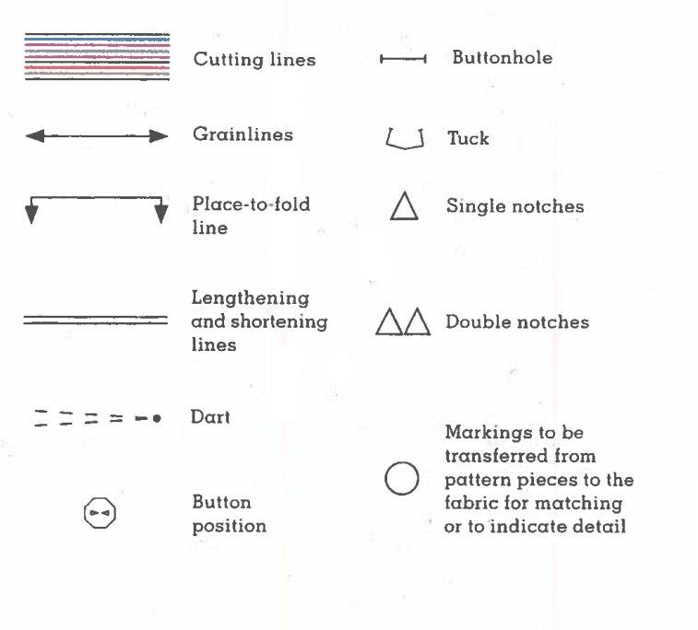
Seam Allowance - This is the amount of fabric taken up by the seam, usually 1cm (5/8 inch) and the distance between the cutting line and the stitching line. 