Interfacing for jackets
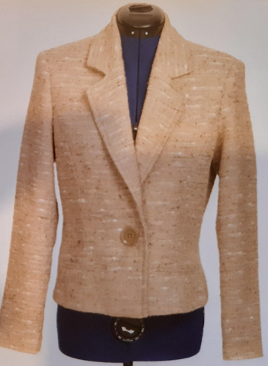 Finished Jacket – styles may differ so this guide to using interfacing can be adapted to suit. The interfacings will reduce stretching and help a jacket keep it’s shape and look crisp for longer.

Front Side front Front facing
Medium weight fusible Medium weight fusible Lightweight fusible interfacing
interfacing, seam allowance interfacing, seam allowance over entire facing
removed. removed.
Shoulder plate: additional Bias strip around armhole to
interfacing to reinforce reinforce.
the shoulder.
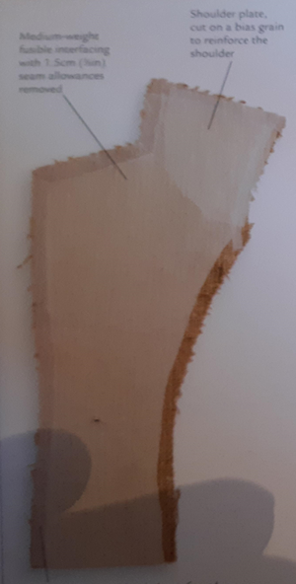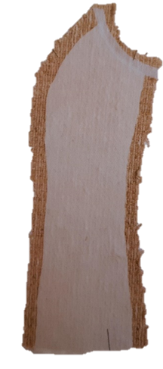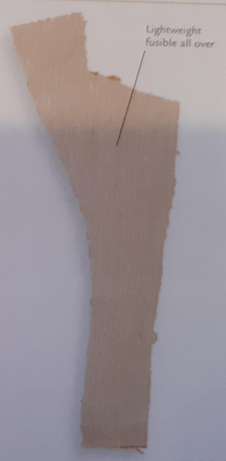
Fusible tape to prevent stretch on
entire front and collar edge

Back Side back Sleeve
Medium weight fusible interfacing to Medium weight fusible Lightweight fusible
reinforce shoulder and armhole. interfacing to strengthen interfacing on upper
Bias tape at neck and armhole edges armhole, seam allowance sleeve, lower edge
Lightweight interfacing over all. removed. Tape on armhole. cut with pinking shears.
Lightweight interfacing Slotted hem tape to
over all. reinforce sleeve hem.
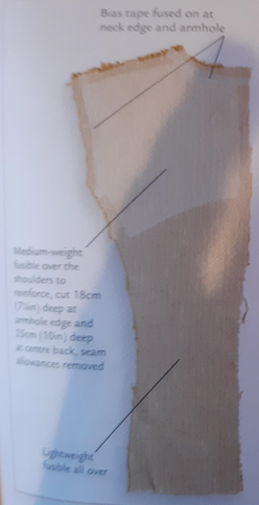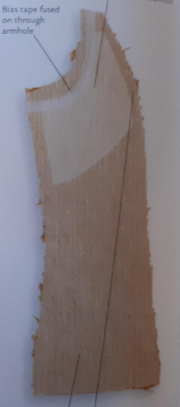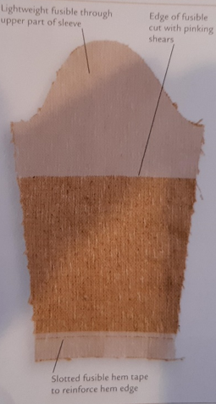

Upper collar Under collar
Lightweight fusible interfacing all over Medium weight fusible interfacing with seam allowances removed.
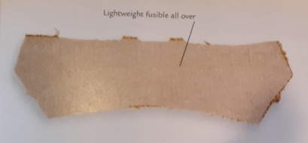 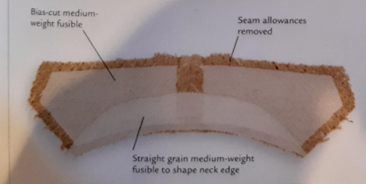 Medium weight interfacing to shape neck edge.

