**Using up scraps of wool and fabric creatively**

Play with left overs and scraps and find ways of overlaying fabrics: include paper and plastic if you like, lace is good.

You can use free embroidery but ordinary embroidery/satin stitches work well and you can make strong recycled fabrics

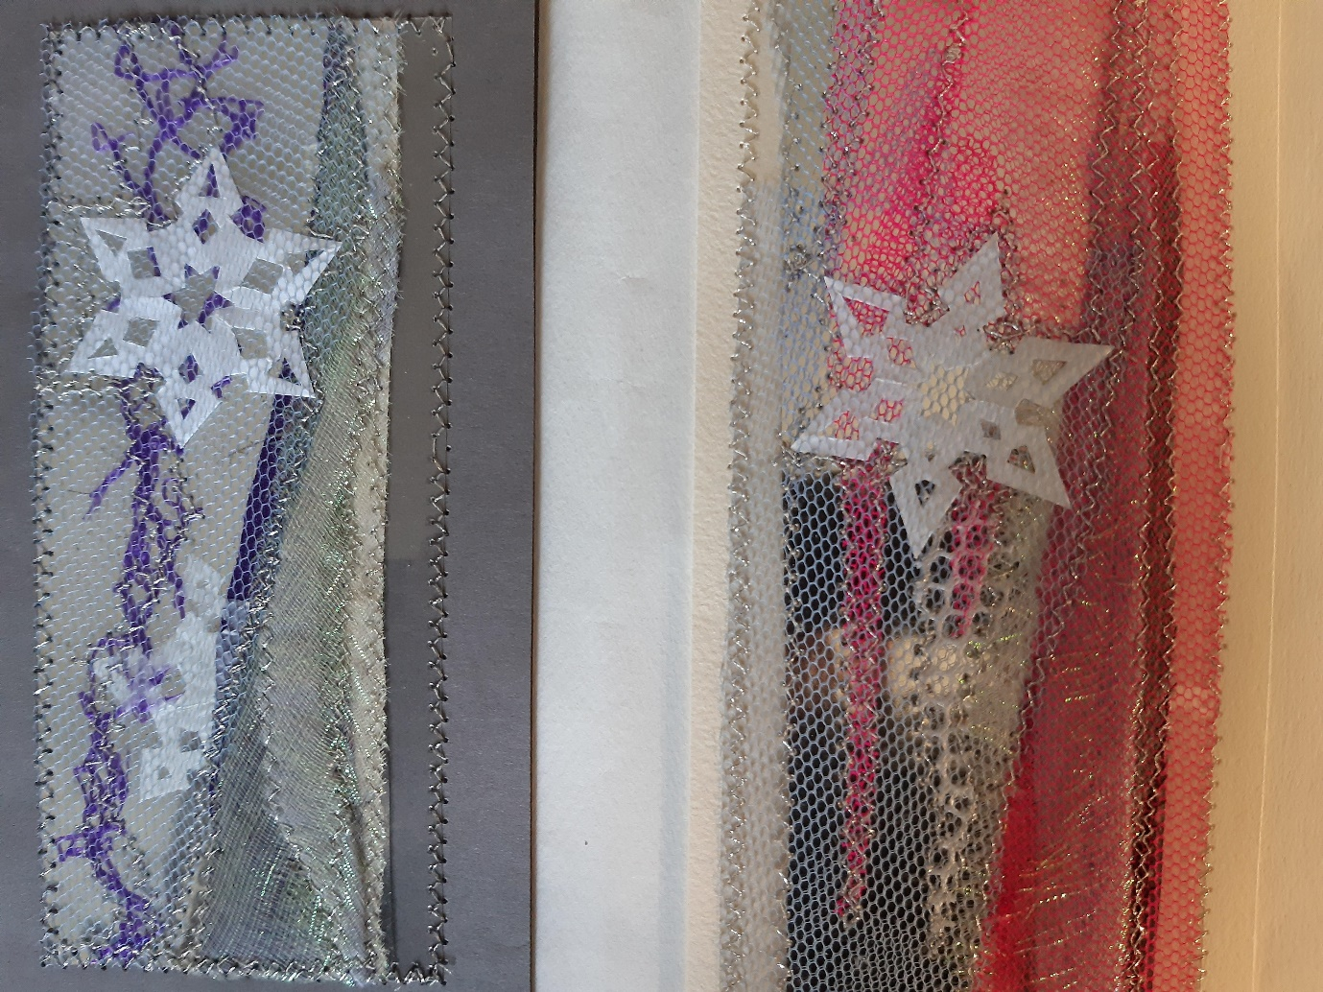 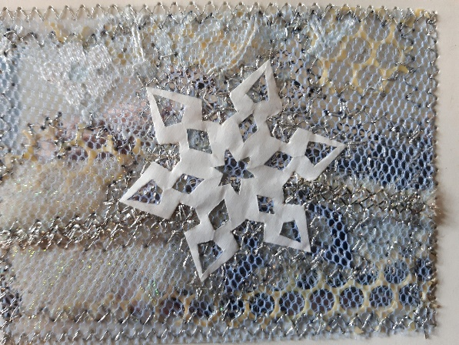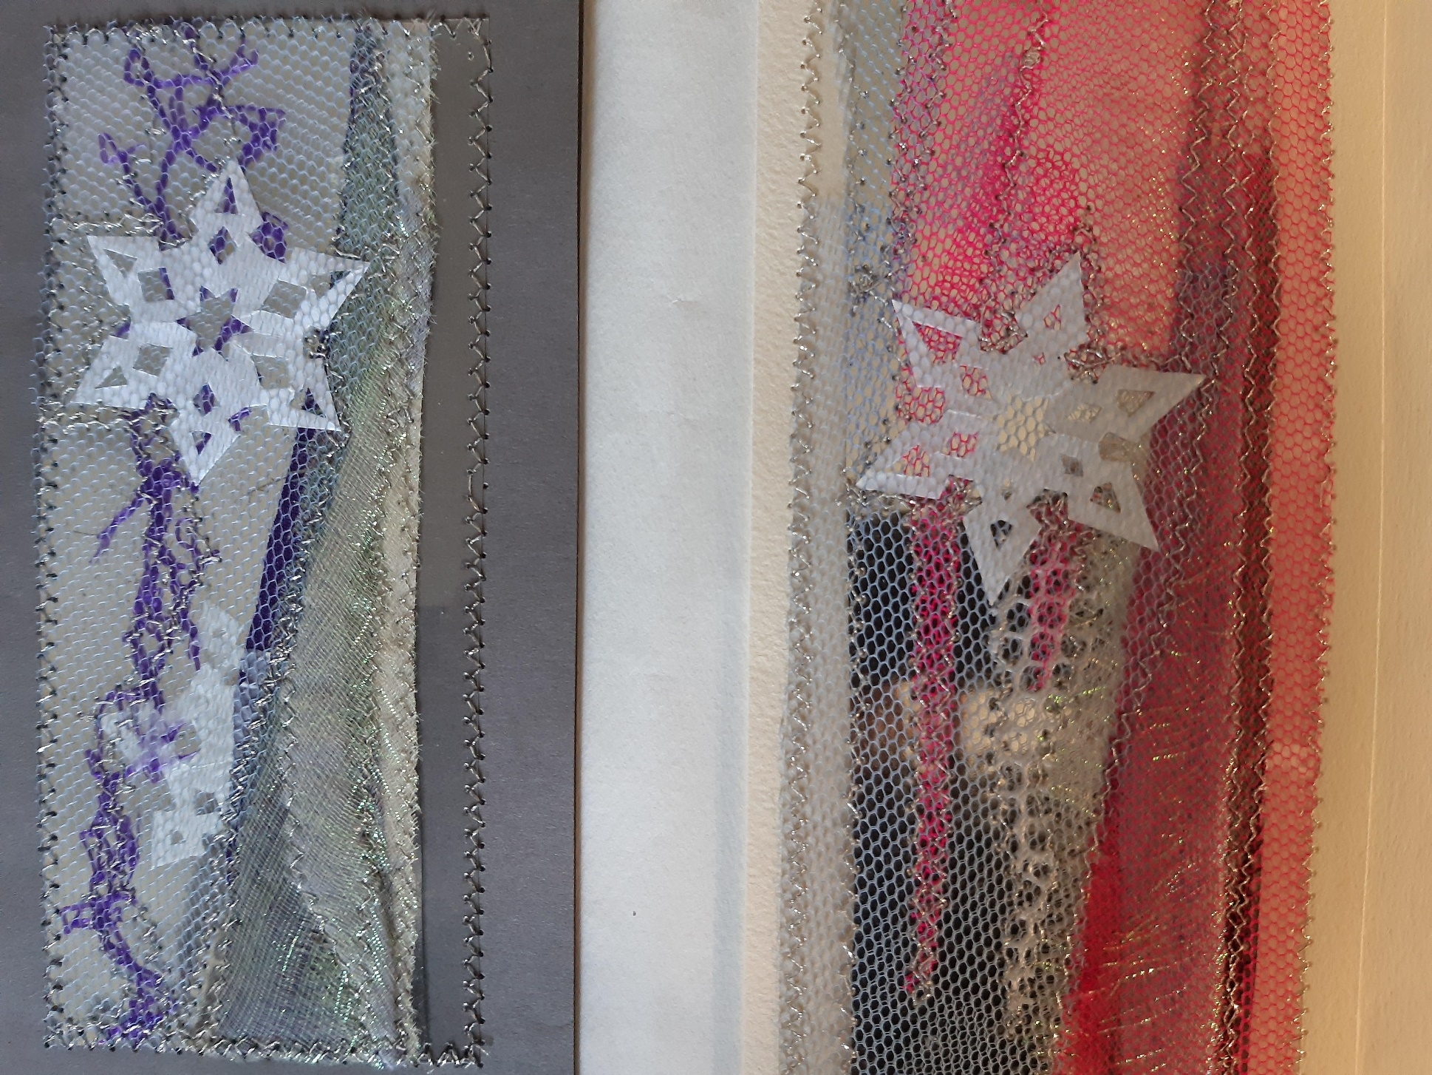

Alternatively there are a range of fusible (iron on) adhesives:

* Wondaweb available as strips for quick hemming or in sheets that you can cut to fit your design.
* Supermend is a powder so you can sprinkle it on, useful for finer fibres and fabrics.
* Both were used in this example and are washable to a certain extent.
* I recommend using greaseproof or baking paper either side of the fabrics to protect your ironing board and iron from the glue. This means you need quite a high temperature.
* Once cool you can also stitch back in with satin stitches and a sharp 14/90 needle.

