

# Adult Community Learning

## Learner Handbook 2024/25



Welcome to your Adult Community Learning course.

We want you to get the most out of your course.

To help you we have put together this handbook so that you have all the information you need.

If you have any further questions, please ask your tutor

### Contents Page

1. Your Course Details 3/4
2. Adult Community Learning Courses 5
3. Closure of courses………………………………………………………………. 5
4. Safeguarding 5
5. Learning Venue Rules and online learning rules 5
6. Punctuality and Attendance on Courses 6
7. Drop-In & Employment Support Sessions 7
8. Information, Advice and Guidance (IAG) and Progression 7
9. Virtual Learning Environment - Islington ACL Learning Gateway…………... 7
10. Individual Learning Plan 7
11. Textbooks 8
12. Printing 8
13. Confidentiality 8
14. Comments and Suggestions 8
15. Complaints Procedure 8
16. Acceptable Use: Internet and Email..............................................................8
17. Dignity for All (Equal Opportunities) 9
18. Health and Safety 9
19. Contacts 9
20. Policy Briefing Sheets
    1. Learning and Behaviour Agreement 9
    2. Acceptable Use and AI 10-11
    3. Protected Characteristics briefing sheet 12
    4. Adult Community Learning Values 13
    5. Safeguarding and E-Safety Information 14-18
    6. Adult Community Learning Complaints procedure ….…….………………19

### 1. Your Course Details

You have enrolled on a course that we hope will suit your needs. For most of our courses you will be able to access you course material online through Moodle, our Virtual Learning Environment. [Click here to go to Islington Adult Community Learning Moodle](https://aclgateway.islington.gov.uk/)

At the end of your course your tutor will talk to you about available options. If you want more information, you can meet with an Information, Advice and Guidance (IAG) Advisor who will talk to you about your options and next steps.

Complete this section with the information given to you by your tutor and if you are doing more than one course, please complete one for each course

|  |  |
| --- | --- |
| Course Title (1) |  |
| Accreditation/Level |  |
| Name of Tutor |  |
| Venue |  |
| Tel No. |  |
| Class Day(s) |  |
| Start/End Times |  |

Notes

|  |  |
| --- | --- |
| Course Title (2) |  |
| Accreditation/Level |  |
| Name of Tutor |  |
| Venue |  |
| Tel No. |  |
| Class Day(s) |  |
| Start/End times |  |

Notes

|  |  |
| --- | --- |
| Course Title (3) |  |
| Accreditation/Level |  |
| Name of Tutor |  |
| Venue |  |
| Tel No. |  |
| Class Day(s) |  |
| Start/End times |  |

Notes

### 2. Adult Community Learning courses

We offer a range of courses which are available in various venues across the borough and online. These courses are for residents aged 19 or over. There are also other eligibility requirements depending on the course.

Our aim is to build upon the career aspirations of Islington residents by helping our learners move into long term paid employment.

You can also find out about our courses online: [Click here for more information about our courses](http://www.adultlearning.islington.gov.uk/). Courses may be advertised on notice boards in libraries and community centres. For more information speak to your tutor or email [ACL@islington.gov.uk](mailto:ACL@islington.gov.uk).

### 3. Closure of courses

Islington Adult Community Learning reserves the right to cancel, combine or reschedule courses and/or to make changes to details advertised including costs, location, and dates. Islington Adult Community Learning reserves the right to only run a course if enrolment has reached the minimum numbers required, subject to funding availability. More information is available at the end of this document.

### 4. Safeguarding

We want all learners to feel safe in our learning venues and online. If you are worried or concerned about your safety, please speak to a member of staff.

Our Safeguarding posters are available in our venues and at ACL learning website [Click here to access ACL Moodle](https://aclgateway.islington.gov.uk/). A copy of this poster can be found on page 14

### 5. Learning Rules

Venue Learning Rules

* All mobile phones must be set to silent mode and calls must be taken outside the classroom
* No eating or drinking is permitted in the venue except in designated areas
* Smoking is strictly not permitted in all buildings
* Violent or offensive language and behaviour to other learners and staff will not be tolerated
* Wilful damage to centre property will not be tolerated
* Learners under the influence of alcohol or drugs will be refused entry
* The internet may only be used in line with Islington Adult Community Learning Acceptable Use Policy, which can be found on page 11
* The learning venue cannot take responsibility for loss or damage to personal possessions
* All learners must comply with Islington’s Dignity for All policy (see page 12)
* Learners must attend all lessons and arrive on time
* Learners must inform their tutor if they will be late
* All learners speak English in class as this is an opportunity for you to improve your English-speaking skills

Any learner who does not comply with these rules may be refused access to Adult Community Learning venues and courses in the future. Please refer to Learning & Behaviour Agreement on page 10.

If a member of staff has concerns that you have not complied with these rules, they will speak with you and keep a written record signed by both of you.If there are further incidents, then there will be a meeting between you and your representative, the member of staff and the venue manager. Again, a written record must be kept and signed by all present.

If any further incidents occur, you will meet with the learning venue manager or a member of the Adult Community Learning management team.

By enrolling on a course, you agree to abide by the rules of the venue as stated above as well as the Acceptable Use and Dignity for All policies.

Online Learning Rules

* Try to be somewhere quiet, away from noise where you can fully concentrate on your learning
* Even if you are at home, you should wear appropriate clothes as you would in the classroom
* Log in to the session 5-10 minutes before the start time to give yourself time to test your microphone and speakers and resolve any technical issues if needed
* Be on time to every online session
* Respect everyone and follow instructions
* Mute your microphone whenever you are not speaking to reduce background noise
* Be patient when the internet is slow or does not work
* Ensure you do your homework on time
* Never record or screenshot any part of the lesson
* Keep your camera turned on (unless agreed otherwise with your tutor)
* A tea/coffee is fine, but please avoid eating during the sessions
* Be present, engaged, and ready to contribute
* Do not multitask. Documents &presentations that are required for the session are the only things you should have up on your screen Although it is tempting to check emails or work on other things when you are not speaking, please remain focused
* If you need to excuse yourself, please use the chat function to let the tutor know that you need to leave and when you will return.

### 6. Punctuality and Attendance

It is important that you attend on time and participate in every class. You must tell your tutor if you are going to be late or absent.

**If your attendance is below 88% then you will not be allowed to re-enrol on future courses.**

### 7. Digital Skills and Employment Support Drop-Ins

These drop-ins can help you if you need to improve your digital or employability skills without having to sign up to a full course.

With our digital skills drop-ins you will get one to one help and support using your computer, laptop, and other devices such as Tablets and Smartphones more effectively. The employment support drop-ins will help you better prepare for the world of work. We can support you with job searching, writing your CV, filling in application forms and with preparing for that important interview.

One to one support will be offered online and/or face to face where possible and you will need to book sessions with a tutor.

### 8. Information, Advice and Guidance (IAG) and Progression

We can arrange a one-to-one meeting with an IAG advisor to help you to plan your future. Please talk to your tutor to book a meeting with an advisor.

We also work with Islington iWork service who can provide one-to-one coaching to support you in gaining employment.

Within your course you will also receive support from your tutor to help you achieve your learning goals. You will be informed about relevant courses that you may wish to do to help you progress onto higher education and/or into work.

### 9. Islington ACL Gateway

You will be able to access your course resources through our Virtual Learning Environment (VLE) [Click here to access ACL Moodle](https://aclgateway.islington.gov.uk/) and at the start of your course you will be given a username and password. When you log in for the first time, you will be asked to change the default password to something you can remember. If you forget your password, please use this link [ACL Moodle password click here](https://aclgateway.islington.gov.uk/login/forgot_password.php).

### 10. Individual Learning Plan

As well as having regular reviews with your tutor, you will have an Individual Learning Plan. This will help us, and you identify what you want to learn and keep track of your goals, progress, and achievements throughout your course.

Your Individual Learning Plan is available online which you can access via the ACL Gateway.

### 11. Textbooks for learning in venues

You are welcome to use the textbooks that are available at the venues. However, the textbooks must not be removed from the venues unless agreed with your tutor.

### 12. Printing in learning in venues

If you need to print a large amount or if you need to print in colour, please speak with your tutor. We would ask you to think about the environment before printing and only print if you really need to.

### 13. Confidentiality

Any personal information that you provide will be treated as strictly confidential. However, we reserve the right to share or disclose information if we feel that you, another learner, or member of staff is at risk. We will discuss this with you first.

We may use certain information anonymously without including any of your personal details for statistical reports to ensure that we are reaching people of all backgrounds and age groups. Please discuss this with the venue manager if you have any concerns.

### 14. Comments and Suggestions

We want to ensure that we continually improve the services we provide. At the start of your course, you will be asked to complete an online survey for the Greater London Authority (GLA). At the end of your course, you will receive a link to complete an online evaluation form. This will give you the opportunity to comment on any aspect of your learning, online delivery, the venue, and the service that we offer.

### 15. Complaints and Appeals Procedure

We hope you enjoy your course, however, if you wish to complain, please speak to your tutor first. They may be able to clarify or solve the problem quickly and will welcome your feedback. If you are unhappy with the result of your initial complaint and you wish to take it further, please refer to Adult Community Learning Complaints Policy.

Learners wishing to appeal against an assessment of work they have completed, or an examination result need to follow the procedure in the Islington Exams and Assessment Policy.

### 16. Acceptable Use: Internet and Email

Adult Community Learning provides access to the Internet at its learning venues. However, it does not have control over the Internet or its content. As with other information sources including television, videos and books, some material may be unsuitable and could be considered offensive. Please see page 11 for ICT (Information and Communication Technology) acceptable use policy.

### 17. Dignity for All (Equal Opportunities)

All staff and users of Adult Community Learning venues must comply with Islington’s Dignity for All Policy. Please see our Learning Centres’ Policy Folders on the Adult Community Learning Gateway.

No person will be discriminated against on the grounds of their race, gender, sexuality, disability, culture, religion, age, colour, language, HIV status, political or other opinion, national or social origin, association with a national minority, property, birth, or other status.

Any discriminatory action, language, opinions, or assumptions, including harassment and victimisation will be challenged. Please see Protected Characteristics Sheet on page 12.

### 18. Health & Safety in learning venues

Please pay attention to staff notices and induction regarding Fire Safety. These also include:

* First Aid
* Emergency procedures
* Refreshments

### 19. Contacts

You may find the following contacts useful.

|  |
| --- |
| **Arsenal Learning Centre**  Arsenal Hub, Emirates Stadium, 56 Benwell Road, N7 7BA Tel: 020 7704 4500 |
| **Finsbury Library**  245 St John Street, EC1V 4NJ, Tel- 020 7527 5083 |
| **First Steps Learning Centre**  Central Library, 2 Fieldway Crescent, N5 1PF, Tel: 020 7527 7002 |

### 20. Policy Briefing Sheets

A: Learning and Behaviour agreement

This agreement explains the commitments and responsibilities expected of you, the Learning Venue and Islington Adult Community Learning.

**What can you expect?**

* To learn in safe and comfortable surroundings
* To have your skills valued & recognised
* To receive the support that you need
* To be taught by an experienced & qualified tutor
* A stimulating and enjoyable learning experience
* To receive helpful feedback from the tutor
* Impartial advice and information
* To be offered a course at the appropriate level for you

**What do we expect in return from you?**

* To attend your course on time
* To inform your tutor if you cannot attend your class
* To complete your homework on time
* To treat the tutors and other learners with respect and understanding
* To listen to your tutor and follow instruction
* To participate in discussions and listen to other people’s opinions
* To speak English in class -an opportunity for you to improve your English-speaking skills
* To discuss problems that you are having with your learning with your tutor or service staff
* A commitment to the Health and Safety of yourself and other learners.
* A commitment to Islington’s Dignity for All Policy.

If you do not observe all the above, we may withdraw your offer of a place on your course and/or may be unable to offer you a place on a course in the future.

B: ICT Acceptable Use Policy. AI usage.

|  |
| --- |
| **Learning Centre Rules** |
| * No eating or drinking is permitted near the computers, only in the designated area * Close programs and turn off the computer when you have finished * Delete your files when you have too many on the network * Do not store sensitive data (such as your contact details) on the shared drive * Inform the tutor if there is a problem with a computer * Wilful damage to centre property will not be tolerated * We are not responsible for loss or damage to personal possessions  *The Internet may only be used in line with our acceptable use policy (see below).* |

|  |
| --- |
| **Acceptable use policy** |
| All citizens are entitled to Internet access for their information, education, and recreation. Whilst the learning centre provides access to the Internet, it does not have control over the Internet or its content. As with other information sources, including television, videos and books, some material may be unsuitable and could be considered offensive. Individual users are responsible for their use of the Internet at the Learning Centre. The computer equipment must not be used to:   * Create, send, store, exchange, display, print or circulate offensive material, obscene or indecent data (or material likely to cause annoyance, inconvenience, or needless anxiety) in any form or medium (including abusive emails, text messages, social media posts, pornographic material or anything that depicts violence or incites racial hatred) * Violate the privacy of other users or harass others with unwanted electronic communication of any description * Deliberately attempt to access unauthorised facilities or services via the computer network * Send unsolicited commercial or advertising material (junk or spam mail) * Hack into unauthorised areas, install software, alter the settings, or make changes to the computers, which make them unusable by others * Commit any form of illegal activity, including software and music piracy, cyber bullying, defined as threats and intimidation by mobile phone, email comments on websites, social networking sites or message boards * Waste staff effort or networked resources and corrupt or destroy any data belonging to staff or other users * View, share, store, exchange or print any form of extremism or encourage radicalisation   **You must adhere to HM Government Prevent Agenda and the Council’s Prevent policies** |
| **Using Email** |
| Please be aware that e-mails are easy to intercept   * Do not send confidential, sensitive, or personal data via e-mail * Do not send anything illegal: anything that is defamatory, copyrighted, or pornographic * Do not send abusive messages * Do not attempt to monitor, intercept, read or tamper with anyone else’s e-mail |

**Artificial intelligence (AI)**

While the range of AI tools, and their capabilities, is likely to expand greatly in the

near future, misuse of AI tools in relation to qualification assessments at any time

constitutes malpractice. Teachers and students should also be aware that AI tools are

still being developed and there are often limitations to their use, such as producing

inaccurate or inappropriate content.

(AI) misuse

AI misuse constitutes malpractice as defined in the JCQ Suspected Malpractice:

Policies and Procedures <https://www.jcq.org.uk/exams-office/malpractice/> The

malpractice sanctions available for the offences of ‘making a false declaration of

authenticity’ and ‘plagiarism’ include disqualification and debarment from taking

qualifications for a number of years. Students’ marks may also be affected if they

have relied on AI to complete an assessment and, as noted above, the attainment

that they have demonstrated in relation to the requirements of the qualification does

not accurately reflect their own work.

Examples of AI misuse include, but are not limited to, the following:

* Copying or paraphrasing sections of AI-generated content so that the work is
* no longer the student’s own
* Copying or paraphrasing whole responses of AI-generated content
* Using AI to complete parts of the assessment so that the work does not reflect
* the student’s own work, analysis, evaluation or calculations
* Failing to acknowledge use of AI tools when they have been used as a source of
* information
* Incomplete or poor acknowledgement of AI tools
* Submitting work with intentionally incomplete or misleading references or
* bibliographies.

C: Protected Characteristics

Everyone has a legal right to be protected from discrimination in the workplace and in wider society. Please also refer to the Safeguarding sections in the ACL Learner and Tutor Handbooks

**Protected Characteristics Groups:**

* age
* being or becoming a transsexual person
* being married or in a civil partnership
* being pregnant or having a child
* disability
* race including colour, nationality, ethnic or national origin
* religion, belief, or lack of religion/belief
* sex
* sexual orientation

**Adult Community Learning has a duty to:**

* have due regard to the need to eliminate discrimination
* advance equality of opportunity
* foster good relations between different people when carrying out their activities

**Action Against Discrimination**

Legally you can do something voluntarily to help people with a protected characteristic if they:

* are at a disadvantage
* have specific needs
* are under-represented in an activity or type of work

If you would like more information, please speak to your tutor.

D: Adult Community Learning Values

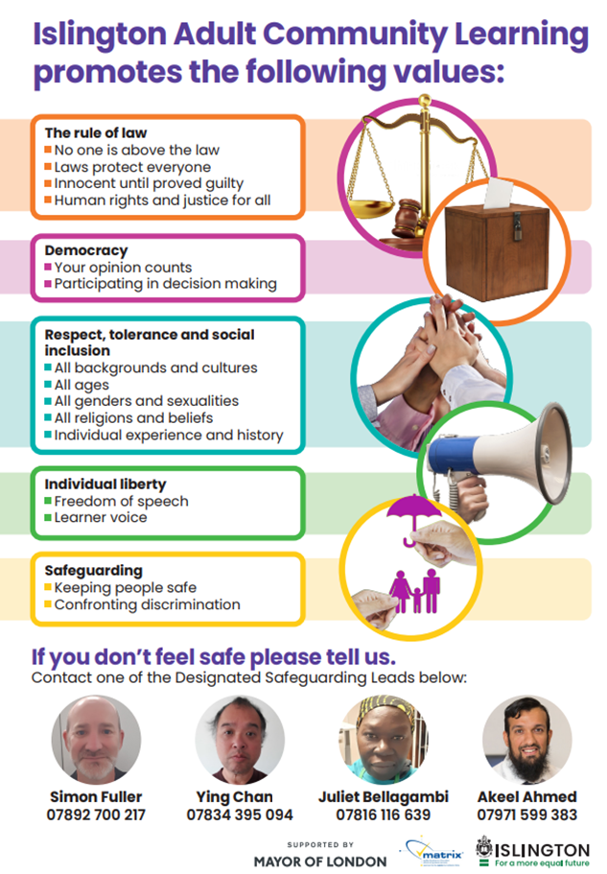

E: Safeguarding and E-Safety Information

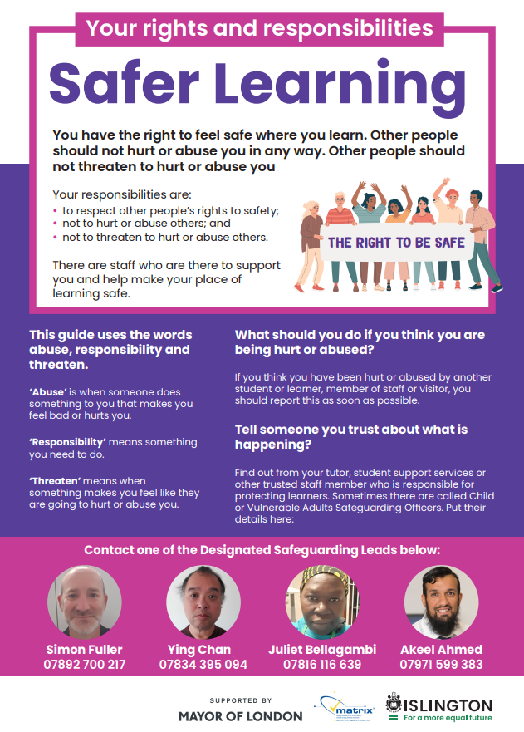

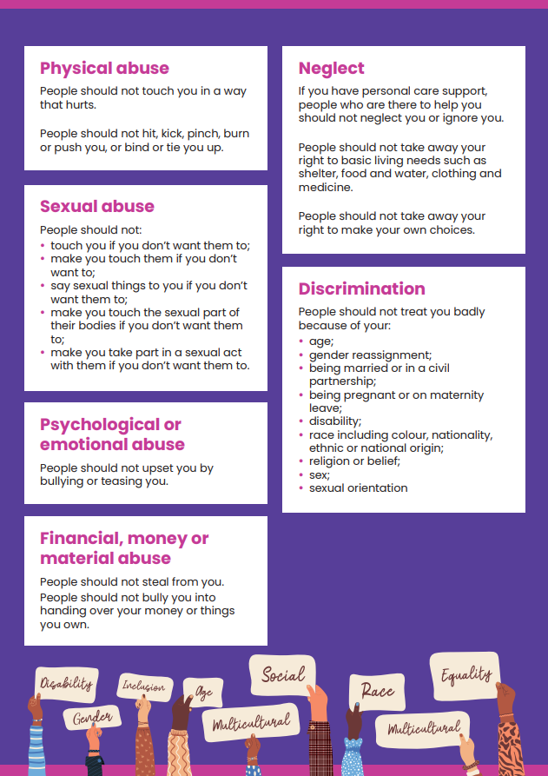

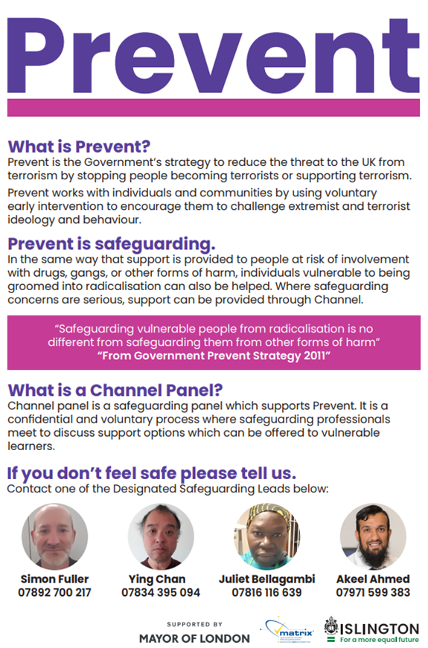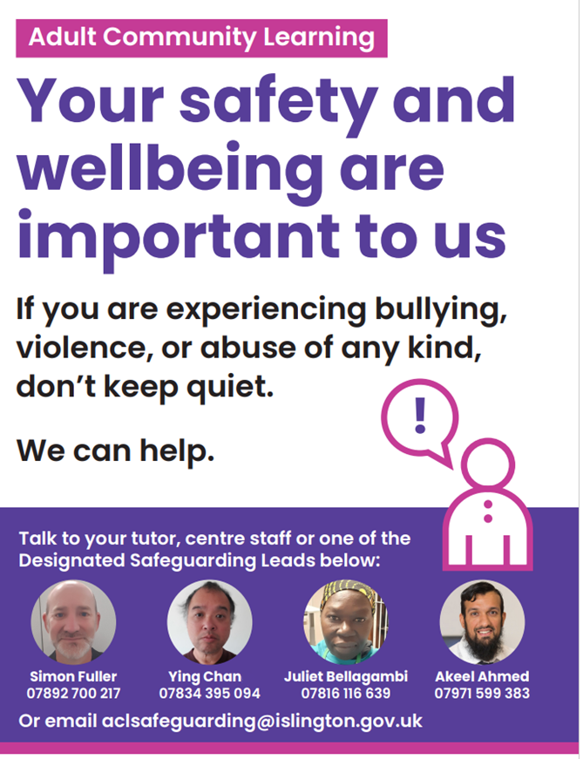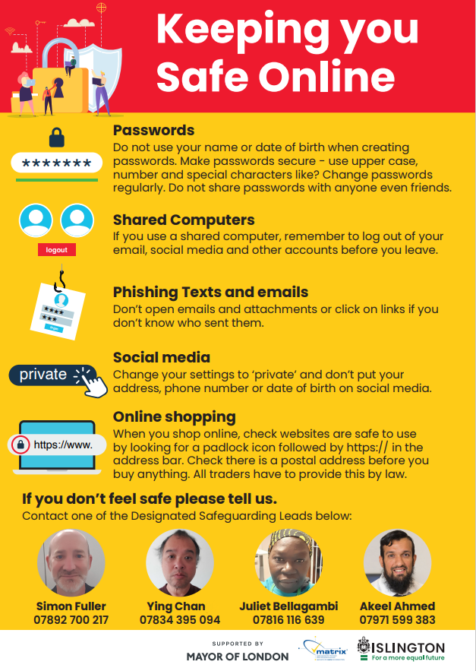

F. Adult Community Learning Complaints Procedure

We hope that you enjoy your learning with us. If you are at any time unhappy with the service provided, you can follow these procedures:

1. Initially, please discuss any issues you may be experiencing with your tutor. They may be able to clarify or solve the problem quickly and will welcome your feedback.
2. If you are still unhappy, you can make a formal complaint to the ACL Curriculum Manager, Simon Fuller- Adult Community Learning, Central Library, London N5 1PF.

Tel: 020 7527 3405 / 07892 700 217 Email: [simon.fuller@islington.gov.uk](mailto:simon.fuller@islington.gov.uk)

1. The Tutor/Centre Staff will log your complaint and try to resolve your concern or pass it on, with your approval, to the Quality Manager to investigate. You will also receive an acknowledgment of your complaint within 3 working days and a full written reply within 10 working days in accordance with Islington Council Procedures.
2. If you believe your complaint has still not been dealt with properly you can make a formal complaint to: The Central Complaints Unit, Town Hall, Upper St, London, N1 2UD. * Tel: 020 7527 3007. Email: central.complaints@islington.gov.uk www.Islington.gov.uk/complaints

We also welcome your thoughts and feedback on the positive experiences you have had learning with us. Please tell us!