Presenting your work/samples

Make a story of the process using photos and text, recording:

1. the heading from the assignment at the top of each page, eg Unit 102: 2+3 Cuff with placket
2. any health and safety implications
3. the techniques and experiments, what worked or didn’t
4. evaluation of your sample/s: notes on how you feel about the results, anything you could do differently another time or are particularly pleased with
5. sign and date your work
6. save as a pdf and submit for feedback and grading. Keep the hard copies safely in your course folder for final assessment

The example below is just a guide to start you off, the photo documentation helps you to write less and remember more. Take photos as you work.

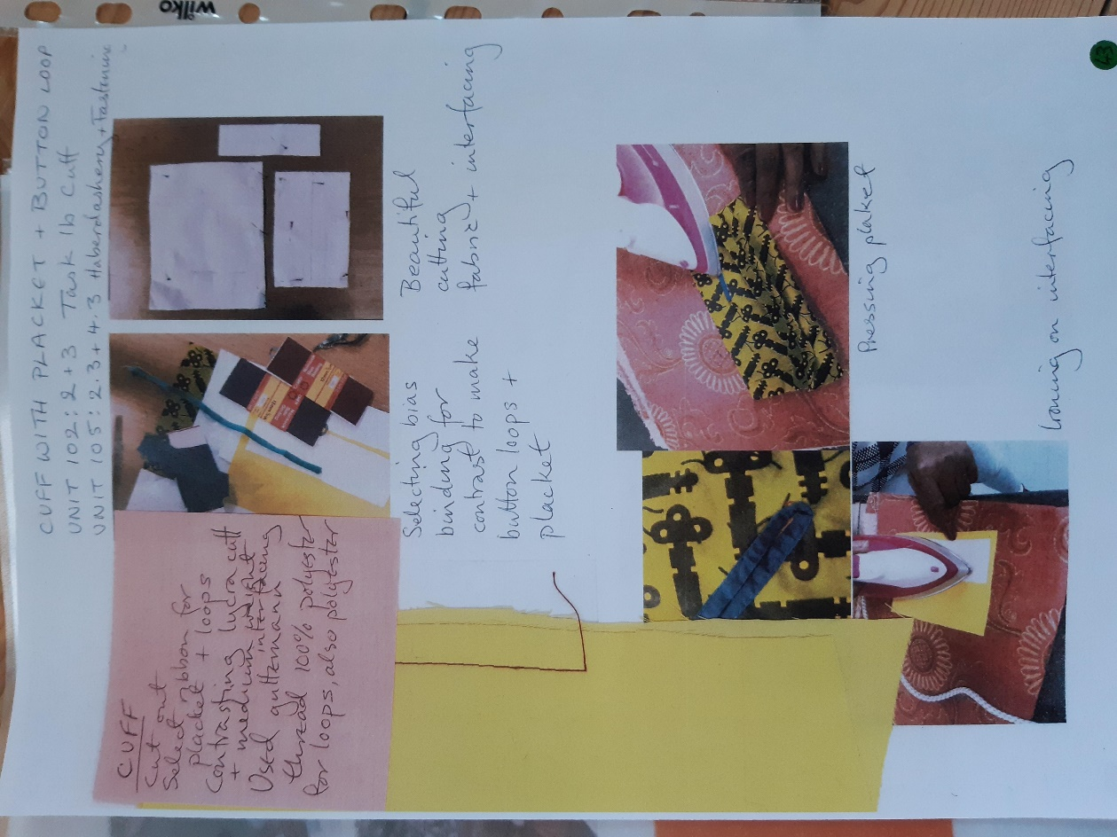 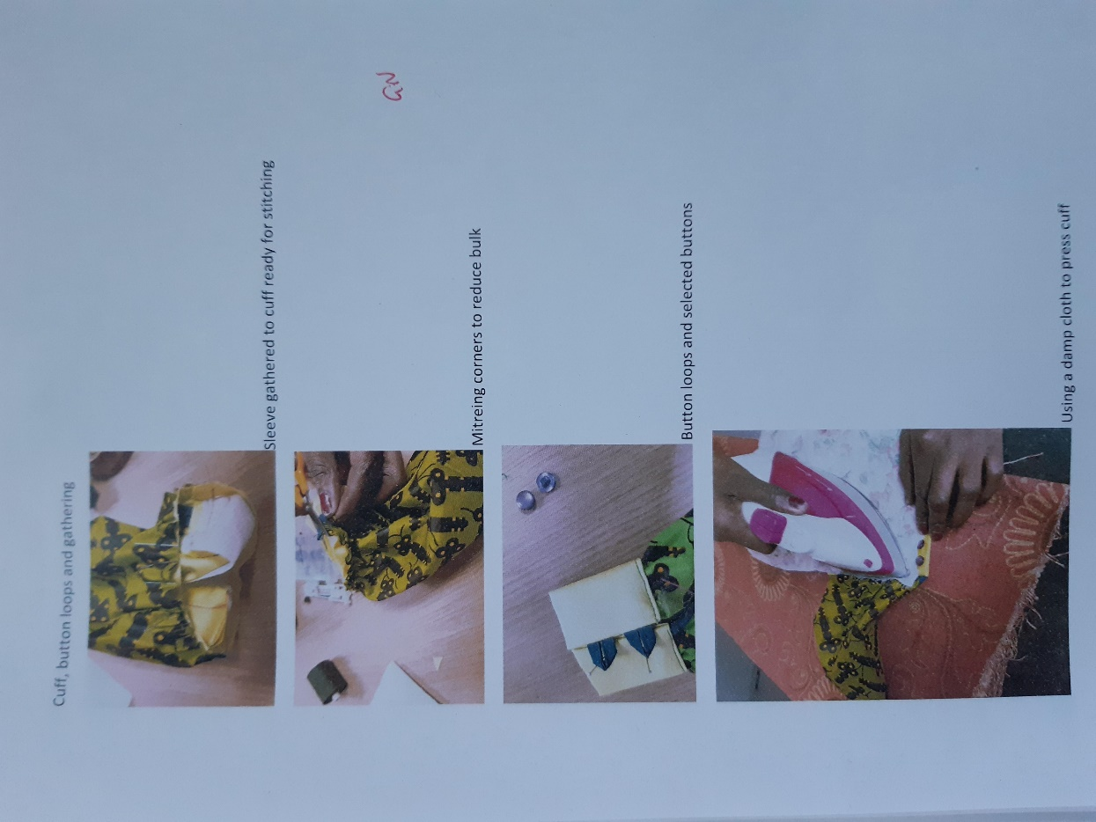

N.B. Above on the yellow fabric is a test stitch because it was a stretch fabric and likely to need care selecting tension/stitch/needle.

