Pivot turns

Pivot turns are used for sewing round corners and angles neatly, with no jamming, for pockets or collars for example.
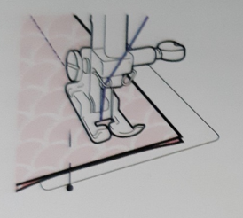 Sew the seam up to the next seam allowance and turning the hand (balance) wheel towards you put the needle into the fabric so it anchors the fabric.
If you have an automatic or semi automatic you can probably set the needle to stop stitching in the down position.

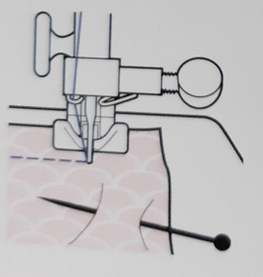 Now you can safely lift the presser foot and turn the fabric to its new direction without loosing your position.
Drop the presser foot and continue sewing.

This seems simple but is important. Whenever you want to hold the fabric in place but need to lift the presser foot, taking a pin out or adjusting the lay of the fabric for example, place the needle in. This will help avoid wobbly seams and jamming.

