Presenting your work/samples

Make a story of the process using photos and text, recording:

1. the heading from the assignment at the top of the page, eg Unit 102 : 2 + 3.1 Facings
2. any health and safety implications
3. the techniques and experiments, what worked or didn’t
4. evaluation of your sample/s: notes on how you feel about the results, anything you could do differently another time or are particularly pleased with
5. sign and date your work
6. save as a pdf and submit for feedback and grading. Keep the hard copies safely in your course folder for final assessment

The example below is just a guide to start you off, the photo documentation helps you to write less and remember more. Take photos as you work.

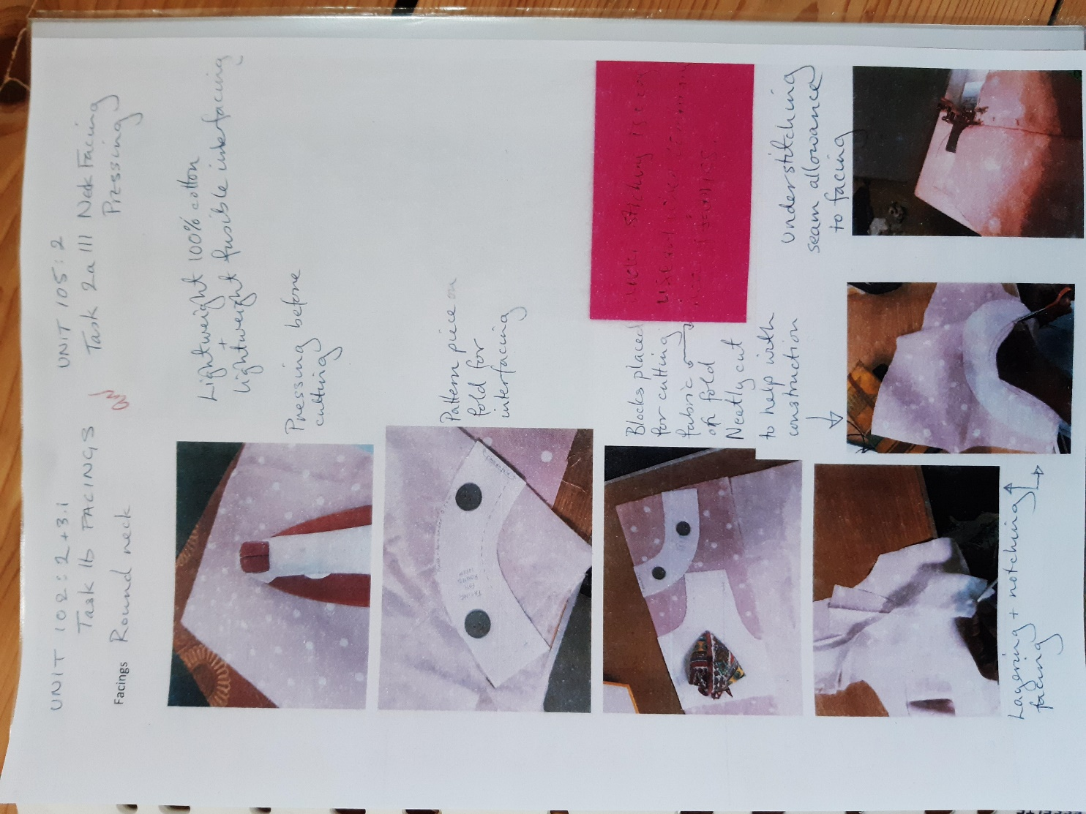

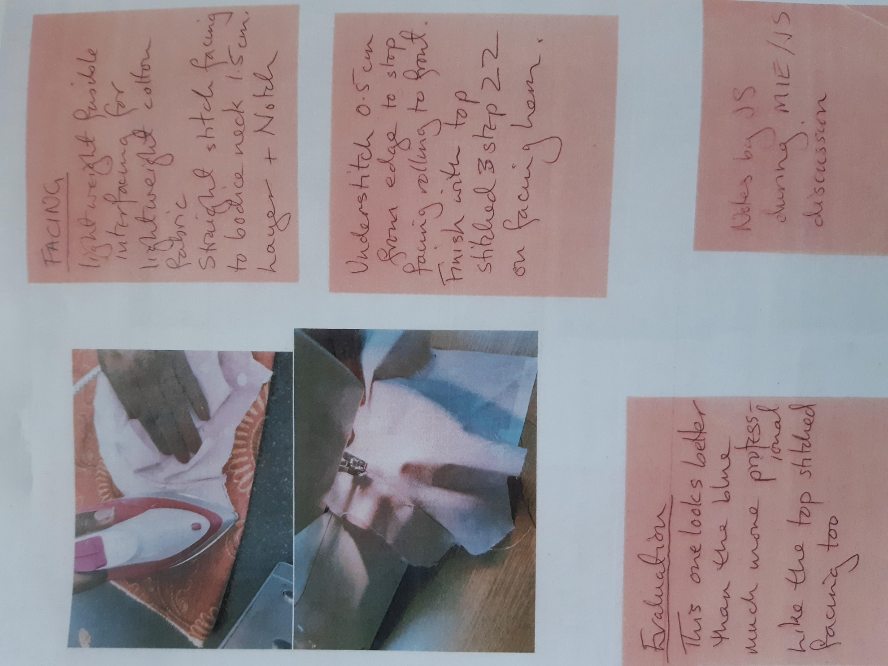

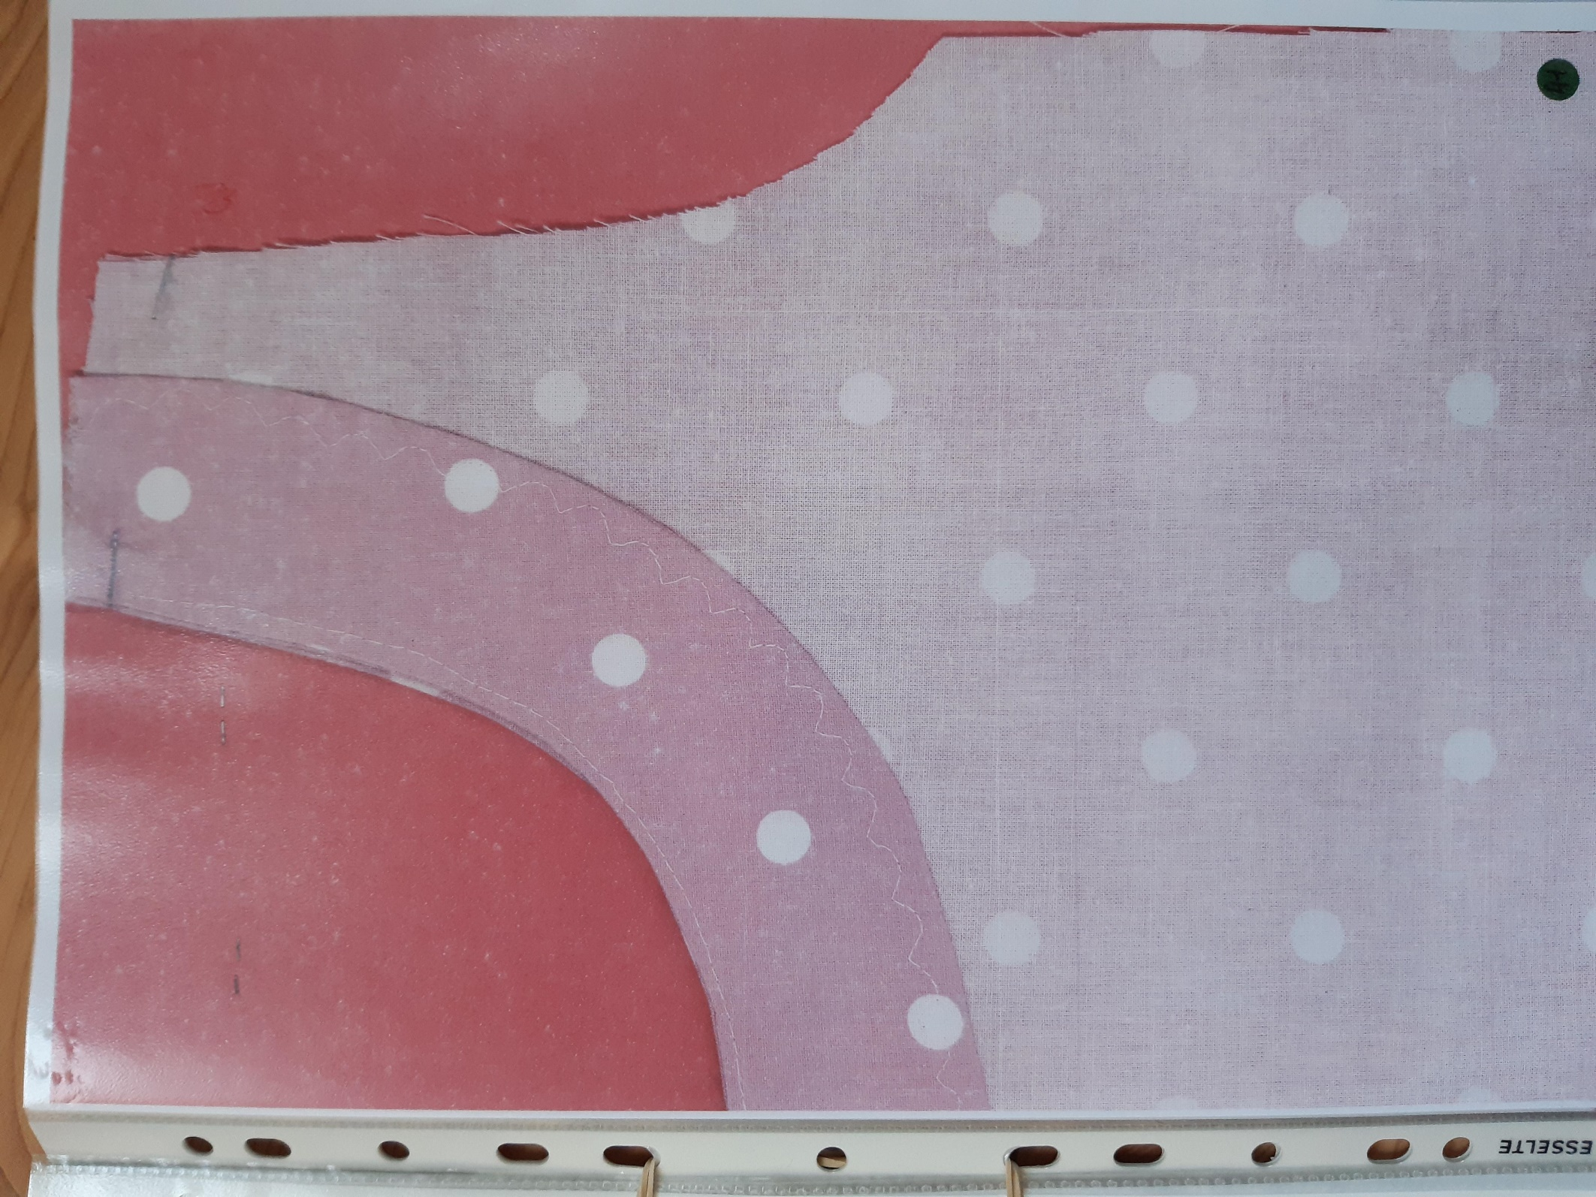

The example above has lots of info that needs to be included, I’ve added part of the one below because it was presented so the two armhole finishes can be seen, both the bias strip and easing for the sleeve. The understitching is also shown.

