Presenting your work/samples

Make a story of the process using photos and text recording:

* use the heading from the assignment at the top of the page, eg Unit 102 applique
* the resources you selected, used and why you chose them
* tools and equipment used
* any health and safety implications
* the techniques and experiments, what worked or didn’t
* evaluate your sample: notes on how you feel about the results, anything you could do differently another time or are particularly pleased with
* sign and date your work
* save as a pdf and submit for feedback and grading. Keep the hard copies safely in a course folder for final assessment
* The example below is just a guide to start you off, it has no H&S info or evaluation, the photo documentation helps you to write less and remember more. Take photos as you work.

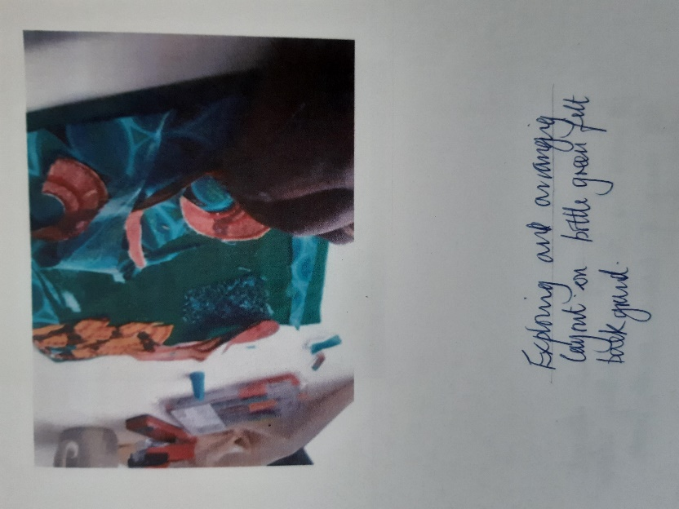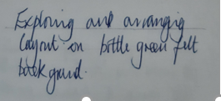 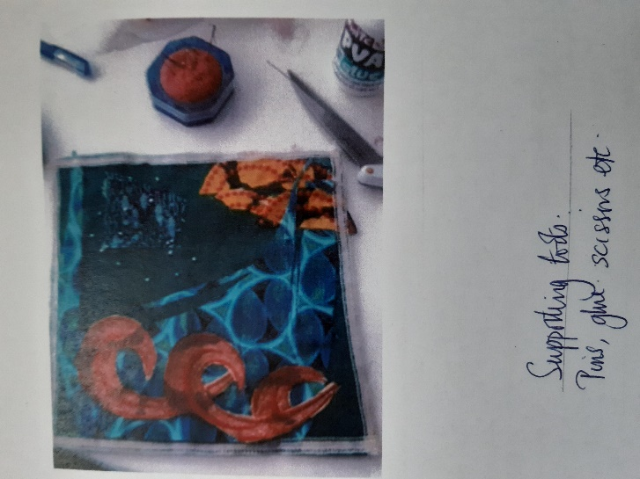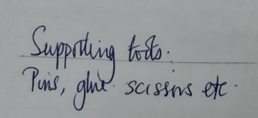

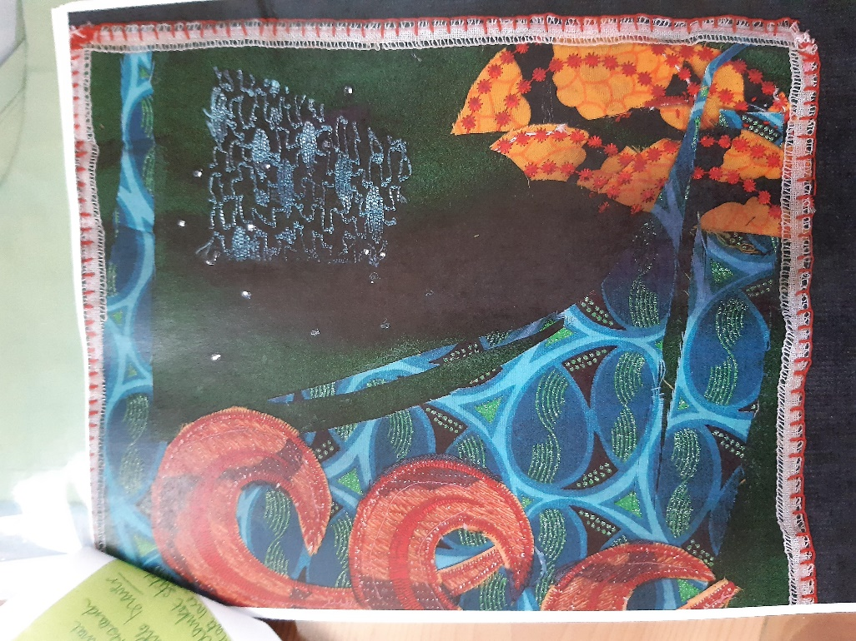 Finished piece