* 
* [Josie Clarke](https://www.independent.co.uk/author/josie-clarke)
* Wednesday 29 May 2019 09:15

**WHSmith voted UK's worst high street chain as shoppers complain of 'cramped and messy' stores**

Top of Form



Bottom of Form

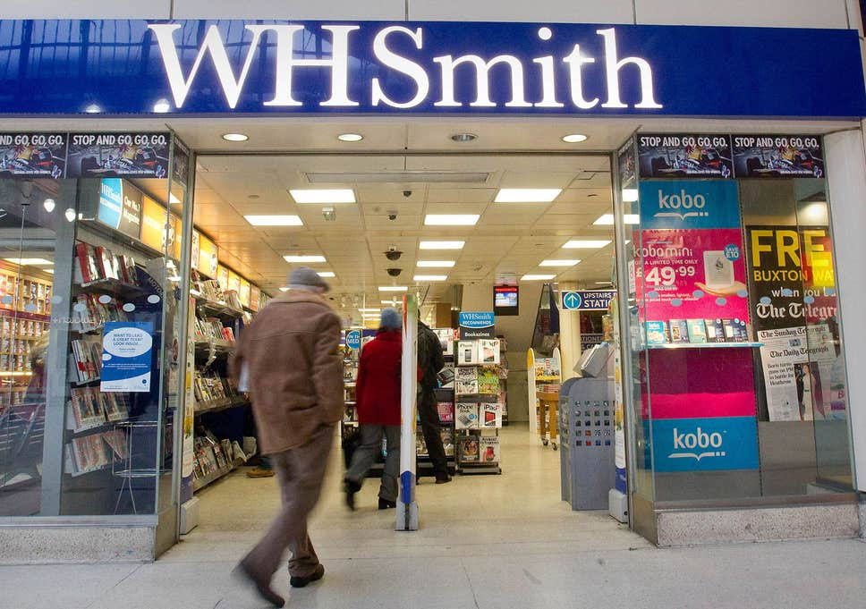

[WHSmith](https://www.independent.co.uk/topic/whsmith-0) has once again been voted the UK’s worst [high street](https://www.independent.co.uk/topic/high-street) shop, with customers criticising the chain for its poor value for money and “cramped and messy” stores.

The chain came bottom of an annual survey by consumer group Which? with a customer score of just 50 per cent, behind Homebase on 53 per cent and Sports Direct on 54 per cent.

WHSmith kept up its record of consistently being voted the worst chain on UK high streets, but it hit back at the poll, pointing out that it had maintained its presence while others were closing down stores.AdChoices

**We’ll tell you what’s true. You can form your own view.**

From 15p €0.18 $0.18 USD 0.27 a day, more exclusives, analysis and extras.

[Subscribe now](https://www.independent.co.uk/subscribe?utm_medium=prompt&utm_source=internal&utm_campaign=brexit_inline&regSourceMethod=Standard+Article)

Customers complained of bad service as specialist retailers came out on top thanks to their superior in-store experience.

Sports Direct was described by one shopper as having “a very oppressive atmosphere”, while Homebase was criticised for being difficult to navigate.

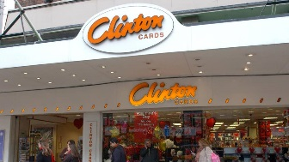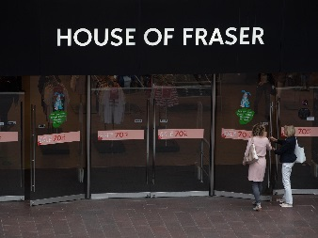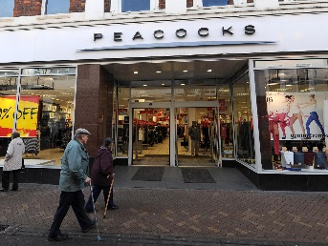

Richer Sounds, which recently announced it would hand over control of the business to employees, was voted the best retailer with a customer score of 89 per cent.

Outdoor and travel equipment chain Rohan came in second with 87 per cent, followed by John Lewis with 86 per cent.

Customers praised Richer Sounds for carrying purchases to their cars and paying for parking. Five of the top six retailers were specialists with customers commending the expert advice provided.

The only general retailer at the top of the table John Lewis was praised by customers for being “a reliable store with products I can trust” with “nicely laid out stores with helpful staff and good parking”

* [](https://www.independent.co.uk/news/business/news/richer-sounds-staff-owners-partnership-julian-founder-retail-a8913451.html)

[Richer Sounds owner hands over control of hi-fi retailer to staff](https://www.independent.co.uk/news/business/news/richer-sounds-staff-owners-partnership-julian-founder-retail-a8913451.html)

A number of retailers underperforming in the high street survey also ranked poorly in Which?’s most recent online shops survey. Homebase.co.uk and SportsDirect.com languished at the bottom of the table with 55 per cent and 61 per cent respectively. WHSmith.co.uk fared only slightly better, with a score of 63 per cent.

*Which?* magazine editor Harry Rose said: “Worries about the future of the high street aren’t going away anytime soon, but it’s clear that there is still demand from shoppers for the experience and services offered by physical stores that can’t always be replicated online.

“Giving shoppers a great in-store experience is more important than ever if brands want to thrive on the high street. Our findings go to show that, if retailers can deliver great value, quality products and first-class [customer service](https://www.independent.co.uk/topic/CustomerService), customers will keep coming back.”

WHSmith said: “This survey accounts for the views of only 586 Which? subscribers and is neither statistically relevant nor meaningful relative to our loyal customer base.

“Every week we serve 3 million customers in our 600 UK high street stores and have maintained our presence on the high street where many other retailers are closing stores. We work hard to improve customer experiences and continue to invest in new and existing stores.”

**The bottom-rated shops are:**

101 Clinton Cards (61 per cent)

102 Peacocks (59 per cent)

103 House of Fraser (59 per cent)

104 New Look (58 per cent)

105 River Island (56 per cent)

106 JD Sports (56 per cent)

107 Sports Direct (54 per cent)

108 Homebase (53 per cent)

109 WHSmith (50 per cent)