Hand Stitched Hems: Herringbone and Hidden Slip Stitch.

Press the over edged or turned hems.

Use a single thread to stitch these examples.

By picking up only one thread on the outer side of the garment your stitches will be invisible and don’t pull the thread tight, these stitches will hold and allow for movement too.

Herringbone Stitch

Work the overall hem from left to right with stitches from right to left so the thread crosses itself.

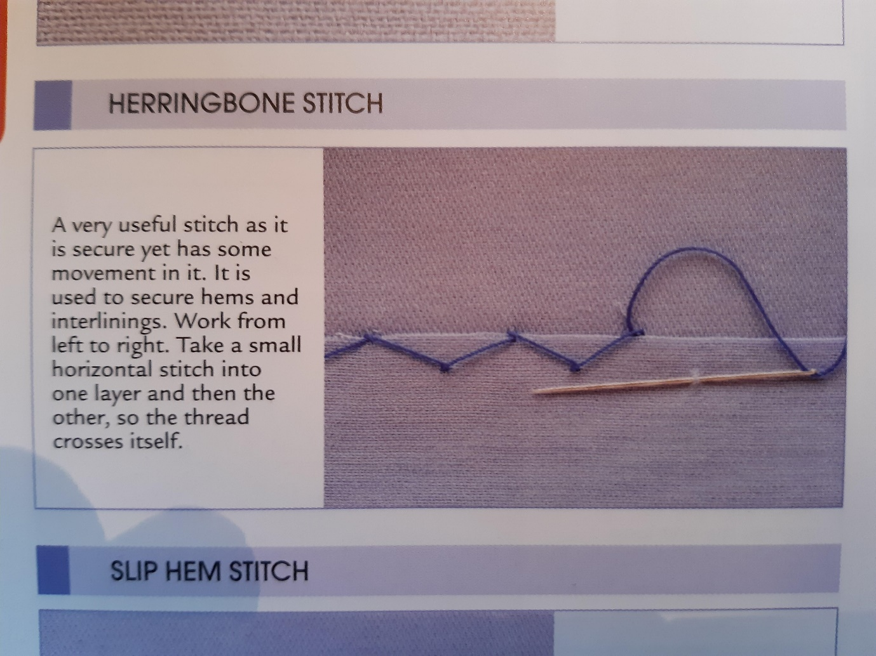

Hidden slip stitch

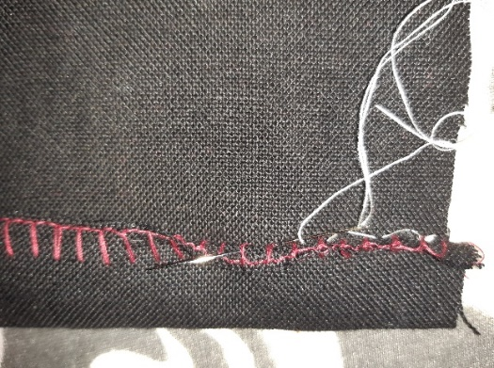Work from right to left picking up one thread from the outer fabric and a couple from the inside of the hem about 0.5 cm between stitches. This is for a finished edge.

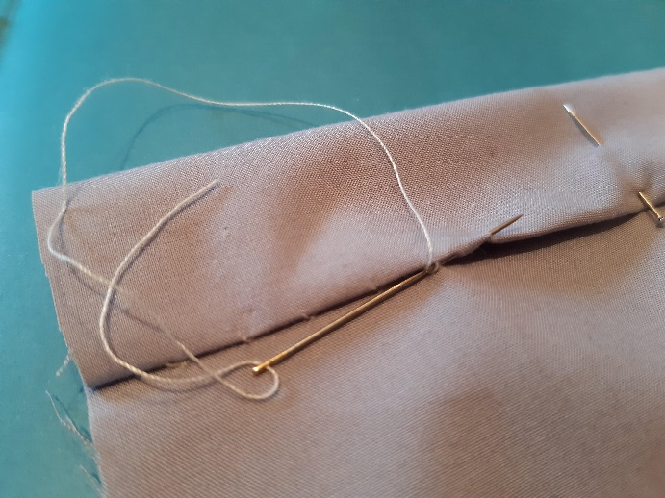 For a turned edge, pick up one thread from the outer fabric and the needle goes through the edge of the hem 0.5 – 0.75 cm. Use this to finish bindings by hand too. It’s very neat and secure.

I used contrasting threads so you can see the stitches, red = over edging, white = hemming stitches, but you can use matching threads and it will look lovely.

Herringbone stitch is also used to fix non-fusible interfacing to blocks but with much longer, loose and slightly random stitches so they don’t distort the outer fabric. Because of the cross in the stitching they give flexibility and strength but allow both the fabric and interfacing to move a little.