**Customer Complaints Case Studies**

**How would you deal positively with each of these customer complaints?**

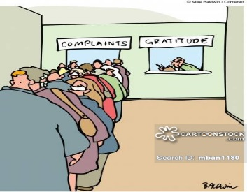

**Case Study 1.**

**Alan buys some new tools online from Amazon and receives an email to confirm his purchase and say it will be delivered on Tuesday. Alan stays in all day and by 6.00 his parcel still hasn’t arrived. He calls the customer help desk at Amazon to complain.**

**How would you handle his complaint?**



**Case Study 2.**

**Daniella needs to get a new track suit for her school sports day and her mum has given her her debit card to make the purchase. She finds a nice lime green one on sale at Sportygirl and is really pleased to get a bargain. When she gets home her mum finds out that one of the zips is broken and tells her to take it back to the shop to get her money back. Danielle says she’s lost the receipt but her mum says if it’s still got the tags on she should put it in the bag and take it back.**

**As a customer service assistant at Sportygirl how would you handle her complaint in a positive way?**

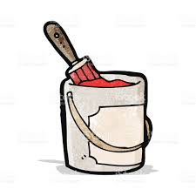

**Case Study 3**

**Mohammed needs to buy some paint to redecorate the living room at home before his parents come to stay. He goes to Paintbusters and buys 3 litres of oatmeal matt paint. When he gets to work at home he realises that the paint is not the same colour that is described on the tin. He takes the paint back to the store the next day to get a refund.**

**What would you say to him if you worked at Paintbusters in order to positively handle his request?**



**Case Study 4**

**You are a customer service assistant at Foodeez Supermarket. Saturday afternoons are always your busiest times and the queues today are longer than normal. You need to get some more change from the Supervisor who has had to go downstairs to get some. She seems to be taking a long time and the customer’s start complaining amongst themselves. Eventually one customer comes to the front of the queue and starts shouting at you that they have run out of parking time and it’s your fault they will get fined.**

**How would you handle the complaint?**

**Case Study 5 **

**You are working on reception at dental surgery and a patient comes in for an appointment. You cannot see his appointment on the system and tell him there must have been a mistake because his appointment is not today. He gets very upset and angry and says he was sent a letter saying he has an appointment today and he has had to take time off work to attend. He wants to complain to the practice manager but the practice manager is not in today.**

**How would you handle his complaint?**

**Case Study 6 **

**You are working on reception at a hair and beauty salon and a young woman comes in to say she had an appointment to have her hair and make- up done at home for a friend’s wedding at the weekend where she was a bridesmaid. She tells you she wants to complain about the service she received because the lady who came didn’t give her what she wanted and didn’t listen to what she said. The customer says your colleague rushed the make-up and didn’t do her hair the way liked and was rude to her. The customer tells you it ruined her day and she had to do her own hair and make- up again after she left. She shows you a photograph of how she looked at the end of the make-over and another picture of how she looked at the wedding.**

**How would you deal with the complaint?**