**Complaints Scenarios**



1. You are working in a doctor’s surgery on reception and the waiting room is very crowded. The appointments are running late and a young woman arrives at the desk to say she needs to get back to work because she can’t stay any longer and she wants to complain about how long she has had to wait.

What kind of complaint is this?

What would you do?

1. You are working behind the till at a supermarket and a young mum is unpacking her shopping onto the conveyor when she notices a packet of apples contains one apple which is bruised and broken.

She wants to complain. What type of complaint is this and what would you do?

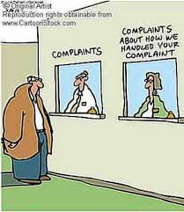

1. You are working as a housing adviser and a couple who had an appointment last week come over to the desk. They want to complain about the housing worker who interviewed them at home about their housing needs. They say the person was very dismissive and not interested in what they said, they didn’t take proper notes of the interview, didn’t listen to what they said was rude about their home.

What kind of complaint is this and what would you do?

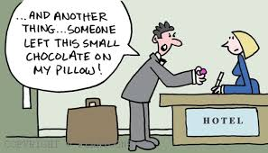

1. You are working on the customer help desk at Amazon and a customer phones to say their parcel has not arrived. He wants to complain as he stayed in all day to wait for his parcel.

What kind of complaint is this and what would you do?

1. You are working on the counter at a chemists and an older man comes in with his prescription drugs. He picked them up from you yesterday but the instructions say he should take the tablets twice a day. He says he has been on them for years and he always takes them 4 times a day. He is noticeably annoyed and says he is going to take them 4 times a day anyway and he wants to complain. You are sure you didn’t make a mistake when you checked the instructions were correct from the prescription yesterday.

What kind of complaint is this and what would you do?