Summer Couscous salad

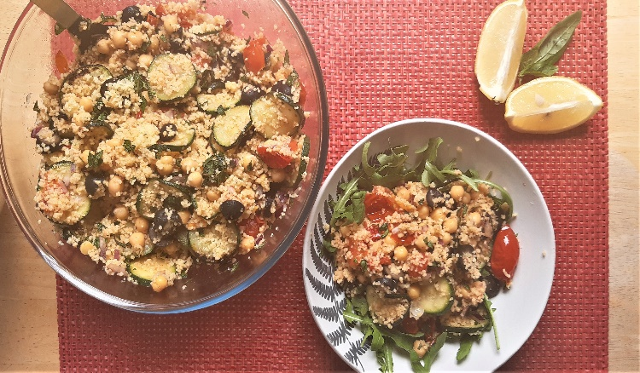

Ingredients
- 200 g couscous
- 200ml vegetable stock, boiling
- 100g pitted black olives, sliced
- 400g can chickpeas , drained and rinsed
- 1-2 tablespoon vegetable or olive oil
- 2 medium courgettes , sliced
- 300g cherry tomatoes, halved
- ½ red onion, diced
- Salt and pepper to taste

For the dressing
- 3 tablespoon olive oil olive oil
- 1 lemon, juiced
- 2 tablespoon chopped mint
- 2 tablespoon chopped basil
Method
- Put the couscous into a bowl, pour the boiling stock over and mix well with a fork. Cover with a plate and leave for 4 minutes.
- Heat 1 tablespoon oil in a large frying pan and fry the courgette slices over a high heat for 2-3 minutes until dark golden brown.
- Put corgettes on the side, and now put the tomatoes cut-side down into the pan with 1 tablespoon of oil,, and cook for another couple of minutes until golden brown on the underside.
- Fluff up the couscous with a fork, stir in the drained chickpeas, tomatoes, courgettes, diced cucumber, diced onion and olives.
- Prepare your dressing by mixing olive oil, lemon juice, 1 finely chopped garlic clove and chopped fresh herbs
- Drizzle the dressing over the couscous salad and mix well.

