To submit an assignment via ACL Gateway

- Click on the title of the assignment (Free writing – diagnostic assessment)
- Click Add submission
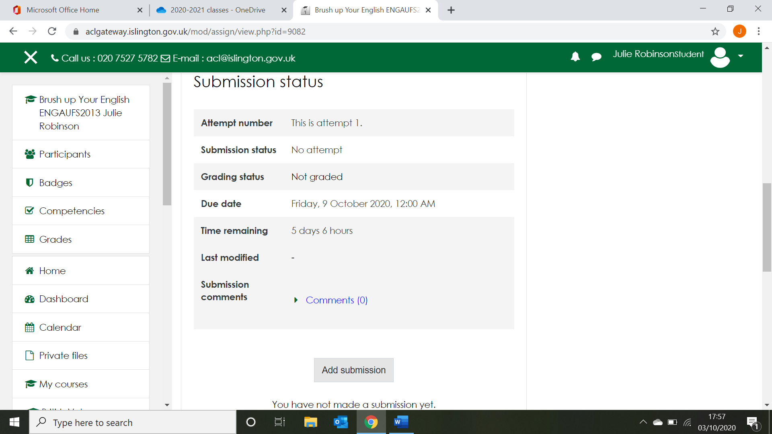

- Click on add file
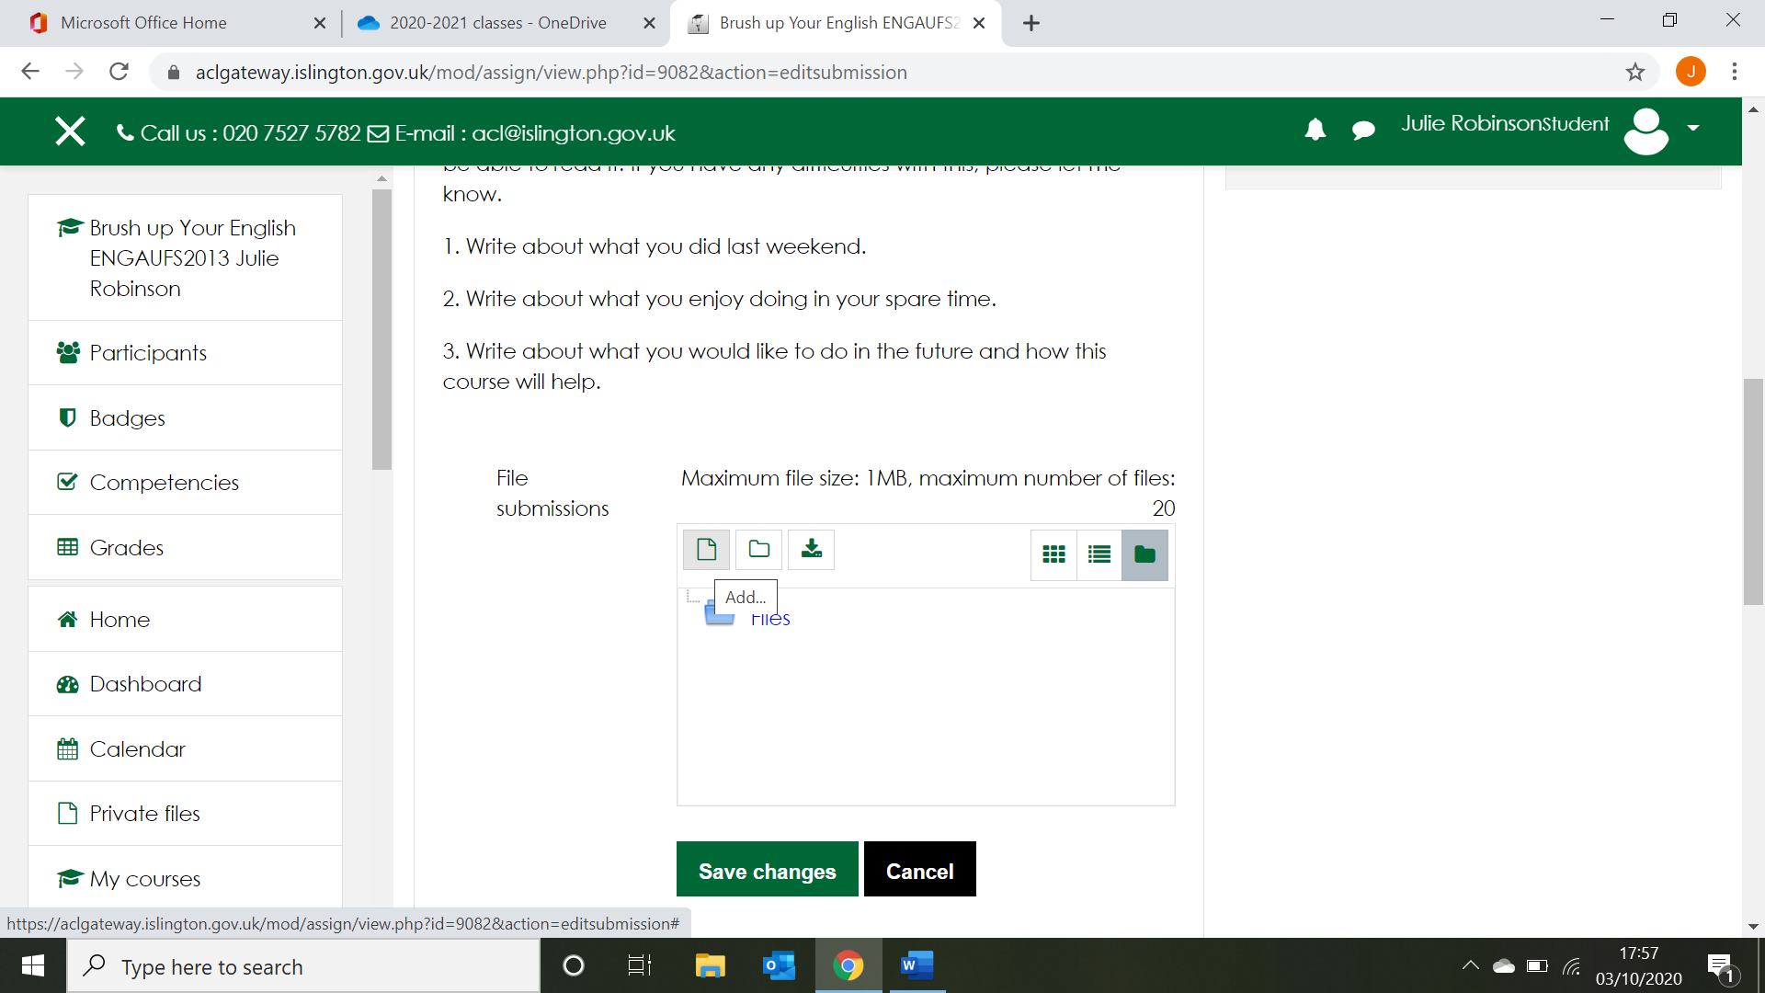

- Click choose file and choose the file from your computer
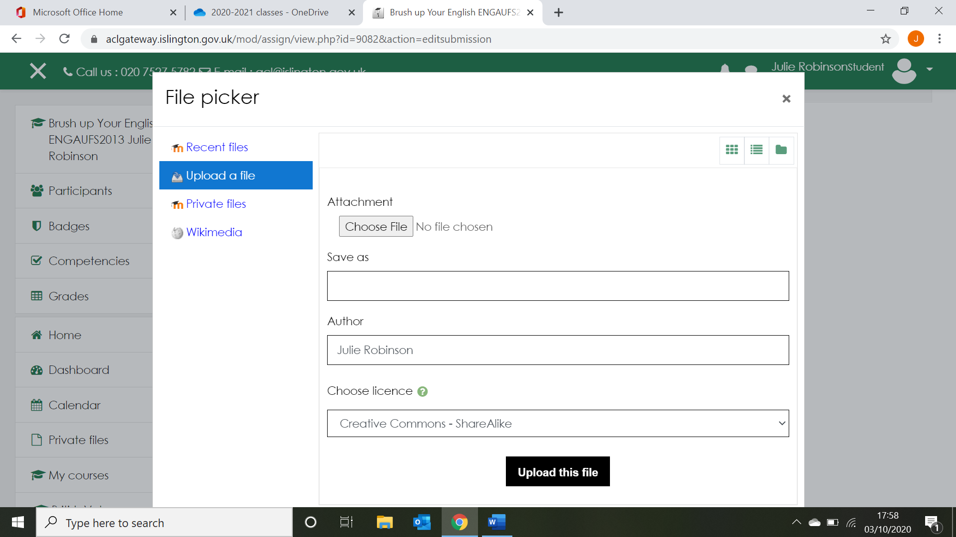

- Once you have chosen your file, click Upload this file
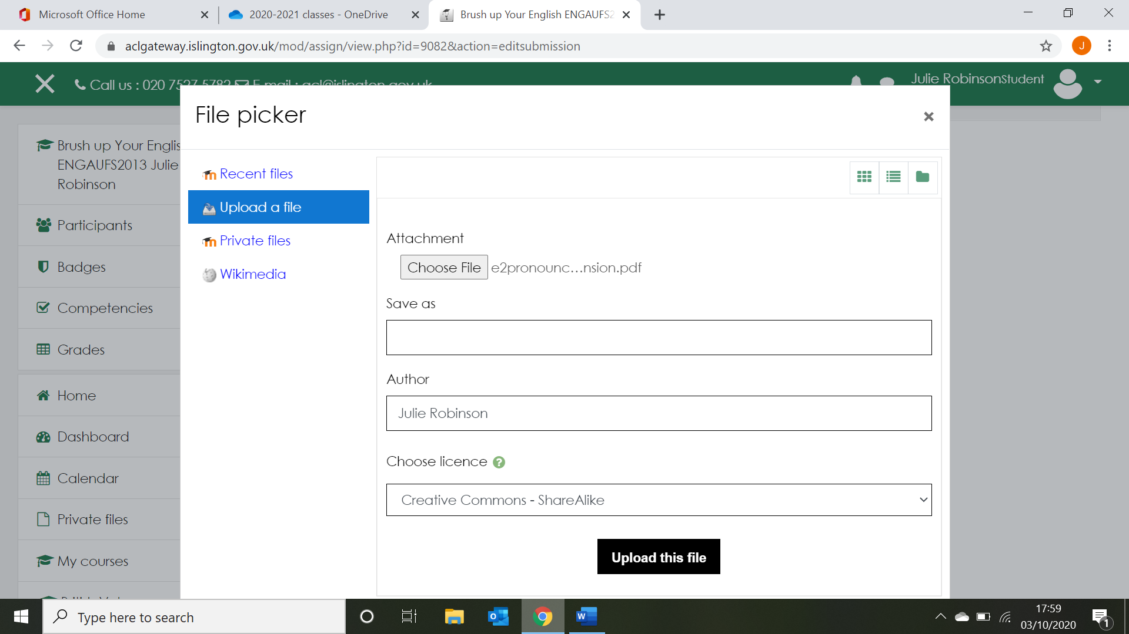

- Click Save changes
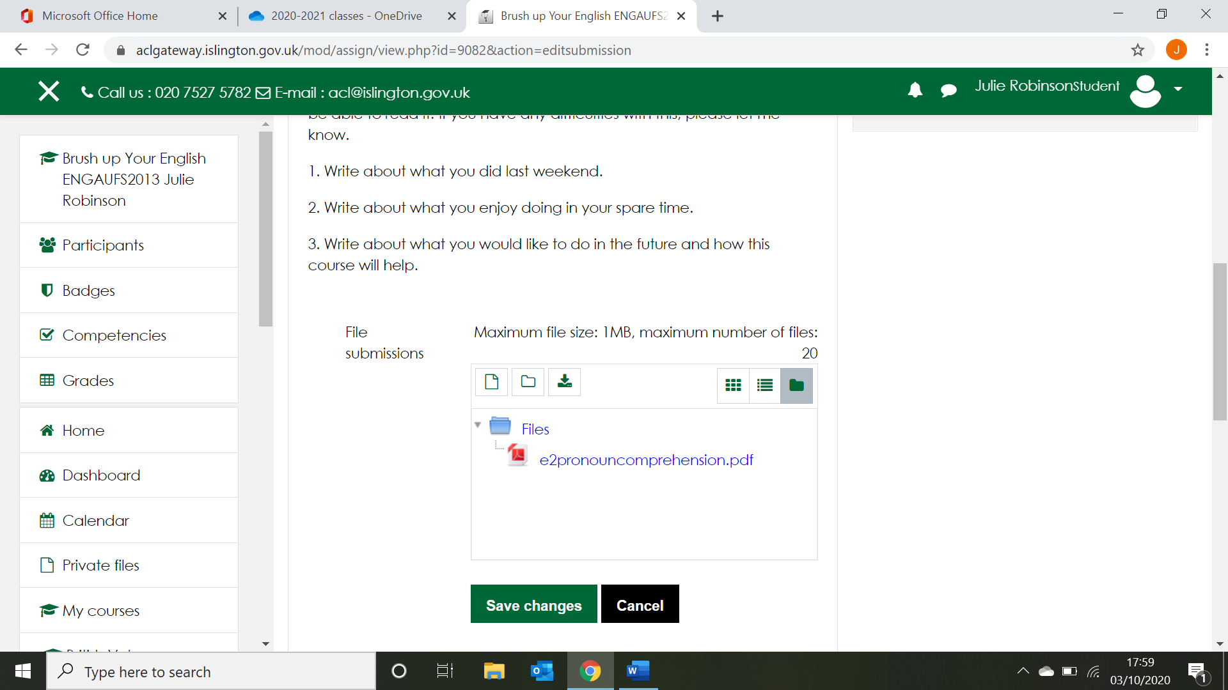

- Click Submit assignment
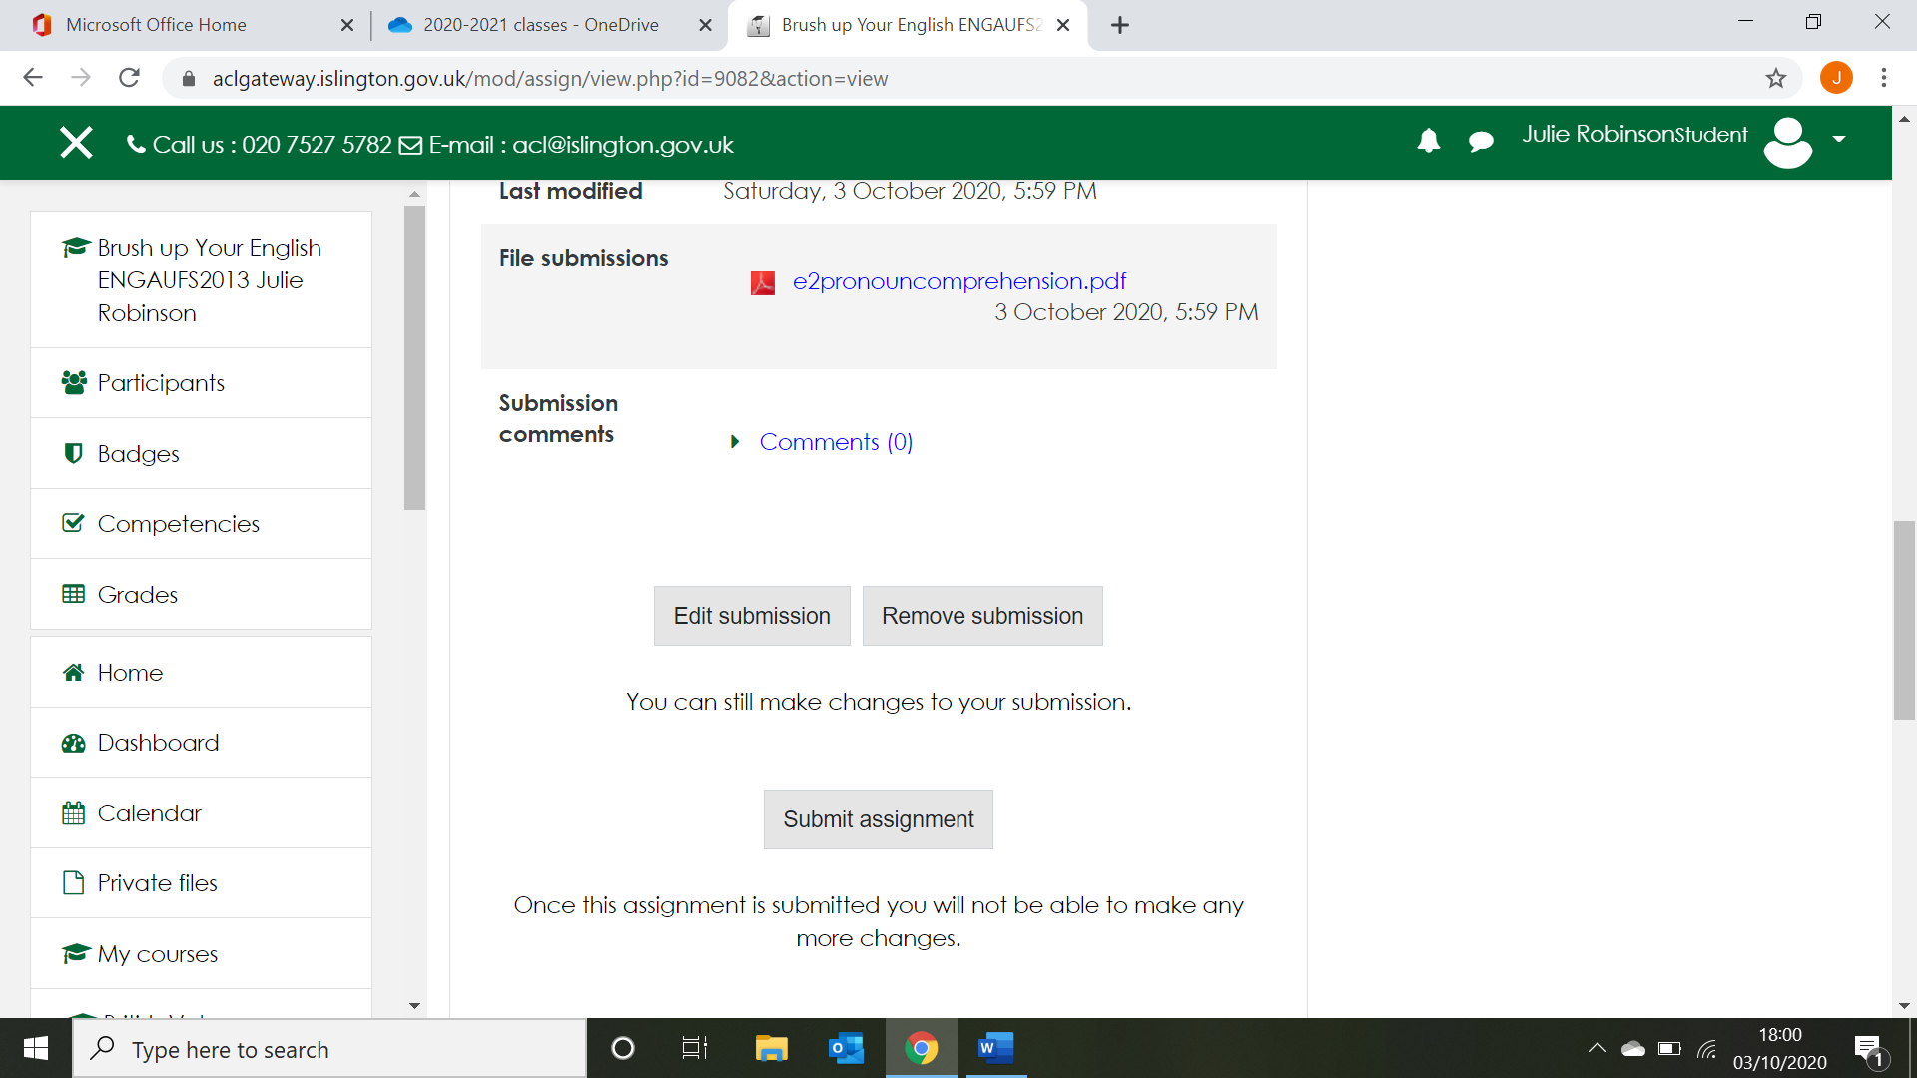

- Where it says confirm submission, tick the box which says This assignment is all my own work…, and then click Continue
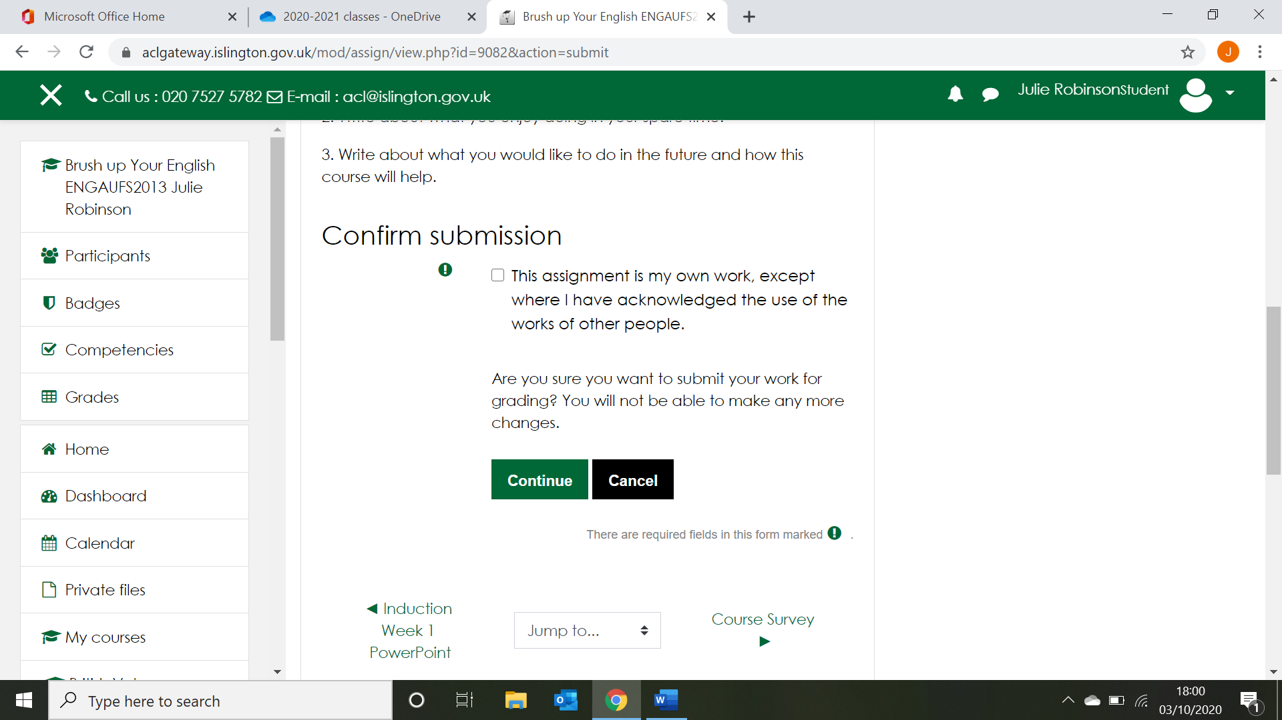

That’s it. You’ll receive an email to confirm that you have submitted your assignment.

