# Adult Community Learning

## Information Advice and Guidance Policy and Procedures

|  |  |
| --- | --- |
| Responsible person | Quality Manager |
| Date of approval | August 2014 |
| Approved by | Quality Manager |
| Doc. Ref | Doc 15 |
| Version | V-7 September 2023 |
| Review date | July 2024 |
| Updated by | Quality Manager |

# 

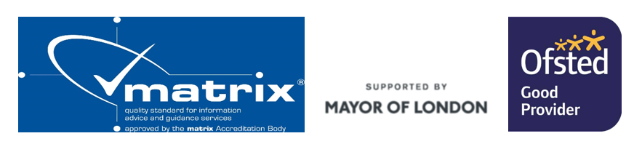

## Information Advice and Guidance Policy and Procedures

### Overview

Islington Adult Community Learning offers free Information, Advice and Guidance (IAG) services to all eligible learners who attend both non-accredited and accredited courses and during the completion of their learning programme. We are proactive in offering information and advice services at all stages of learner engagement.

### Start

* Publicity is targeted at the relevant audience and is accessible to that audience
* Telephone, online and face to face enquiries are supported to maximum effect
* At enrolment learners' complete assessments and, in discussion with tutors and staff, embark on the correct course at the right level
* Learners will be advised of what information and advice services are available prior and how to obtain it.

### During

* During induction learners are informed of the information and advice services available to them
* An Individual Learning Plan is agreed with the learner.
* If the course is not appropriate for the learner, they will be given advice regarding suitable alternative learning programmes or referred to appropriate external services
* Learners are given accurate and timely information pertaining to opportunities for them to pursue their learning plans and receive any support they require to do so.
* Discussions around progress are recorded in course material and on registers

### End

* At the completion of their course programme, learners understand progression in their learning and employment journeys.
* Course feedback relating to the learner’s experience of Information and advice services will be gathered at end of course
* ACL (Adult Community Learning) service monitors, supports and tracks learner’s progress

**Informal information and advice** is provided by staff who engage with learners, and prospective learners, at any point.

**Formal information advice** **and guidance** is provided by designated staff, offered by appointment, and 1:1 meeting.

The IAG service at Islington Adult Community Learning gives you the opportunity to have a confidential 1- 1 appointment with a qualified advisor. This is free if you are an Islington resident in receipt of benefits. Sessions can last up to an hour and are designed to help you to give you the opportunity to move forward with your employment, education, and training.

We are offering online Information Advice and Guidance sessions both online and face to face on Tuesday and Friday mornings from 9.30 – 12.30. To book an appointment please contact Alison Moore 07808 879044 or email [Alison.Moore@islington.gov.uk](mailto:Alison.Moore@islington.gov.uk)

### Guidance on roles and responsibilities:

* ACL has a duty of care, to all its learners and we always act in their best interest. ACL will also encourage individual ownership of the IAG process and provides a service that is learner centred.
* Tutors are responsible for speaking to learners about IAG and progression offered by the ACL service during course induction at the start of courses, such as, what other courses are available, IAG appointments with advisors, and referring to iWork staff for employment support.
* Tutors are responsible for having progression discussions with each learner at the end of courses – this can be done as a group activity and/or 1:1 during end of course reviews and must be factored/embedded into Scheme of Work and lesson plans. The tutor must complete an intended progression outcome or an actual progression outcome on the register.
* Learning Hub Officer, Team Leaders, Curriculum manager and management staff are responsible for ensuring that tutors are supported with carrying out the above as part of on-going support with delivery and/or as part of line management/1:1 supervision
* Tutors must keep learning hub officers, external venue staff and curriculum staff up to date re the visits that have been arranged for their classes and the impact must be evaluated as part of their Tutor End of Course Feedback form
* Curriculum Staff are responsible for ensuring that the monitoring and accountability of IAG and progression is included as part of curriculum reviews and end of year Self-Assessment Review process and is discussed with management on a termly basis or as and when necessary.

**Accessible and Visible** – Adult Community Learning services should be recognised and trusted by learners, have convenient entry points from which clients may be signposted or referred to the services they need, and be open at times and in places which suit learners’ needs.

**Professional and Knowledgeable** – Adult Community learning staff have the skills and knowledge to identify quickly and effectively the learner’s needs. They have the skills and knowledge either to address the learner’s needs or to signpost or to refer them to suitable alternative provision. All information given to learners up to date and current.

**Effective Connections** – Links between services and partners should be clear from the learner’s perspective. Where necessary, clients should be supported in their transition between services.

**Availability, Quality and Delivery** – The Adult Community Learning provision is targeted at the needs of learners, and informed by social and economic priorities at local, regional, and national levels.

**Diversity** – Adult Community Learning services reflects the diversity of learners’ needs.

**Impartial** – Adult Community Learning service supports learners to make informed decisions about learning and work based on their needs and circumstances.

**Responsive** – Adult Community Learning Service responds to learners’ present needs.

**Friendly and Welcoming** – Adult Community Learning service encourages clients to engage successfully with the service and supports them to evaluate and feedback on the service

**Enabling** – Adult Community Learning service encourages and supports residents to become lifelong learners by enabling them to access and use information to plan their careers, supporting them to explore the implications for both learning and work in their future career plans.

**Awareness** – At induction, all learners are made aware of Information Advice and Guidance services that is available to them and how this can be accessed. In line with GDPR (General Data Protection Requirements) regulation data is shared with the learner's consent.