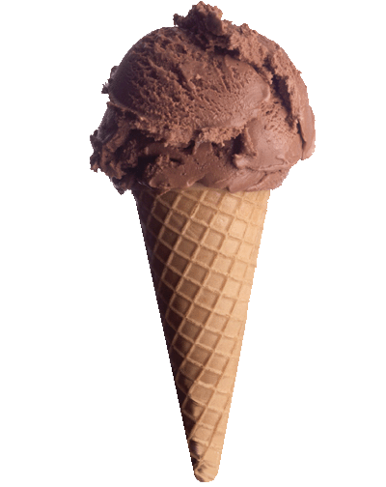

1. Come up with as descriptive words as you can for this item.

cold delicious icy

creamy welcome tooth-tingling

chocolate smooth refreshing

1. Write some similes using your descriptive words

An ice cream is

as cold as the Arctic

as creamy as milk

as welcome as a cool breeze on a hot day

1. Try and write some metaphors

An ice-cream is an Arctic treat. A creamy refresher on a hot day.

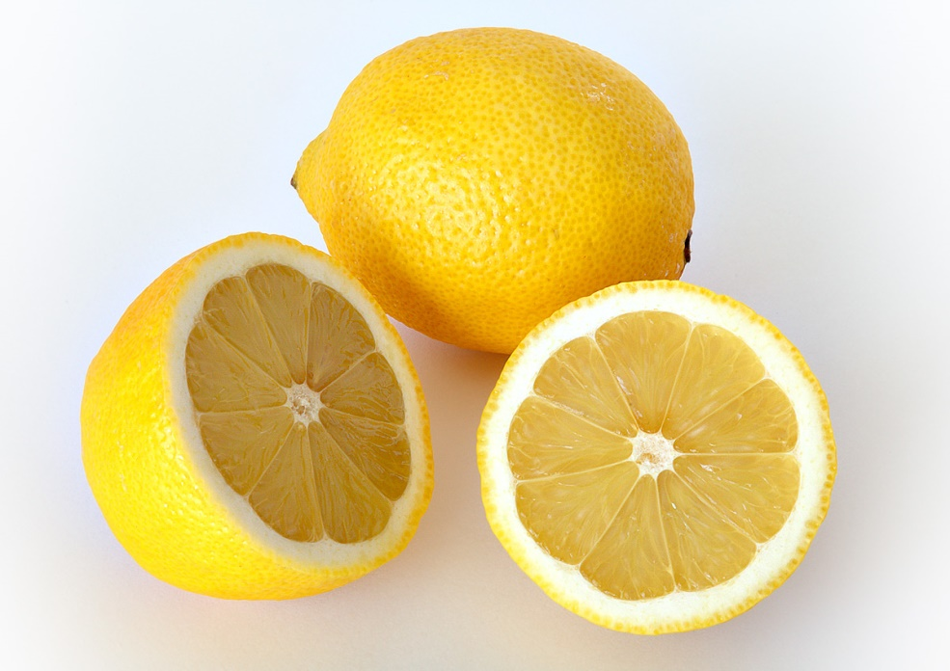

1. Come up with as descriptive words as you can for this item.
2. Write some similes using your descriptive words

A lemon is

as ______________ as ______________

as ______________ as ______________

as ______________ as ______________

as ______________ as ______________

as ______________ as ______________

1. Try and write some metaphors

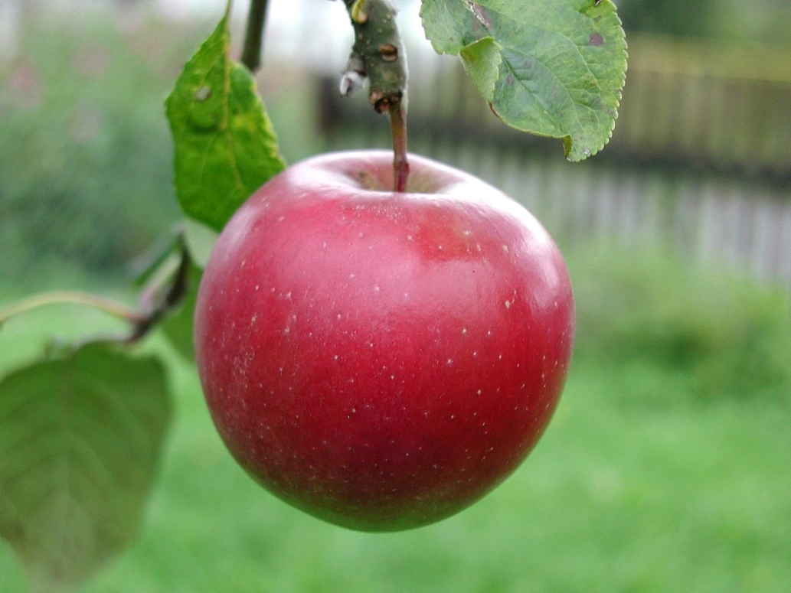

1. Come up with as descriptive words as you can for this item.
2. Write some similes using your descriptive words

An apple is

as ______________ as ______________

as ______________ as ______________

as ______________ as ______________

as ______________ as ______________

as ______________ as ______________

1. Try and write some metaphors

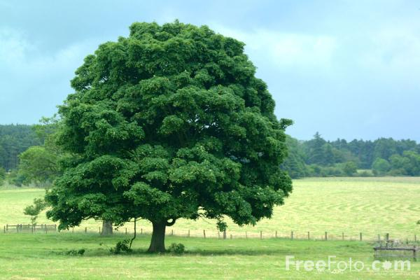

1. Come up with as descriptive words as you can for this item.
2. Write some similes using your descriptive words

A tree is

as ______________ as ______________

as ______________ as ______________

as ______________ as ______________

as ______________ as ______________

as ______________ as ______________

1. Try and write some metaphors

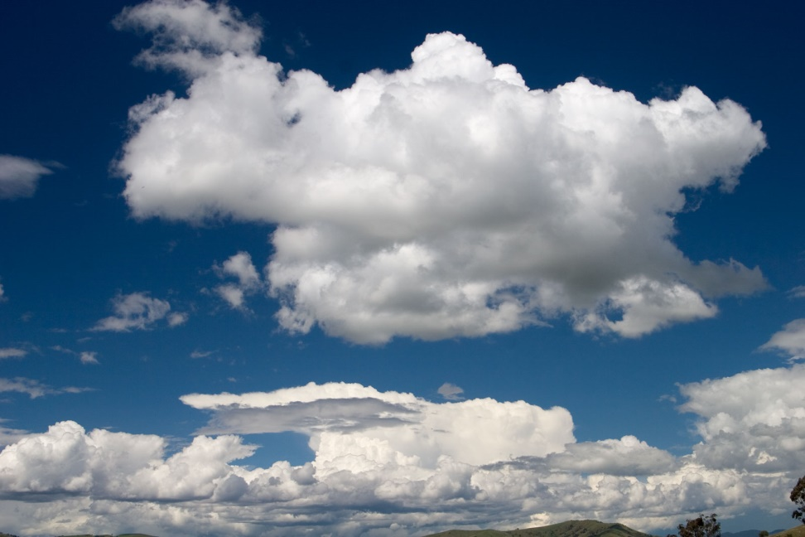

1. Come up with as descriptive words as you can for this item.
2. Write some similes using your descriptive words

A cloud is

as ______________ as ______________

as ______________ as ______________

as ______________ as ______________

as ______________ as ______________

as ______________ as ______________

1. Try and write some metaphors