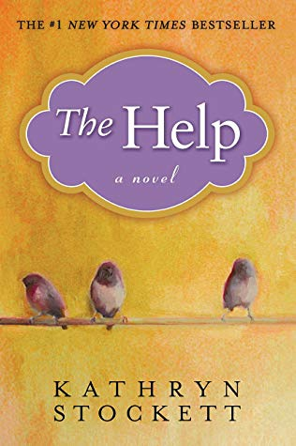

**The Help**

by

[Kathryn Stockett](https://www.goodreads.com/author/show/1943477.Kathryn_Stockett) (Goodreads Author)

 4.47  ·  [Rating details](https://www.goodreads.com/book/show/4667024-the-help) ·  [2,027,737 ratings](https://www.goodreads.com/book/show/4667024-the-help#other_reviews) ·  [83,206 reviews](https://www.goodreads.com/book/show/4667024-the-help#other_reviews)

This is an amazing and moving novel. So much so that tasks, appointments, and everything else in my life were put on hold while I read, laughed, cried, celebrated, hurt, and felt healed. Some friends once told me about a spiritual teacher who would often say, “There is magic in the telling”. The truth in those words vibrates throughout this brilliantly conceived and executed novel.  
  
The author herself talks about the risk of a white woman telling the stories of black women living in an era of slow transition between overt, undisguised racism and a more covert and secretive racism. Yet, many white people of that time did not recognize racism for what it was: the structure of society was simply their everyday life. As long as the black people needed the jobs offered by white society, they would be subject to obeying every command, swallowing frustration, anger, and their own pride – and usually for much less than minimum wage. The consequences of not swallowing were just too dangerous.  
  
This novel, a book about writing a book about the domestic service of black women in early 1960’s Mississippi is a finely balanced, on-the-edge story – like a tightrope walker dozens of feet above Niagara Falls. One slip, one false step, and the entire premise would collapse into the water.  
  
Instead, there is a rare and precious authenticity to these stories that are thematically pulled together by Skeeter - the white woman determined to write the book, and Aibileen – the black domestic worker employed by one of Skeeter’s friends. And then there is Minny. Rebellious, full of anger, intelligent, wise, and good - how she was able to cope with a home life filled with conflict and carry on working fulltime besides is beyond me.  
  
My admiration for so many of these characters started small and continued to build throughout the novel. Their lives, their experiences, their authenticity and humanity touched my soul. I will always be grateful to this beautifully crafted novel for opening my eyes and my heart to a larger perspective.