**[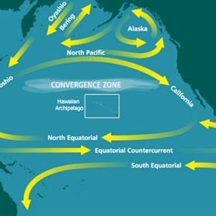](https://readtheory.org/reading/welcomeReader?)The Great Pacific Garbage Patch**

|  |  |
| --- | --- |
| 1  2  3  4  5  6  7  8  9  10  11 | What happens to a plastic bottle after you put it in the rubbish bin? In all likelihood, you forget that it exists. Instead of conveniently disappearing, however, this bottle most likely ends up in the ocean.  The Great Pacific Garbage Patch (GPGP) is a massive collection of plastic, chemicals, and other pieces of rubbish floating in the Pacific Ocean between Japan and California. Similar garbage patches also exist in the Indian Ocean and the North Atlantic. Scientists believe that the GPGP formed gradually. Over time, ocean currents flowing from Japan and western North America, combined with wind-driven surface currents, gathered together scattered pieces of garbage from regions throughout the North Pacific. |