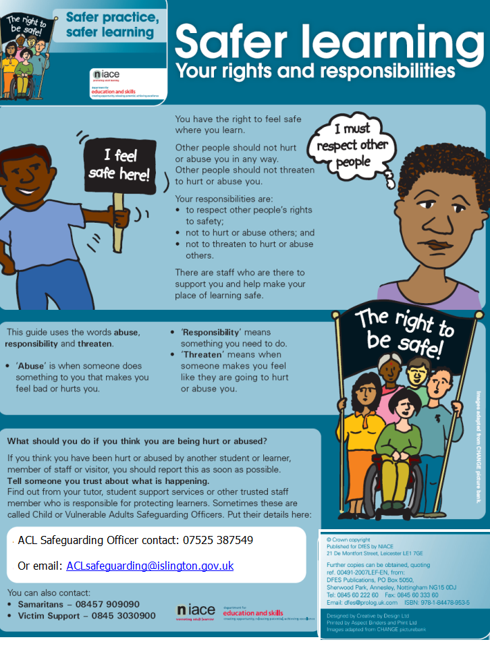

ACL Safeguarding Officer contact:
ACLsafeguarding@islington.gov.uk
07892 700 217 or 07971 599 383



