Accessing your BKSB account
Go onto the internet and in the address bar write the following address exactly as shown.
https://islingtonacl.bksblive2.co.uk
Type the address here.

Then hit the return key or your mouse.
You should arrive at this screen
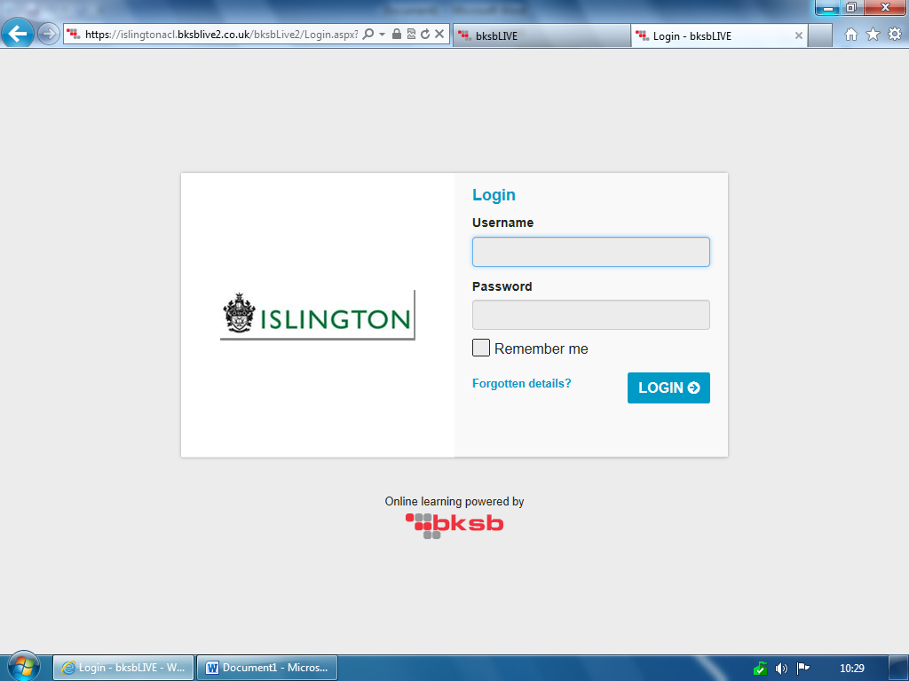

Your username and password will be given to you. Write them down so you do not forget them. You need to make sure you have written down any capital letters or spaces.
Write them in here so you have them for next time

Once you click on the you will arrive at the first screen which shows courses you have been enrolled in. It is called your learning dashboard.
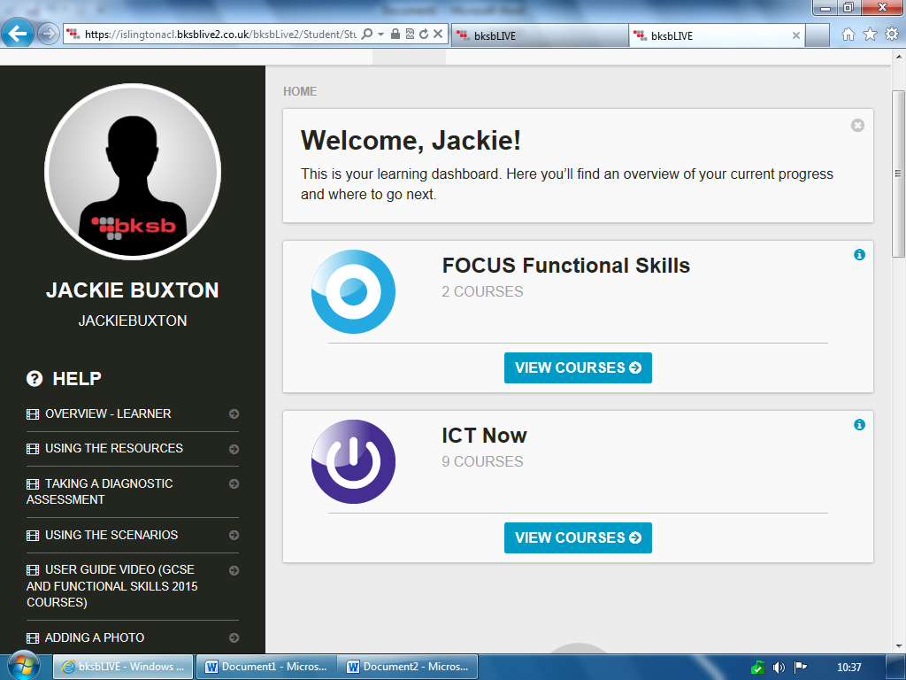
Look for the course you are studying and click on

When you are starting your studies you will be asked to do an initial assessment so that we can find the right level for you to study at.
Once you have completed this, you will be asked to do an assessment at that level. This is called a diagnostic.
To do these assessments you need to use the button

Once you have completed your diagnostic assessment you can start your learning modules.
When you log in you can use the instructions to get to your course. Once you have completed the diagnostic you are ready for the modules.
In the example shown this learner has done 23% of their modules for Maths and needs to do their diagnostic assessment for English.
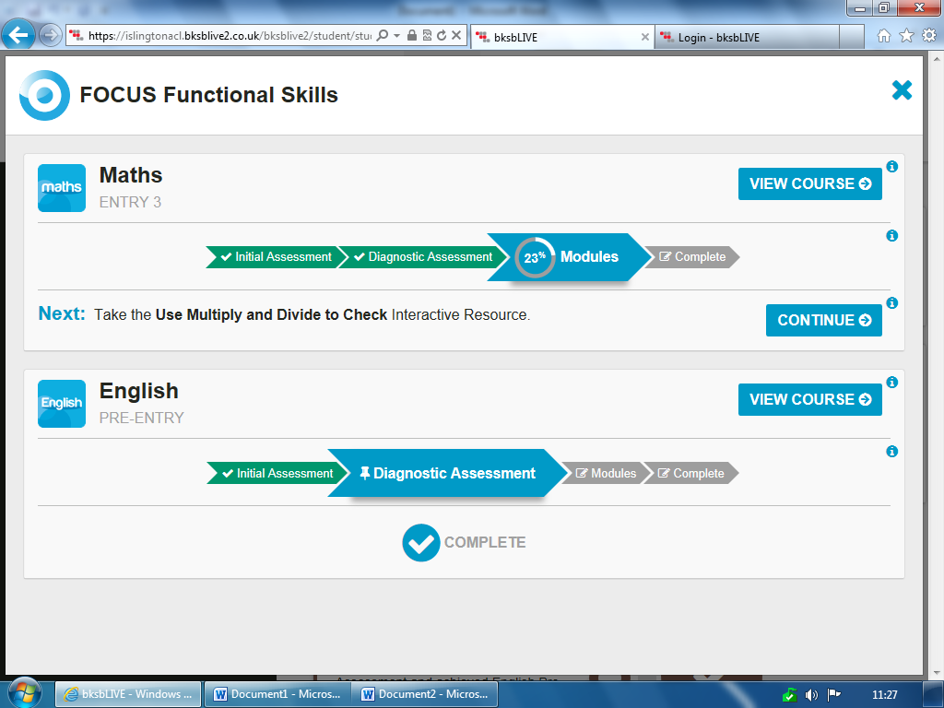

If you are working on your modules DO NOT use the continue button but use

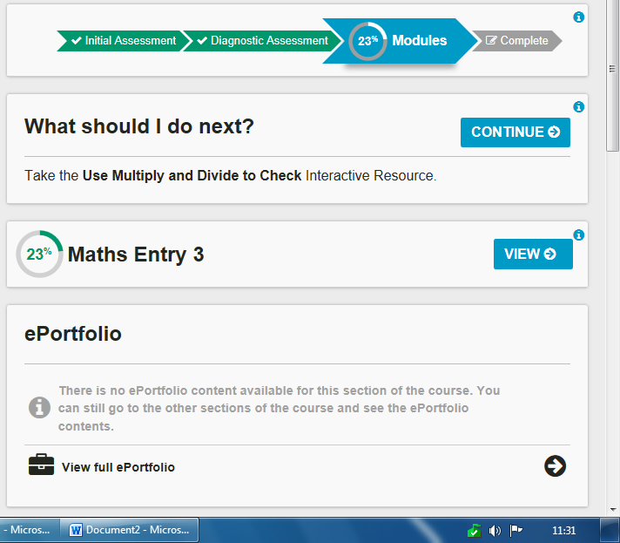
Use the VIEW button rather than CONTINUE so you can see the modules and chose the one you want to work on.

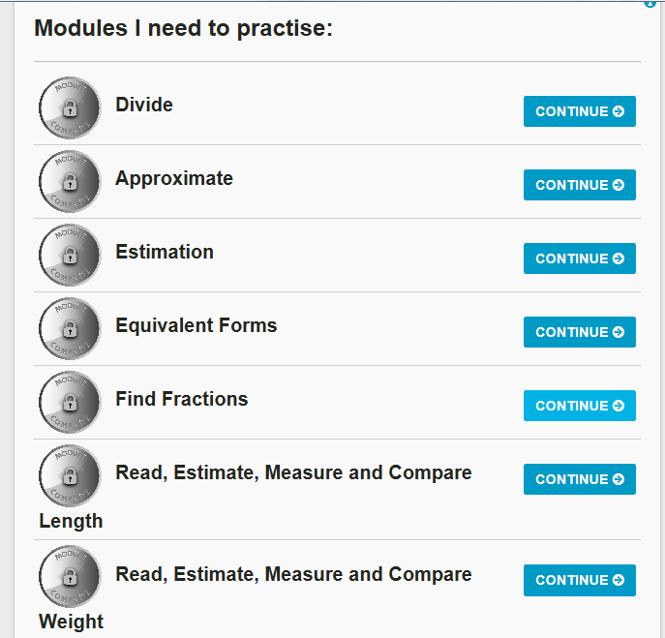
On this page if you scroll down you will see all the modules you need to practise and you can chose the one that you want to work on.
If you get more than 75% you will pass the module and it will turn to gold.

