**Healthy Eating needs from 6months old**

**Starting solid foods- Babies**

1. 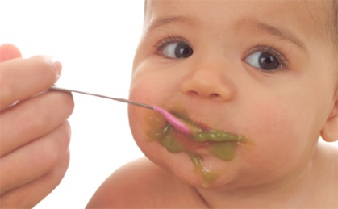When the baby is around six months old, they need to start having solid foods as well as milk feeds.  
     
   Learning to eat solid foods is a gradual process – at first the aim is simply to get baby used to the feel of food in their mouth.
2. There is no need to rush. At the start, the baby will still be getting most of their nourishment from breast or formula milk, and will be breastfed and/or bottle-feeding much the same as before

**Here are some first foods:**

* 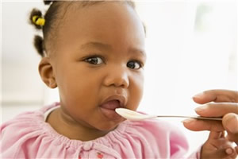mashed or puréed cooked vegetables such as potato, sweet potato or yam, mixed together with parsnip, carrot, broccoli or cauliflower
* mashed ripe fruit such as banana, avocado, cooked apple, pear or mango
* baby rice or well cooked and mashed white rice, oats or other starchy foods such as maize, millet, cornmeal or noodles

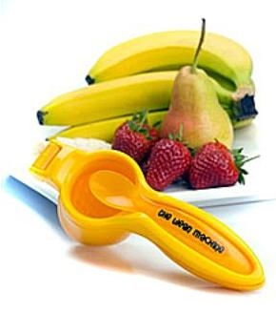

* blended or puréed meat, fish or chicken – well cooked and prepared without salt. Remember to make sure you remove any bones.
* soft cooked and puréed or well mashed lentils (dhal), split peas, chickpeas or other pulses
* 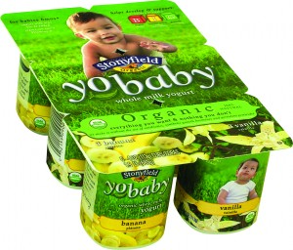full-fat milk products such as yoghurt, fromage frais or custard (choose lower-sugar varieties)

**Children 1- 2years**

1. At this age, children grow very quickly and are usually very active, so they need plenty of calories and nutrients.
2. A healthy and varied diet should provide all the nutrients a toddler needs.

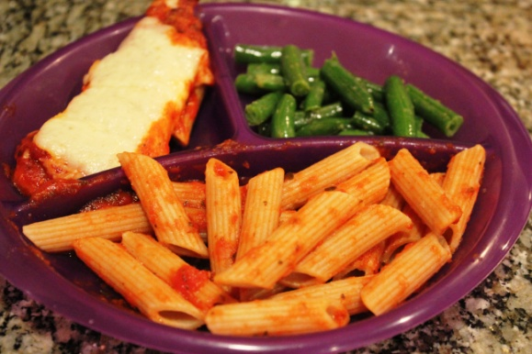  
  
**Include these sorts of foods every day:**

* Milk and dairy foods – these provide protein, vitamins and minerals and are a good source of calories for growing children.
* Meat, fish, eggs, beans, peas and lentils – these are rich in nutrients such as protein, vitamins and minerals. You can give boys up to four portions of oily fish a week, such as mackerel, salmon and sardines, but it's best to give girls no more than two portions of oily fish a week.
* Bread, and other cereals such as rice, pasta and breakfast cereals, and potatoes, yams and sweet potatoes – these starchy foods provide calories, vitamins, minerals and fibre.

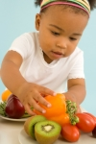

* Fruit and vegetables – these contain vitamin C, and other protective vitamins and minerals, as well as fibre.

**How a toddler's diet is different**

Although toddlers can eat the same food as adults, before they're two years old children can't eat large amounts of food at one sitting. So, until then, they should have meals and snacks packed with calories and nutrients (nutrient dense foods) such as:

* 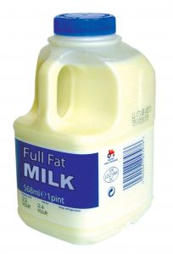full-fat milk and dairy foods
* meat
* eggs

Don't forget to give them fruit and vegetables and starchy foods as well.  
But if you tend to eat high fibre foods, remember that young children's stomachs can't cope with foods such as wholemeal pasta and brown rice. Also, too much fibre can sometimes reduce the amount of minerals they can absorb, such as calcium and iron.

**Healthy Eating needs from 3 - 5 years old**

**The growing child**  
When a child first starts school, he or she will suddenly start growing fast and becoming more active. Children's energy and nutrient needs are high in relation to their body size compared to adults

**What to give**

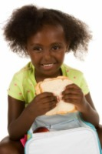  
Children need a healthy, balanced diet, which is rich in fruit, vegetables and starchy foods.   
  
Encourage your child to choose a variety of foods to help ensure that they obtain the wide range of nutrients they need to stay healthy.   
  
**Include these sorts of foods:**

* Milk, cheese, yoghurt, soya beans, tofu and nuts are rich in calcium, which is needed for healthy bones and teeth.

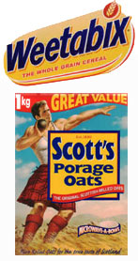

* Fortified breakfast cereals, margarine and oily fish are good sources of dietary vitamin D, which helps ensure a good supply of calcium in the blood and therefore healthy bones.

The main source of vitamin D is from the action of sunlight on skin, but avoid strong sun especially around midday when there is a risk of burning.

* Meat, particularly red meat and fish are rich sources of iron. Pulses (beans and lentils), green vegetables and fortified breakfast cereals are also good sources of iron.

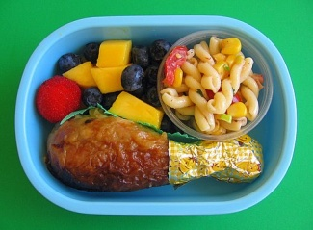Iron is needed for healthy blood and research has shown that some children have low intakes of iron, particularly older girls.

* At least two portions of fish a week because fish are a good source of protein, vitamins and minerals and they are low in saturated fat. Oily fish, such as mackerel, salmon and sardines, also contain omega 3 fatty acids.

You can give boys up to four portions of oily fish a week, but it's best to give girls no more than two portions of oily fish a week.

* Citrus fruit (such as oranges and lemons), tomatoes and potatoes, are all good sources of vitamin C which is essential for health.

Vitamin C may help the absorption of iron, so having fruit juice with an iron-rich meal could increase iron absorption.

* Milk, margarine with added vitamins, green vegetables and carrots are all good sources of vitamin A which is important for good vision and healthy skin.

**Drinks**

Cartons of fruit juice are extremely convenient, but like dried fruit, are high in sugar and should be eaten at mealtimes.   
  
Sweet drinks also damage the teeth, especially if drunk frequently or sipped from a bottle over long periods between meals.  
  
So, keep drinks such as fruit juices or squashes to mealtimes, and try to encourage your child to drink water or milk in between.

**Foods to limit**

**Sweets and snacks**

Eating sweet and sticky foods frequently between meals causes dental decay. Snack foods such as cakes, biscuits, chocolate and sweets can be high in sugar and saturated fat, and low in certain vitamins and minerals.

* help and encourage your child to clean their teeth every day
* try picking a weekly sweet day, or choose the weekends as a time when your child is allowed to eat sweets
* Check the label and choose those options lower in fat, saturated fat, sugars and salt