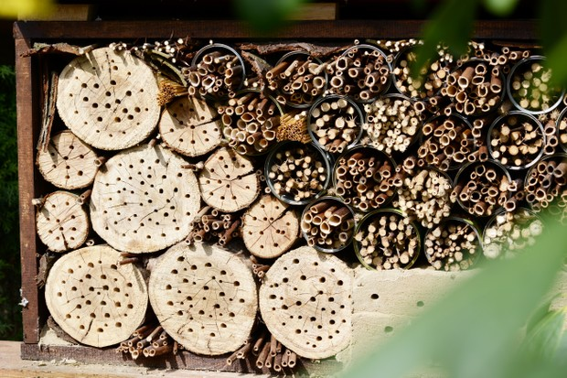
How to make a bee house
Making your own bee house is a fun way of enticing these essential insects into your garden. Our easy step-by-step guide on how to make a bee house and become your own

By Eve Betts
Published: May 7th, 2019 at 2:49 pm
Bee houses are fun and easy to make. Your bee house will be ideal for solitary bees, of which there are over 220 wild species in the UK. These solitary insects do not belong to hives like honey bees, but make their own individual nests for their larvae.

You Will Need
- A wooden box or empty plastic bottle
- A drill
- Bamboo sticks
- Secateurs, saw and screws
- A hook

Step 1
Take a wooden box and remove one side, or alternatively cut the top off a large plastic bottle. An old bit of piping would also be ideal. This will become the container for your bamboo shoots.

Step 2
Cut the bamboo sticks to the same length as the depth of your container. Using different widths of bamboo is ideal, as bees can then choose between the sizes. Alternatively, you can drill deep holes 2-10mm wide into the blocks of wood that fit into your container. Make sure the holes are clean and splinter-free, as bees won’t use untidy holes.

Step 3
Pack the bamboo sticks or blocks of wood tightly into the box, plastic bottle or pipe.

Step 4
Attach a hook to the back of your bee house. Hang or place in full sun, facing the south or south east. Your bee house must be at least a metre off the ground and free from surrounding foliage.
Now simply watch and wait! Make sure your bee house stays dry and consider moving it during the winter months to protect any nesting bees.

