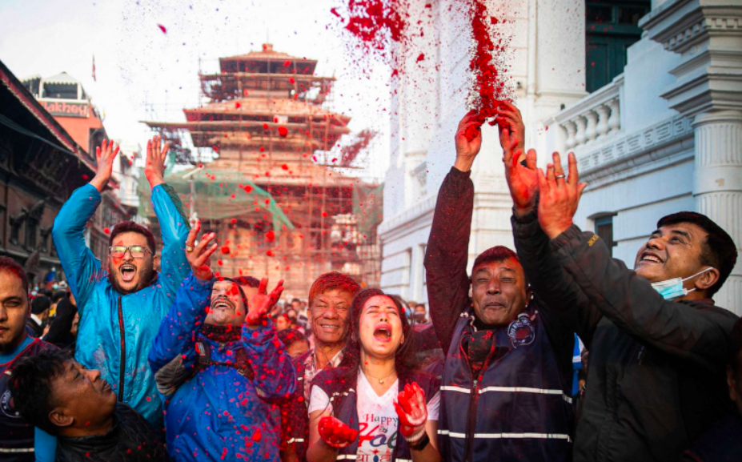

People throw vermilion powder to mark the beginning of Holi festival in Kathmandu, Nepal, March 10, 2022. The Holi festival also known as the Festival of Colors, marks the beginning of spring and is celebrated with great enthusiasm all over Nepal.

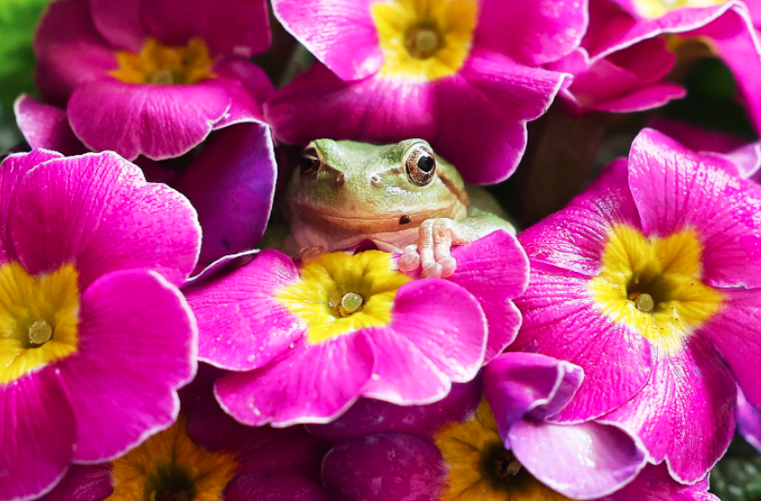

A green frog sits on a moth orchid at a local agricultural research center in Hwaseong south of Seoul, South Korea, March 3, 2022, two days ahead of 'gyeongchip'. On the lunar calendar, gyeongchip is the day when frogs awake from hibernation

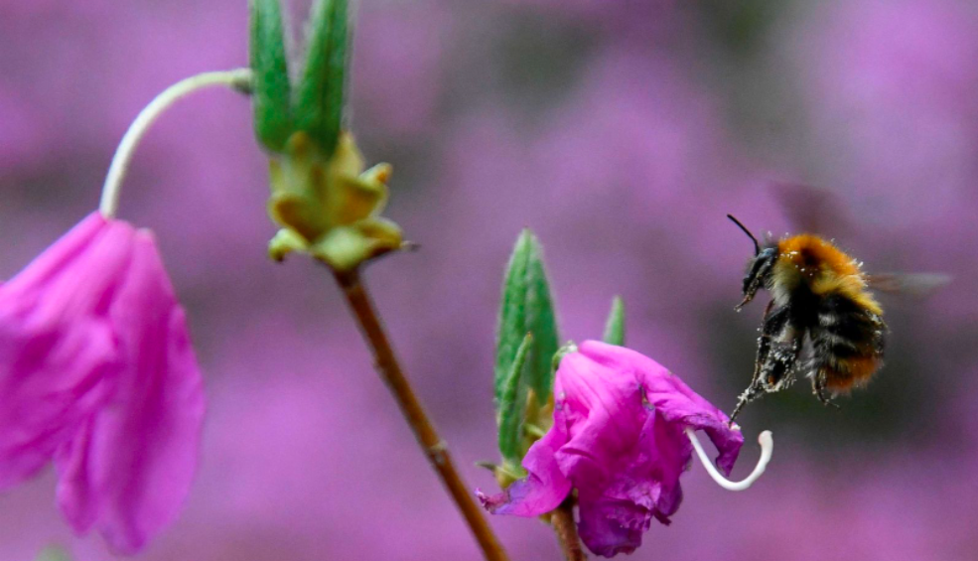

As snow melts, and the world blossoms, spring arrives. Rains bring rebirth and colorful flowers as wildlife returns to the budding trees and fresh fields.  
A bee collects pollen from spring blooms in Richmond Park, London, April 22, 2022.

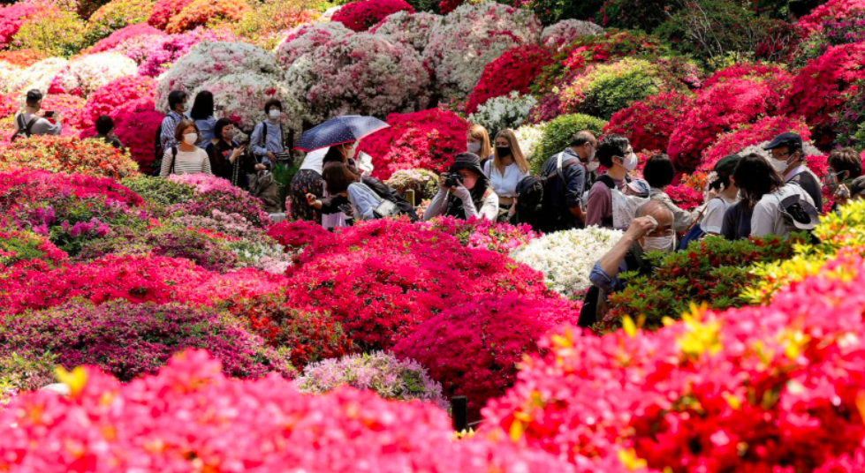

Azaleas in full bloom attract visitors at Nezu Shrine Azaleas Garden in Tokyo, April 22, 2022.

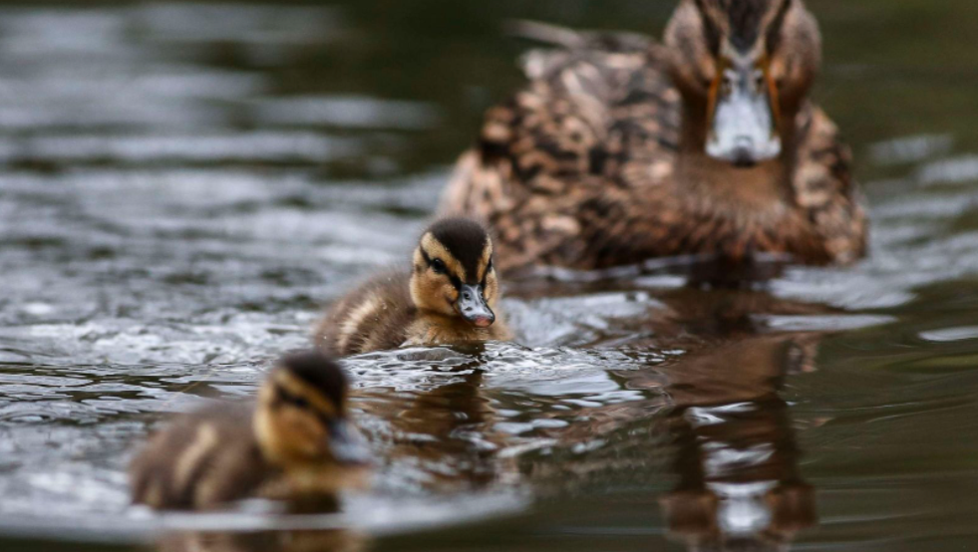

A family of ducks swim across Mag Brook in Holmfirth, England, April 8, 2022.

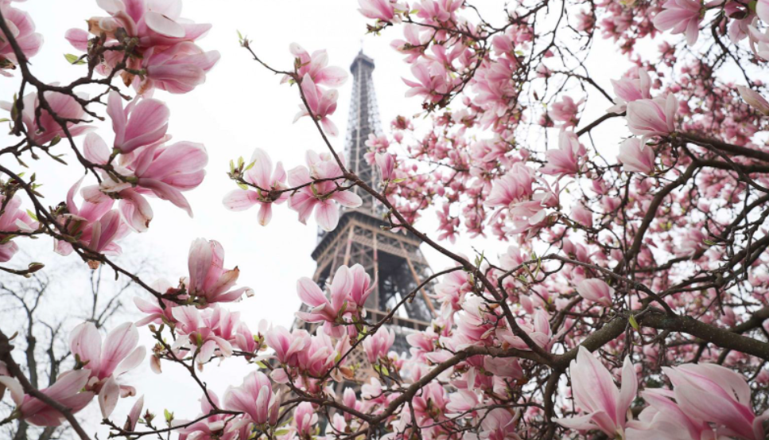

Magnolia blossoms are seen at the Champ de Mars near the Eiffel Tower in Paris, March 16, 2022.