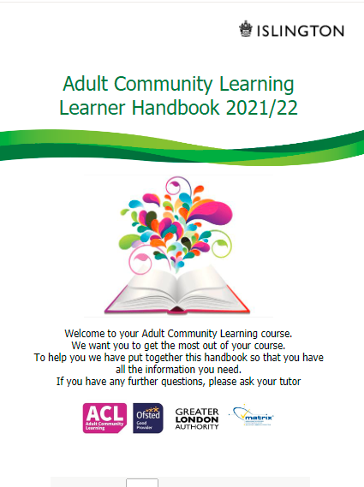Read through the Adult Community Learning Handbook and answer the questions below:

1. What is a VLE?

_____________________________________

2. On what page are the learning rules?​

_____________________________________

3. What can an IAG advisor and Islington iWork help you with (page 7) ?​

_____________________________________

_____________________________________

4. Who has to follow the Dignity for All policy (page 9) ?​

______________________________________

______________________________________

5. What does the Learning and Behaviour agreement explain?​

______________________________________________________________________________________________________________________________________

6. What are the 5 Adult Community Learning values?​

______________________________________________________________________________________________________________________________________

7. Who can you speak to if you are experiencing abuse of any kind?​

______________________________________________________________________________________________________________________________________