Date: **Somewhere I would like to visit in the UK**

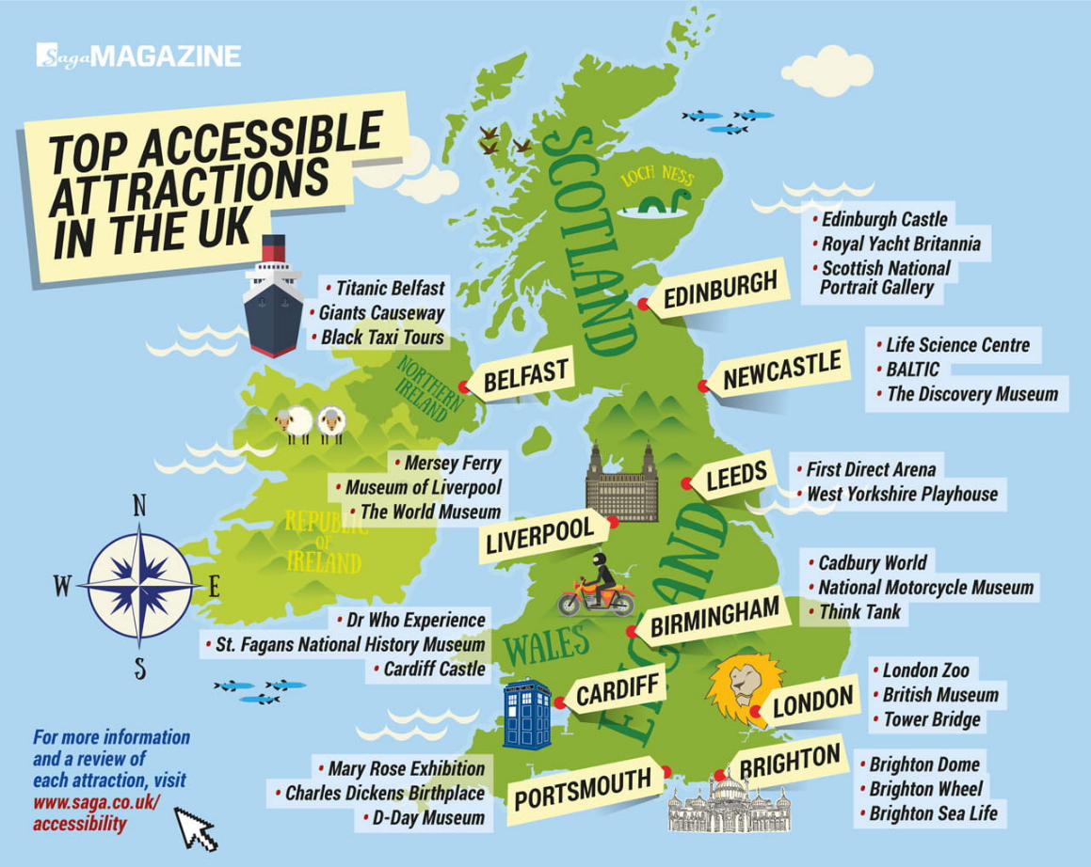

Name of place: _____________________________________________________________

Where in the UK is it? ________________________________________________________

___________________________________________________________________________

How far is it from London?

___________________________________________________________________________

What’s the quickest way to get there?

___________________________________________________________________________

___________________________________________________________________________

What is it famous for?

___________________________________________________________________________

___________________________________________________________________________