Read about the different places in England. Rank them in the order you would like to visit (1-3).

Sherwood Forest is in Nottingham, and covers 100,000 acres. It is where the outlaw Robin Hood is said to have lived in the 1200s. There is no evidence that Robin Hood really existed but he is one of the most famous British legends.
Today Sherwood Forest has an excellent visitors’ centre with an attractive display and shop, in which, according to tradition, Robin Hood and Lady Marion were married. It is one of the visitors favourite sites.

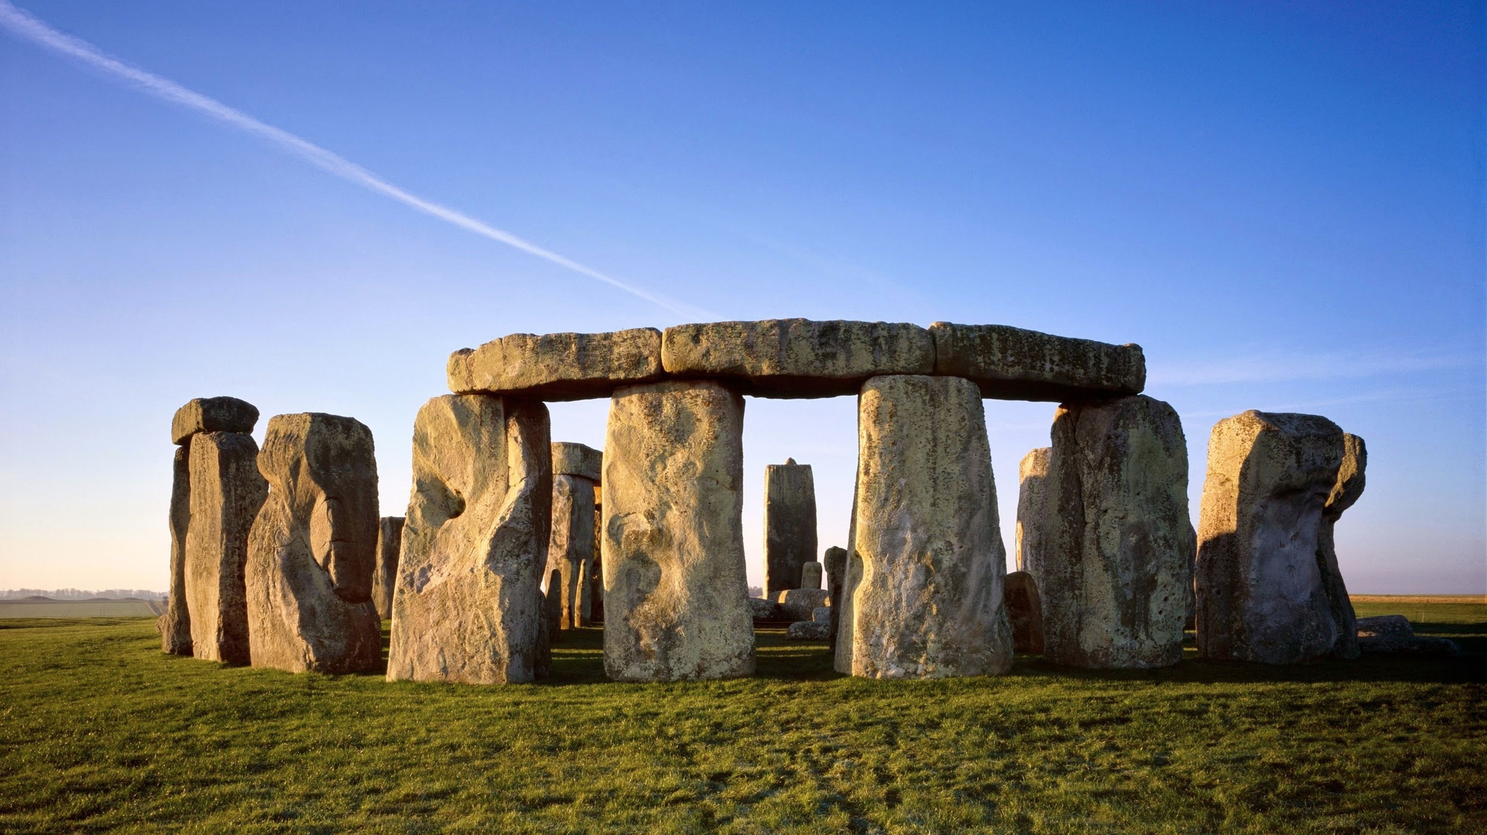

Stonehenge is a prehistoric monument and one of the most visited sites in England. It stands on Salisbury Plain. How did stones get there? Was it a religious place or a place where people watched stars and planets? Nobody knows the answer. It has an inner circle of arches made by laying one stone across the tops of two others. It shows the position of the rising sun on Midsummer’s Day.

Stratford-upon-Avon was Shakespeare’s birthplace. He is one of the most famous poets and writers. He wrote several plays, sonnets and most of his works were performed in the famous Globe Theatre in London. It was built in 1599 on the bank of the river Thames and it was a round building with a stage in the centre open to the sky.
Read the sentences below. Each one has a mistake. Find the mistake and correct it.
1. Sherwood Forest are in Nottingham.
2. There be no evidence Robin Hood was real.
3. Visitors likes the gift shop.
4. Nobody know how the stones got to Stonehenge
5. Stonehenge are a pre historic site.
6. Stonehenge have an inner circle made of arches.
7. Shakespeare am one of the most famous writers in England.
8. The Globe Theatre are in London.
9. The Globe have an open roof.

Subject/verb agreements.
When we write sentences the subject of the sentence (the person doing the action) has to agree with the verb. For example:
James and George like ice cream.
Sam likes ice cream.
I have three brothers.
Ali has two sisters.
Write an ending for each of the sentences below. Remember the verb and the subject have to agree.
1. Paul is going to ____________________________________________________
2. I always __________________________________________________________
3. My sister and her friends _____________________________________________
___________________________________________________________________
4. During the rush hour people __________________________________________
___________________________________________________________________
5. She never _________________________________________________________
6. They didn’t ________________________________________________________

