Partitioning.
This is based on place value HTU. Separating the numbers like this

56= 50 + 6
85 = 80 + 5
135 = 100 +30+5
This aids mental addition and subtraction

Addition
Take a look at this addition sum:
80 + 49
To make it easier, split the 49 into 40 + 9. This makes the sum:
80 + 40 + 9 = 129
First, add the first two numbers:
80 + 40 = 120
Then add the result of that sum to the third number to get the answer:
120 + 9 = 129
Subtraction
Take a look at this subtraction sum:
150 - 34
To make it easier, split the - 34 into 30 - 4. This makes the sum:
150 - 30 - 4
First, subtract the 30 from 150:
150 - 30 = 120
Then, subtract the 4 from the 120 to get the answer:
120 - 4 = 116

Near Doubles
If you are adding together two numbers that are nearly the same, you can double one of them and then adjust the difference.
Imagine you are adding together 38 and 35.
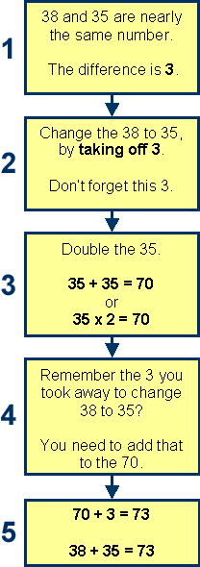

The grid method
When you use the grid method, you break up the number into hundreds, tens and units. Multiply each separately and then add the answers together.
For example, 327 x 6
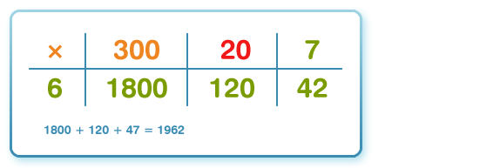
1967
For example, 246 x 3
