Classroom Management Plan
The ideal classroom management plan in the classroom would have as its primary goal the creation of an environment in the class where the teacher with support would look forward to teaching and where the children would be inspired and motivated to learn.
It is possible to have this happen with a management plan that has as its foundation the ethic of caring for each student and the development of every student's full potential.
With these two principles at work the school experience will be about teaching and learning rather than about spending large amounts of class time solving the challenges of dissatisfied and misbehaved children.
Student Needs in the Classroom:
- A safe environment
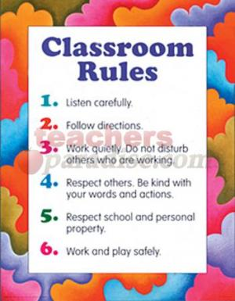
- Ongoing active learning

- Belief in the potential of every child

- Support for differences in learning styles

- Consistent class routine with clear lesson plans

- A sense of class community

- Open communication among children and between
teacher and children

- Acknowledgement for work well done

- Self-discipline, responsibility, accountability, sense of purpose

- Role models

- Opportunities for play and celebration

